
Apply advanced airfare rules and
procedures
D2.TTA.CL2.03
Trainer Guide

Apply advanced airfare rules and procedures

D2.TTA.CL2.03

Trainer Guide





Project Base
William Angliss Institute of TAFE
555 La Trobe Street
Melbourne 3000 Victoria
Telephone: | (03) 9606 2111
Facsimile: | (03) 9670 1330
Acknowledgements
Project Director: | Wayne Crosbie
Project Manager | Jim Irwin
Chief Writer: | Alan Hickman
Subject Writer: | Sheena D’Souza and Dianne Whelan
Editor: | Jim Irwin
DTP/Production: | Daniel Chee, Mai Vu, Cindy Curran

The Association of Southeast Asian Nations (ASEAN) was established on 8 August 1967. The Member States of the Association are Brunei Darussalam, Cambodia, Indonesia, Lao PDR, Malaysia, Myanmar, Philippines, Singapore, Thailand and Viet Nam.
The ASEAN Secretariat is based in Jakarta, Indonesia.
General Information on ASEAN appears online at the ASEAN Website: www.asean.org.
All text is produced by William Angliss Institute of TAFE for the ASEAN Project on “Toolbox Development for Tourism Labour Divisions for Travel Agencies and Tour Operations”.
This publication is supported by the Australian Government’s aid program through the ASEAN- Australia Development Cooperation Program Phase II (AADCP II).
Copyright: Association of Southeast Asian Nations (ASEAN) 2015. All rights reserved.
Disclaimer
Every effort has been made to ensure that this publication is free from errors or omissions. However, you should conduct your own enquiries and seek professional advice before relying on any fact, statement or matter contained in this book. The ASEAN Secretariat and William Angliss Institute of TAFE are not responsible for any injury, loss or damage as a result of material included or omitted from this course. Information in this module is current at the time of publication. Time of publication is indicated in the date stamp at the bottom of each page.
Some images appearing in this resource have been purchased from stock photography suppliers Shutterstock and iStockphoto and other third party copyright owners and as such are non-transferable and non-exclusive. Clip arts, font images and illustrations used are from the Microsoft Office Clip Art and Media Library. Some images have been provided by and are the property of William Angliss Institute.
Additional images have been sourced from Flickr and SXC and are used under Creative Commons licence: http://creativecommons.org/licenses/by/2.0/deed.en
File name: TG_Apply advance airfare rules & procedures_291015



Table of contents
Competency Based Training (CBT) and assessment – An introduction for trainers 1
Competency standard 11
Notes and PowerPoint slides 23
Recommended training equipment 93
Instructions for Trainers for using PowerPoint – Presenter View 95
Appendix – ASEAN acronyms 97

© ASEAN 2015
Trainer Guide Apply advanced airfare rules and procedures

© ASEAN 2015
Trainer Guide
Apply advanced airfare rules and procedures

Competency Based Training (CBT) and assessment – An introduction for trainers
Competency
Competency refers to the ability to perform particular tasks and duties to the standard of performance expected in the workplace.
Competency requires the application of specified knowledge, skills and attitudes relevant to effective participation, consistently over time and in the workplace environment.
The essential skills and knowledge are either identified separately or combined.
Knowledge identifies what a person needs to know to perform the work in an informed and effective manner.
Skills describe the application of knowledge to situations where understanding is converted into a workplace outcome.
Attitude describes the founding reasons behind the need for certain knowledge or why skills are performed in a specified manner.
Competency covers all aspects of workplace performance and involves:
- Performing individual tasks
- Managing a range of different tasks
- Responding to contingencies or breakdowns
- Dealing with the responsibilities of the workplace
- Working with others.

Unit of competency

Like with any training qualification or program, a range of subject topics are identified that focus on the ability in a certain work area, responsibility or function.
Each manual focuses on a specific unit of competency that applies in the hospitality workplace.
In this manual a unit of competency is identified as a ‘unit’.
Each unit of competency identifies a discrete workplace requirement and includes:
- Knowledge and skills that underpin competency
- Language, literacy and numeracy
- Occupational safety and health requirements.
Each unit of competency must be adhered to in training and assessment to ensure consistency of outcomes.

Element of competency
An element of competency describes the essential outcomes within a unit of competency. The elements of competency are the basic building blocks of the unit of competency.
They describe in terms of outcomes the significant functions and tasks that make up the competency.
In this manual elements of competency are identified as an ‘element’.

Performance criteria

Performance criteria indicate the standard of performance that is required to demonstrate achievement within an element of competency. The standards reflect identified industry skill needs.
Performance criteria will be made up of certain specified skills, knowledge and attitudes.

Learning

For the purpose of this manual learning incorporates two key activities:
- Training
- Assessment.
Both of these activities will be discussed in detail in this introduction.
Today training and assessment can be delivered in a variety of ways. It may be provided to participants:
- On-the-job – in the workplace
- Off-the-job – at an educational institution or dedicated training environment
- As a combination of these two options.
No longer is it necessary for learners to be absent from the workplace for long periods of time in order to obtain recognised and accredited qualifications.

Learning approaches

This manual will identify two avenues to facilitate learning: Competency Based Training (CBT)
This is the strategy of developing a participant’s competency.
Educational institutions utilise a range of training strategies to ensure that participants are able to gain the knowledge and skills required for successful:
- Completion of the training program or qualification
- Implementation in the workplace.
The strategies selected should be chosen based on suitability and the learning styles of participants.

Competency Based Assessment (CBA)

This is the strategy of assessing competency of a participant.
Educational institutions utilise a range of assessment strategies to ensure that participants are assessed in a manner that demonstrates validity, fairness, reliability, flexibility and fairness of assessment processes.

Flexibility in learning

It is important to note that flexibility in training and assessment strategies is required to meet the needs of participants who may have learning difficulties. The strategies used will vary, taking into account the needs of individual participants with learning difficulties.
However they will be applied in a manner which does not discriminate against the participant or the participant body as a whole.

Catering for participant diversity
Participants have diverse backgrounds, needs and interests. When planning training and assessment activities to cater for individual differences, trainers and assessors should:
- Consider individuals’ experiences, learning styles and interests
- Develop questions and activities that are aimed at different levels of ability
- Modify the expectations for some participants
- Provide opportunities for a variety of forms of participation, such as individual, pair and small group activities
- Assess participants based on individual progress and outcomes.
The diversity among participants also provides a good reason for building up a learning community in which participants support each other’s learning.

Participant centred learning
This involves taking into account structuring training and assessment that:
- Builds on strengths – Training environments need to demonstrate the many positive features of local participants (such as the attribution of academic success to effort, and the social nature of achievement motivation) and of their trainers (such as a strong emphasis on subject disciplines and moral responsibility). These strengths and uniqueness of local participants and trainers should be acknowledged and treasured
- Acknowledges prior knowledge and experience – The learning activities should be planned with participants’ prior knowledge and experience in mind
- Understands learning objectives – Each learning activity should have clear learning objectives and participants should be informed of them at the outset. Trainers should also be clear about the purpose of assignments and explain their significance to participants
- Teaches for understanding – The pedagogies chosen should aim at enabling participants to act and think flexibly with what they know
- Teaches for independent learning – Generic skills and reflection should be nurtured through learning activities in appropriate contexts of the curriculum. Participants should be encouraged to take responsibility for their own learning

- Enhances motivation – Learning is most effective when participants are motivated. Various strategies should be used to arouse the interest of participants
- Makes effective use of resources – A variety of teaching resources can be employed as tools for learning
- Maximises engagement – In conducting learning activities, it is important for the minds of participants to be actively engaged
- Aligns assessment with learning and teaching – Feedback and assessment should be an integral part of learning and teaching
- Caters for learner diversity – Trainers should be aware that participants have different characteristics and strengths and try to nurture these rather than impose a standard set of expectations.

Active learning
The goal of nurturing independent learning in participants does not imply that they always have to work in isolation or solely in a classroom. On the contrary, the construction of knowledge in tourism and hospitality studies can often best be carried out in collaboration with others in the field. Sharing experiences, insights and views on issues of common concern, and working together to collect information through conducting investigative studies in the field (active learning) can contribute a lot to their eventual success.
Active learning has an important part to play in fostering a sense of community in the class. First, to operate successfully, a learning community requires an ethos of acceptance and a sense of trust among participants, and between them and their trainers. Trainers can help to foster acceptance and trust through encouragement and personal example, and by allowing participants to take risks as they explore and articulate their views, however immature these may appear to be. Participants also come to realise that their classmates (and their trainers) are partners in learning and solving.
Trainers can also encourage cooperative learning by designing appropriate group learning tasks, which include, for example, collecting background information, conducting small-scale surveys, or producing media presentations on certain issues and themes.
Participants need to be reminded that, while they should work towards successful completion of the field tasks, developing positive peer relationships in the process is an important objective of all group work.

Competency Based Training (CBT)

Principle of Competency Based Training
Competency based training is aimed at developing the knowledge, skills and attitudes of participants, through a variety of training tools.

Training strategies
The aims of this curriculum are to enable participants to:
- Undertake a variety of subject courses that are relevant to industry in the current environment
- Learn current industry skills, information and trends relevant to industry
- Learn through a range of practical and theoretical approaches
- Be able to identify, explore and solve issues in a productive manner

- Be able to become confident, equipped and flexible managers of the future
- Be ‘job ready’ and a valuable employee in the industry upon graduation of any qualification level.
To ensure participants are able to gain the knowledge and skills required to meet competency in each unit of competency in the qualification, a range of training delivery modes are used.

Types of training
In choosing learning and teaching strategies, trainers should take into account the practical, complex and multi-disciplinary nature of the subject area, as well as their participant’s prior knowledge, learning styles and abilities.
Training outcomes can be attained by utilising one or more delivery methods:

Lecture/tutorial
This is a common method of training involving transfer of information from the trainer to the participants. It is an effective approach to introduce new concepts or information to the learners and also to build upon the existing knowledge. The listener is expected to reflect on the subject and seek clarifications on the doubts.

Demonstration
Demonstration is a very effective training method that involves a trainer showing a participant how to perform a task or activity. Through a visual demonstration, trainers may also explain reasoning behind certain actions or provide supplementary information to help facilitate understanding.

Group discussions
Brainstorming in which all the members in a group express their ideas, views and opinions on a given topic. It is a free flow and exchange of knowledge among the participants and the trainer. The discussion is carried out by the group on the basis of their own experience, perceptions and values. This will facilitate acquiring new knowledge. When everybody is expected to participate in the group discussion, even the introverted persons will also get stimulated and try to articulate their feelings.
The ideas that emerge in the discussions should be noted down and presentations are to be made by the groups. Sometimes consensus needs to be arrived at on a given topic.
Group discussions are to be held under the moderation of a leader guided by the trainer. Group discussion technique triggers thinking process, encourages interactions and enhances communication skills.

Role play
This is a common and very effective method of bringing into the classroom real life situations, which may not otherwise be possible. Participants are made to enact a particular role so as to give a real feel of the roles they may be called upon to play. This enables participants to understand the behaviour of others as well as their own emotions and feelings. The instructor must brief the role players on what is expected of them. The role player may either be given a ready-made script, which they can memorize and enact, or they may be required to develop their own scripts around a given situation. This technique is extremely useful in understanding creative selling techniques and human relations. It can be entertaining and energizing and it helps the reserved and less literate to express their feelings.

Simulation games
When trainees need to become aware of something that they have not been conscious of, simulations can be a useful mechanism. Simulation games are a method based on "here and now" experience shared by all the participants. The games focus on the participation of the trainees and their willingness to share their ideas with others. A "near real life" situation is created providing an opportunity to which they apply themselves by adopting certain behaviour. They then experience the impact of their behaviour on the situation. It is carried out to generate responses and reactions based on the real feelings of the participants, which are subsequently analysed by the trainer.
While use of simulation games can result in very effective learning, it needs considerable trainer competence to analyse the situations.

Individual /group exercises
Exercises are often introduced to find out how much the participant has assimilated. This method involves imparting instructions to participants on a particular subject through use of written exercises. In the group exercises, the entire class is divided into small groups, and members are asked to collaborate to arrive at a consensus or solution to a problem.

Case study
This is a training method that enables the trainer and the participant to experience a real life situation. It may be on account of events in the past or situations in the present, in which there may be one or more problems to be solved and decisions to be taken. The basic objective of a case study is to help participants diagnose, analyse and/or solve a particular problem and to make them internalize the critical inputs delivered in the training. Questions are generally given at the end of the case study to direct the participants and to stimulate their thinking towards possible solutions. Studies may be presented in written or verbal form.

Field visit
This involves a carefully planned visit or tour to a place of learning or interest. The idea is to give first-hand knowledge by personal observation of field situations, and to relate theory with practice. The emphasis is on observing, exploring, asking questions and understanding. The trainer should remember to brief the participants about what they should observe and about the customs and norms that need to be respected.

Group presentation
The participants are asked to work in groups and produce the results and findings of their group work to the members of another sub-group. By this method participants get a good picture of each other's views and perceptions on the topic and they are able to compare them with their own point of view. The pooling and sharing of findings enriches the discussion and learning process.

Practice sessions
This method is of paramount importance for skills training. Participants are provided with an opportunity to practice in a controlled situation what they have learnt. It could be real life or through a make-believe situation.

Games
This is a group process and includes those methods that involve usually fun-based activity, aimed at conveying feelings and experiences, which are everyday in nature, and applying them within the game being played. A game has set rules and regulations, and may or may not include a competitive element. After the game is played, it is essential that the participants be debriefed and their lessons and experiences consolidated by the trainer.

Research
Trainers may require learners to undertake research activities, including online research, to gather information or further understanding about a specific subject area.

Competency Based Assessment (CBA)

Principle of Competency Based Assessment
Competency based assessment is aimed at compiling a list of evidence that shows that a person is competent in a particular unit of competency.
Competencies are gained through a multitude of ways including:
- Training and development programs
- Formal education
- Life experience
- Apprenticeships
- On-the-job experience
- Self-help programs.
All of these together contribute to job competence in a person. Ultimately, assessors and participants work together, through the ‘collection of evidence’ in determining overall competence.
This evidence can be collected:
- Using different formats
- Using different people
- Collected over a period of time.
The assessor, who is ideally someone with considerable experience in the area being assessed, reviews the evidence and verifies the person as being competent or not.

Flexibility in assessment
Whilst allocated assessment tools have been identified for this subject, all attempts are made to determine competency and suitable alternate assessment tools may be used, according to the requirements of the participant.
The assessment needs to be equitable for all participants, taking into account their cultural and linguistic needs.

Competency must be proven regardless of:
- Language
- Delivery Method
- Assessment Method.

Assessment objectives
The assessment tools used for subjects are designed to determine competency against the ‘elements of competency’ and their associated ‘performance criteria’.
The assessment tools are used to identify sufficient:
- Knowledge, including underpinning knowledge
- Skills
- Attitudes
Assessment tools are activities that trainees are required to undertake to prove participant competency in this subject.
All assessments must be completed satisfactorily for participants to obtain competence in this subject. There are no exceptions to this requirement, however, it is possible that in some cases several assessment items may be combined and assessed together.

Types of assessment
Allocated Assessment Tools
There are a number of assessment tools that are used to determine competency in this subject:
- Work projects
- Written questions
- Oral questions
- Third Party Report
- Observation Checklist.
Instructions on how assessors should conduct these assessment methods are explained in the Assessment Manuals.
Alternative assessment tools
Whilst this subject has identified assessment tools, as indicated above, this does not restrict the assessor from using different assessment methods to measure the competency of a participant.
Evidence is simply proof that the assessor gathers to show participants can actually do what they are required to do.
Whilst there is a distinct requirement for participants to demonstrate competency, there are many and diverse sources of evidence available to the assessor.
Ongoing performance at work, as verified by a supervisor or physical evidence, can count towards assessment. Additionally, the assessor can talk to customers or work colleagues to gather evidence about performance.

A range of assessment methods to assess competency include:
- Practical demonstrations
- Practical demonstrations in simulated work conditions
- Problem solving
- Portfolios of evidence
- Critical incident reports
- Journals
- Oral presentations
- Interviews
- Videos
- Visuals: slides, audio tapes
- Case studies
- Log books
- Projects
- Role plays
- Group projects
- Group discussions
- Examinations.

Recognition of Prior Learning
Recognition of Prior Learning is the process that gives current industry professionals who do not have a formal qualification, the opportunity to benchmark their extensive skills and experience against the standards set out in each unit of competency/subject.
Also known as a Skills Recognition Audit (SRA), this process is a learning and assessment pathway which encompasses:
- Recognition of Current Competencies (RCC)
- Skills auditing
- Gap analysis and training
- Credit transfer.

Assessing competency
As mentioned, assessment is the process of identifying a participant’s current knowledge, skills and attitudes sets against all elements of competency within a unit of competency. Traditionally in education, grades or marks were given to participants, dependent on how many questions the participant successfully answered in an assessment tool.
Competency based assessment does not award grades, but simply identifies if the participant has the knowledge, skills and attitudes to undertake the required task to the specified standard.

10
© ASEAN 2015
Trainer Guide
Therefore, when assessing competency, an assessor has two possible results that can be awarded:
- Pass Competent (PC)
- Not Yet Competent (NYC).
Pass Competent (PC)
If the participant is able to successfully answer or demonstrate what is required, to the expected standards of the performance criteria, they will be deemed as ‘Pass Competent’ (PC).
The assessor will award a ‘Pass Competent’ (PC) if they feel the participant has the necessary knowledge, skills and attitudes in all assessment tasks for a unit.
Not Yet Competent’ (NYC)
If the participant is unable to answer or demonstrate competency to the desired standard, they will be deemed to be ‘Not Yet Competent’ (NYC).
This does not mean the participant will need to complete all the assessment tasks again. The focus will be on the specific assessment tasks that were not performed to the expected standards.
The participant may be required to:
- Undertake further training or instruction
- Undertake the assessment task again until they are deemed to be ‘Pass Competent’.

Competency standard

UNIT TITLE: APPLY ADVANCED AIRFARE RULES AND PROCEDURES |  | NOMINAL HOURS: 50
UNIT NUMBER: D2.TTA.CL2.03
UNIT DESCRIPTOR: This unit deals with the skills and knowledge required to construct international airfare itineraries and cost those itineraries applying advanced international airfare rules and procedures.
ELEMENTS AND PERFORMANCE CRITERIA | UNIT VARIABLE AND ASSESSMENT GUIDE
Element 1: Confirm client requirements for all purchases  - Identify and confirm needs and preferences of client  - Identify and access appropriate resources  to enable processing of client requirements  Element 2: Construct mixed class fares  - Identify and confirm availability of mixed class combinations  - Match choice of mixed class fare to identified needs of client  - Ensure fare construction complies with  operational requirements  - Calculate mixed fare costs  - Construct and check accuracy and completeness of air itineraries | Unit Variables  The Unit Variables provide advice to interpret the scope and context of this unit of competence, allowing for differences between enterprises and workplaces. It relates to the unit as a whole and facilitates holistic assessment  This unit applies to the application of advanced airfare rules and procedures within the labour divisions of the hotel and travel industries and may include:  - Travel agencies  - Tour operation  Needs and preferences of client may relate to:  - Packages  - Budget  - Timing and duration  - Number of travellers – including considerations applicable to groups, families and individuals  - Destinations  - Carrier  - Quotations and advice supplied to client.

Element 3: Construct airfares incorporating add-ons  - Identify and interpret available and applicable add-on flights  - Ensure fare construction complies with  operational requirements  - Calculate through fare costs including add- ons  - Construct and check accuracy and completeness of air itineraries  Element 4: Prepare international pre-paid ticket advices  - Determine the needs and preferences of client for pre-paid ticket advice (PTA)  - Select flight and carrier that best meets client needs  - Process PTA in accordance with operational requirements  - Issue or forward PTA  Element 5: Construct round-the-world and round trip itineraries  - Identify and confirm needs and preferences of client  - Identify and access appropriate resources  to enable processing of client requirements  - Identify and confirm availability of flights to meet client requirements | Appropriate resources may include:  - Computerised reservation system, including computerised data/information contained within the system  - Airline guides  - Airline schedules/timetables  - Fare manuals  - Tariffs from airlines  - Tariffs from consolidators  - Special bulletins and advisories from airlines and consolidators  - General information from airlines  - Customer quotations.  Availability of mixed class combinations must include:  - Confirming definition and interpretation of mixed class  - Identifying carriers who offer this option  - Verifying routes to which this option applies  - Verifying advanced purchase timelines/dates.  Operational requirements relates to:  - Carrier guidelines  - Regulatory requirements  - Organisational requirements  - IATA requirements and procedures, including IATA fare construction rules  - Use of correct documentation and/or screens and information fields

- Ensure fare construction complies with operational requirements  - Calculate fare costs  - Construct and check accuracy and completeness of air itineraries  Element 6: Construct fares for open jaw journeys  - Identify and confirm needs and preferences of client  - Identify and access appropriate resources  to enable processing of client requirements  - Identify options that enable open jaw journeys  - Identify and confirm availability of flights to meet client requirements  - Ensure fare construction complies with operational requirements  - Calculate fare costs  - Construct and check accuracy and completeness of air itineraries  Element 7: Apply the pricing unit concept to fares  - Divide fare journey into individual pricing units  - Calculate lowest combination of fares for given pricing units | - Checks and calculation requirements, including minimum fare check requirements where applicable to individual booking types, including:  - Neutral units of construction (NUCS)  - Local currency fares (LCF)  - Global indicators (GI)  - Sold and ticketed inside the country of commencement  - Journeys commencing outside the country of sale  - Mileage system:  - Maximum permitted mileages (MPMS)  - Ticketed point mileages (TPMS)  - Extra mileage allowance (EMA)  - Excess mileage surcharges (EMS)  - Higher intermediate points (HIPs)  - One way backhaul checks (BHC)  - Circle trip minimum fare checks (CTM)  - Directional minimum checks (DMC)  - Country of origin minimum checks (CPM)  - Open jaw via country of origin check (COM)  - One way sub-journey check (OSC)  - Return sub-journey check (RSC)  - Re-routing  - Application of indirect travel limitation rules, including sector journeys and side-trips.

Element 8: Maintain client file  - Record and update needs and preferences of client  - Record itineraries and airfares quoted  - Generate and issue documents to clients  - Record and process changes to bookings  - Record, up-date and receipt payments  made by client | Calculate mixed fare costs may include:  - Referring to relevant carrier schedules/timetables and tariff information  - Referring to specials available and packages that apply  - Factoring in applicable discounts, where appropriate.  Air itineraries may include:  - Name and number of passenger/s – including indication of adults and children  - Day and date of travel  - From and to destinations  - Flight number and carrier, including seat allocation, where applicable  - Departure and arrival times  - Fare, taxes, fees and charges, including sub-totals and total  - Amount paid and amount due, if applicable  - Verification of connections and times, where applicable.
Available and applicable add-on flights may relate to:
- Add-on tables
- Specific flights
- Availability
- Nominated carriers
- Specified routes/destinations
- Integration with full packages
- Compatibility with nominated class
- Prohibition on separate sale

- Confirming currency of guidelines that apply to add-ons with carriers
- Individual terms and conditions of carriers.
Calculate through fare costs including add-ons may include:
- Determining relevant carrier charges
- Identifying time of year/seasonal implications and loadings or premiums
- Identifying current rate for add-ons.
Select flight and carrier may include:
- Confirming availability
- Understanding relevant carrier policies and procedures, including limitations and restrictions
- Matching timing requirements to flight availability
- Seat availability
- Meeting connecting flights
- Package limitations, where applicable.
Process PTA may include:
- Following relevant guidelines, policies and procedures
- Confirming applicable timeline requirements for booking
- Verifying agency details with carrier
- Including services covered by PTAs, including excess baggage, unaccompanied children, oxygen use
- Obtaining fare quote
- Applying service charge
- Raising Miscellaneous Charge Order (MCO).

Availability of flights may relate to:
- Time of travel
- Connections
- Seat availability
- Stop-overs
- Time spent at destinations.
Calculate fare costs may include:
- Referring to relevant carrier schedules/timetables and tariff information
- Referring to specials available and packages that apply
- Factoring in applicable discounts, where appropriate
- Including transfers
- Undertaking currency exchange calculations
- Determining adult, children and infant rates, including unaccompanied children
- Considering special fares, including APEX (advanced purchase)
- Including taxes, fees and charges.
Identify options that enable open jaw journeys may include:
- Considering double open jaw trips
- Reading package limitations
- Verifying acceptable destinations, en route destinations and countries, including limitations on intra-country and inter-country applications
- Conformity with airline and airfare rules, including understanding of the limitations imposed by these
- Identifying minimum stay provisions, where applicable

- Identifying relative distances involved, where applicable
- Catering for circle trips, where necessary.
Fare journey must include:
- Single fare
- Return fare.
Itineraries and airfares quoted may include:
- All types of fares and trips offered by the host enterprise
- Through fares incorporating add-ons
- Mixed class fares
- Round, circle and open jaw trips
- Fares incorporating intermediate points
- Fares incorporating sector journeys and side-trips
- Fares incorporating airport and other taxes.
Documents may include:
- Invoices
- Credit notes
- Receipts
- Confirmation letters
- Itineraries
- Information packs.

Changes to bookings may include:
- Changed arrangements
- Cancellations, including the processing of refunds and issuing of credit notes
- Verifying alterations with carriers
- Confirming alterations with clients and issuing appropriate confirmations and amended documentation.
Payments may include:
- Credit card
- Cash
- Personal, business and traveller’s cheque
- Direct debit, such as electronic funds transfer
- Invoice/account
- Telephone
- E-mail or other electronic transmission.
Assessment Guide
The following skills and knowledge must be assessed as part of this unit:
- The enterprise’s policies and procedures in regard to operational requirements for applying airfare rules, procedures and documentation
- Knowledge of and ability to apply basic research techniques
- Ability to perform basic arithmetic calculations
- Detailed knowledge of fare construction principles and rules
- Ability to identify, access and apply fare-related resources
- Ability to identify and interpret airline and other travel codes

- General knowledge of IATA regulations and requirements
- Ability to convert currencies
- Ability to process payments.
Linkages To Other Units
- Construct and ticket domestic airfares
- Construct and ticket promotional international airfares
- Construct and ticket regular international airfares
- Access and interpret product information
- Process a financial sale transaction
- Promote products and services to customers
- Operate a computerised reservation system
- Access and retrieve computer-based data
- Maintain quality customer/guest service
- Produce documents, reports and worksheets on a computer
- Use common business tools and technology
- Develop and update tourism industry knowledge
- Operate an automated information system
- Produce travel documentation on a computer
- Receive and process reservations
- Source and package tourism products and services
- Source and provide destination information and advice
- Prepare and submit quotations.

Critical Aspects of Assessment
Evidence of the following is essential:
- Understanding of organisational and IATA requirements in relation to fare construction
- Demonstrated ability to construct a mixed client fare and itinerary to accommodate a nominated set of client requirements
- Demonstrated ability to construct a fare and itinerary incorporating add-ons to accommodate a nominated set of client requirements
- Demonstrated ability to prepare an international pre-paid ticket advice and itinerary to accommodate a nominated set of client requirements
- Demonstrated ability to construct an around-the-world fare and itinerary to accommodate a nominated set of client requirements
- Demonstrated ability to construct a fare and itinerary for an open jaw journey to accommodate a nominated set of client requirements
- Demonstrated ability to apply the pricing unit concept to a nominated fare journey fare to calculate lowest combination of fares for given pricing units
- Demonstrated ability to maintain the client file for a nominated client for a designated series of exchanges and transactions which must include supplying a quotation for a nominated journey, an alteration to the initial booking and receipt for payment.
Context of Assessment
This unit may be assessed on or off the job:
- Assessment must ensure practical demonstration either in the workplace or through a simulation activity, supported by a range of methods to assess underpinning knowledge
- Assessment must be able to demonstrate actual or simulated workplace application of airfare construction in a realistic office environment.

Resource Implications
- Training and assessment to include access to a real or simulated workplace including actual computerised reservation and ancillary systems, real travel and airfare documentation or screens, real airfare resource material and actual or simulated journeys for use as the basis of developing airfares and itineraries; and access to workplace and industry (IATA) standards, procedures, policies, guidelines, tools and equipment.
Assessment Methods
The following methods may be used to assess competency for this unit:
- Observation of practical candidate performance
- Portfolio of itineraries and other documentation
- Role plays
- Oral and written questions
- Third party reports completed by a supervisor
- Project and assignment work.
Key Competencies in this Unit
Level 1 = competence to undertake tasks effectively Level 2 = competence to manage tasks
Level 3 = competence to use concepts for evaluating

22
© ASEAN 2015
Trainer Guide

 | Key Competencies | Level | Examples
 | Collecting, organising and analysing information | 2 | Source fare information; interpret airfare resource material; evaluate options to meet client requirements
 | Communicating ideas and information | 1 | Provide options, advice and assistance to clients; explain client requirements to carriers
 | Planning and organising activities | 2 | Integrate client requirements into a personalised itinerary that meets identified need
 | Working with others and in teams | 1 | Liaise with carriers and other agency staff
 | Using mathematical ideas and techniques | 2 | Calculate airfares, discounts and required checks
 | Solving problems | 1 | Source alternatives for client that enable attainment of identified requirements
 | Using technology | 2 | Use computerised reservation system and communication technologies

Notes and PowerPoint slides

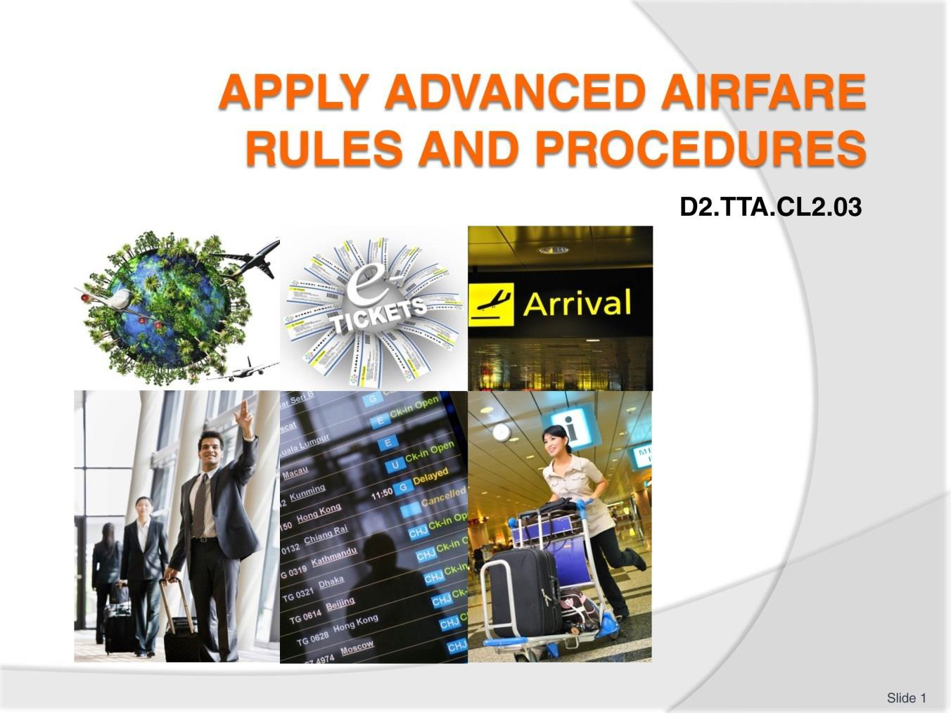
Slide
Slide No
Trainer Notes
1.
Trainer to welcome students to the class.
- Introduce self and state qualification to teach this unit
- Give overview of qualifications and describe industry experience.

Slide
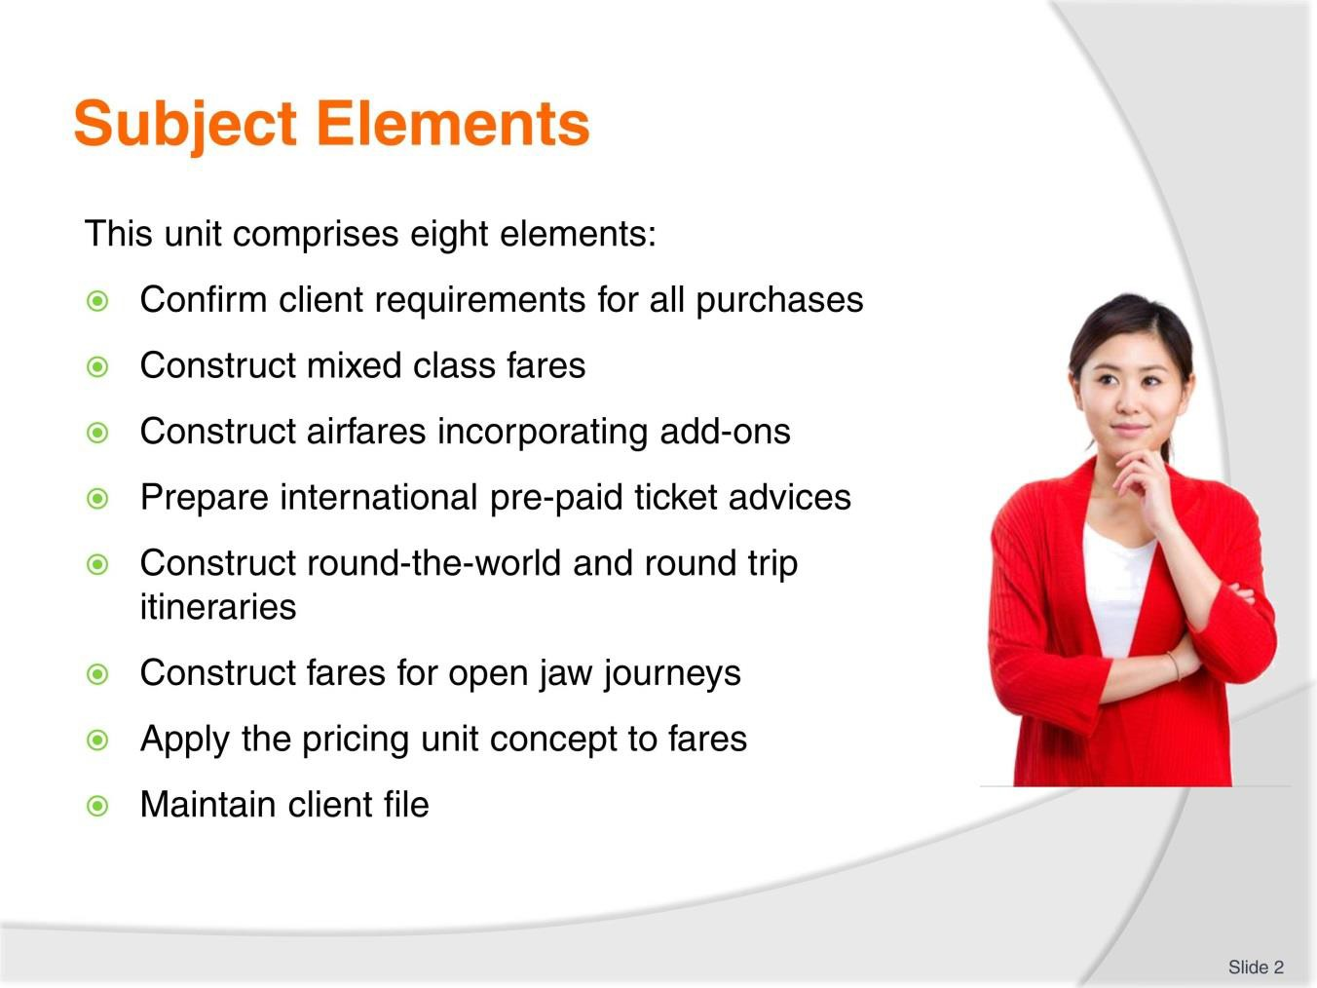
Slide No | Trainer Notes
2. | Trainer advises students this Unit comprises two elements, as listed on the slide explaining:  - Each Element comprises a number of Performance Criteria which will be identified throughout the class and explained in detail  - Students can obtain more detail from their Trainee Manual  - The course presents advice and information but where their workplace requirements differ to what is presented, the workplace practices and standards must be observed.

Slide

Slide No | Trainer Notes
3. | Trainer advises students that assessment for this Unit may take several forms all of which are aimed at verifying they have achieved competency for the Unit as required.  Trainer indicates to students the methods of assessment that will be applied to them for this Unit.

Slide
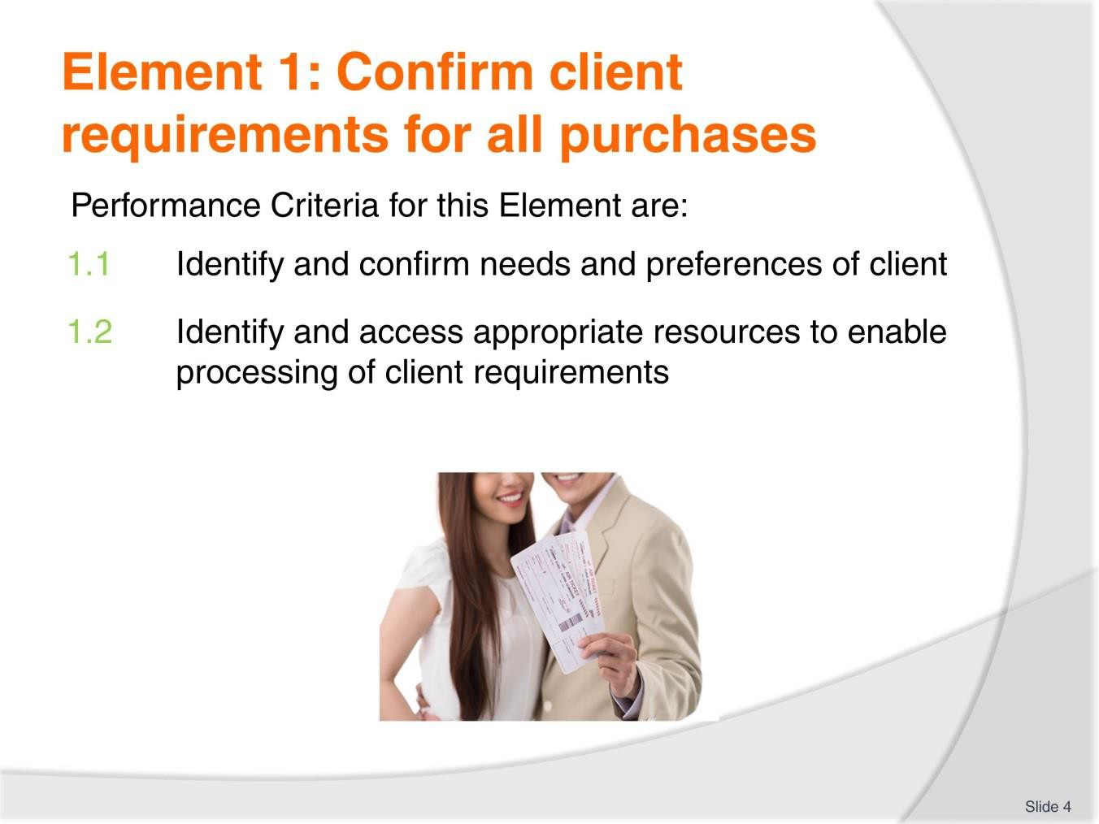
Slide No | Trainer Notes
4. | Trainer to relate performance criteria to element 1.  - Performance criteria is the process by which the students training match the learning element  - The element is the skill  - To assess competency in the skill, the performance criteria is used to outline activities that can be used to assess competency.  The trainer should relate how the performance criteria are related to the element.  To be able to Confirm client requirements for all purposes the students must be able to:  - Identify and confirm needs and preferences of client  - Identify and access appropriate resources to enable processing of client requirements.

Slide
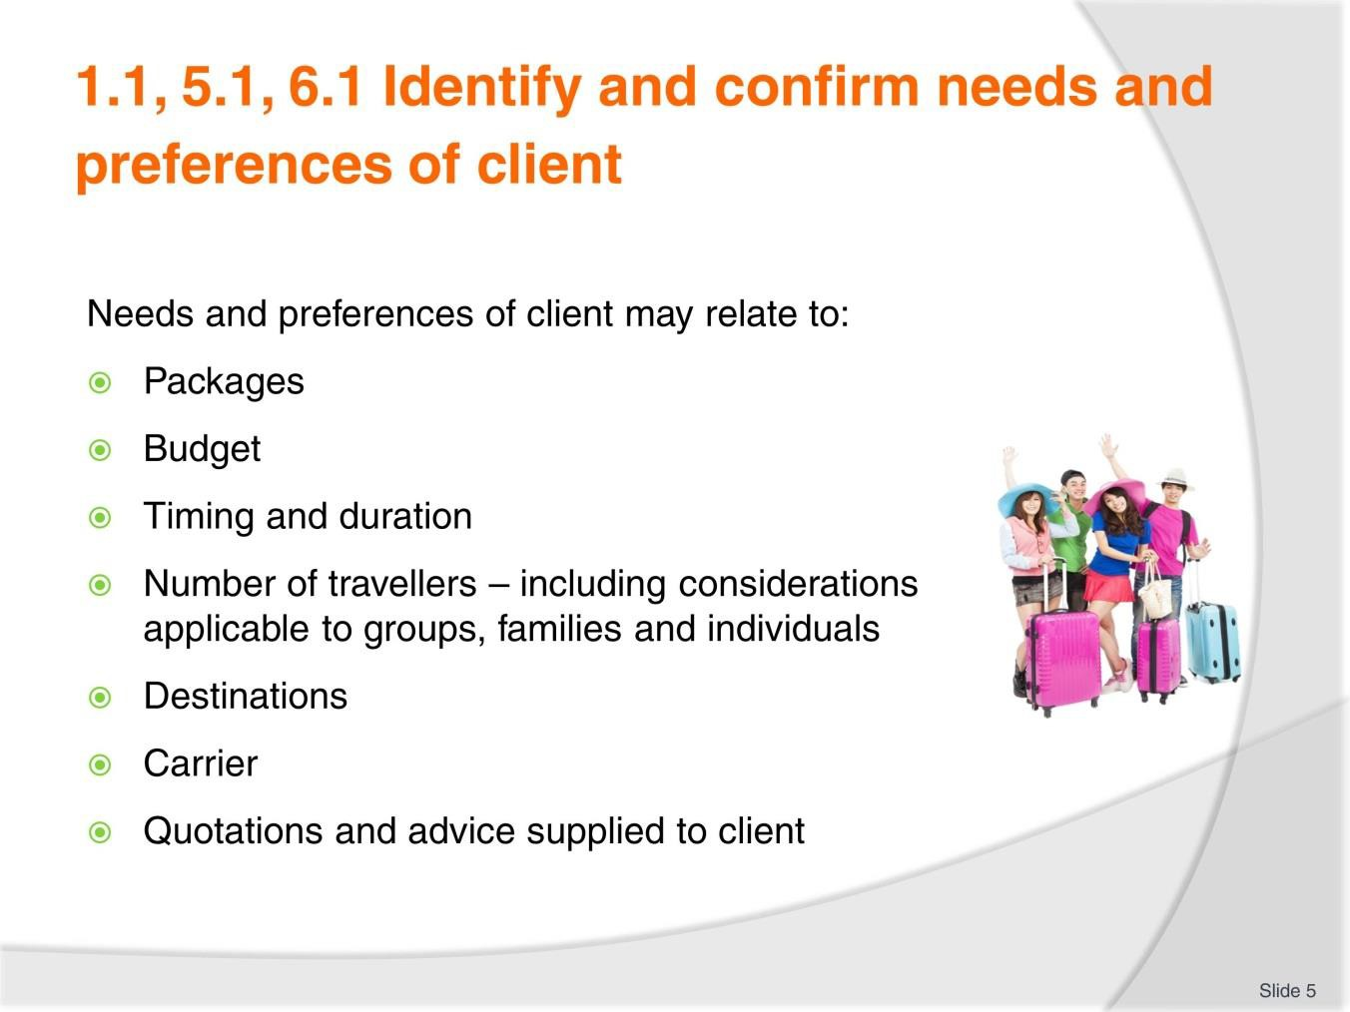
Slide No | Trainer Notes
5. | Trainer to advise: PC: 1.1, 5.1 & 6.1  Needs and preferences of client may relate to:  - Packages  - Budget  - Timing and duration  - Number of travellers – including considerations applicable to groups, families and individuals  - Destinations  - Carrier  - Quotations and advice supplied to client.  Brainstorm/Class discussion:  - Are there any other needs or preferences you would include?  - Ask trainees to work in pairs to role play an initial consultation  - Ask the consultant to ask questions and keep notes to read back to the client to confirm they have understood their needs.

Slide
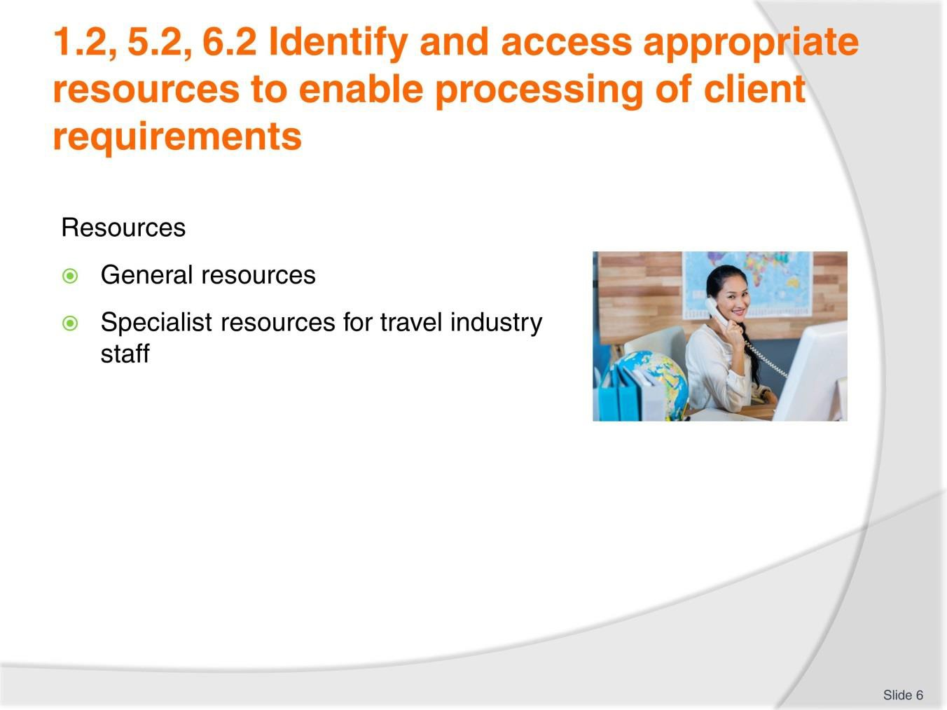
Slide No | Trainer Notes
6. | Trainer to advise: PC: 1.2, 5.2, 6.2  General resources  To construct and calculate international airfares, it will be necessary to have access to a:  - A computer with internet access  - Calendar, Calculator, Pen and paper  - World map  - Airline websites – these websites are a great source of general information on air travel, as well as the airline’s policies. Useful information for the agent and the client will include:  - Airport information – maps of terminals, facilities  - Check-in options and facilities  - Baggage restrictions and fees  - Special assistance offered for passengers  - General policy and travel information.

Specialist resources for travel industry staff
Travel industry enterprises will each develop their own policies and procedures for assisting clients to make international airfare bookings. Enterprises which construct regular airfares will have access to:
- A Computer Reservation System (CRS)
- Airline agency help desks (online and/or phone service)
- The Passenger Air Tariff.

Slide
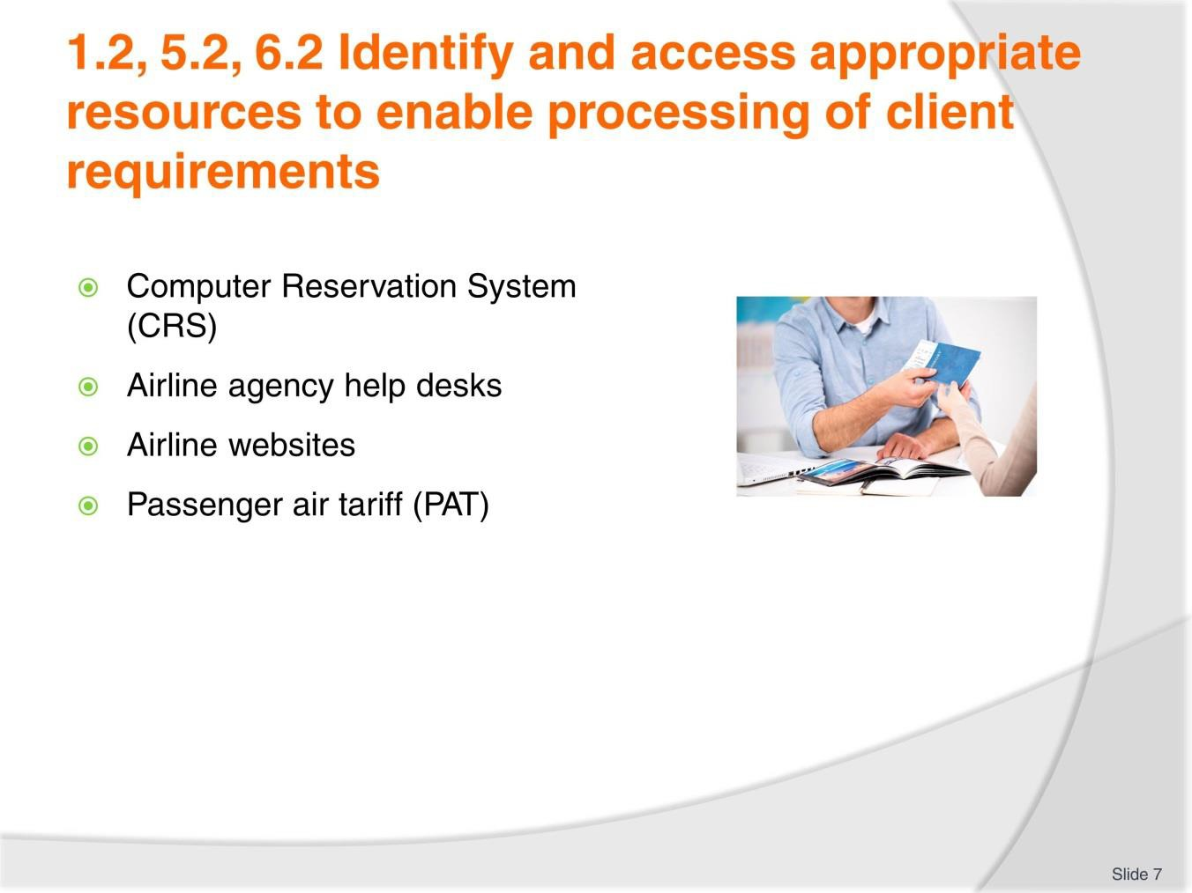
Slide No | Trainer Notes
7. | Trainer to advise: PC: 1.2, 5.2, 6.2  Refer to trainee manual and discuss these resources in some detail ensuring all learners understand their functions.  - Refer to TM and ensure thorough understanding of CRS and its capabilities  - Explain help desks and websites with travel agent login  - Demonstrate accessing PAT online.  Activity  Learners to research one Airline website each and present the following information:  - Airport information – maps of terminals, facilities  - Check-in options and facilities  - Baggage restrictions and fees  - Special assistance offered for passengers  - General policy and travel information.

Slide
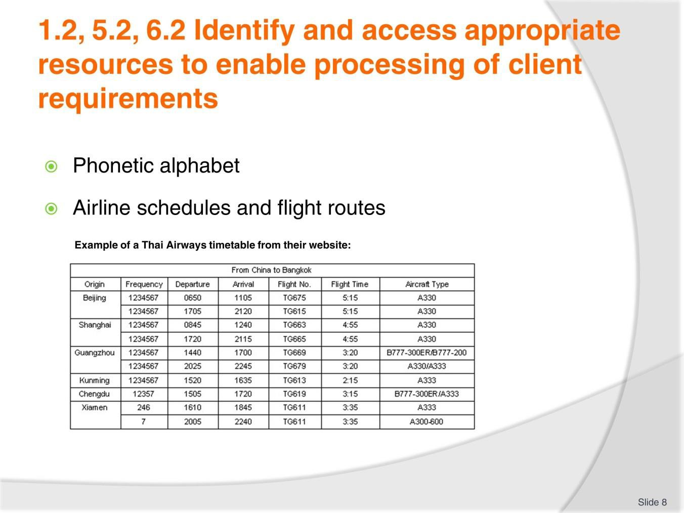
Slide No | Trainer Notes
8. | Trainer to advise: PC: 1.2, 5.2, 6.2 Phonetic alphabet  To avoid confusion with accents and different types of speech and to eliminate spelling mistakes with names and booking details, the phonetic alphabet is routinely used.  The phonetic alphabet is used for communication between staff involved in the airline industry. It is particularly useful when spelling out a client’s name over the telephone or when you need to receive or advise a reservation number. An airline or CRS booking number commonly referred to as a PNR or a Reloc is a unique code made up of six letters and numbers. To avoid confusion, the phonetic alphabet is used when staff involved in air travel need to share this information. This will be discussed in more detail in future topics and these terms also appear in the Glossary.  Airline schedules and flight routes  Access to schedules (timetables), fares and information relating to the flights operated by the various carriers is available electronically to travel agents via their Computer Reservation System (CRS) and airline websites.  Activity  In pairs have learners confirm passenger details with each other using their own names.  This activity may also be completed with learners sitting back to back to encourage listening and speaking techniques as specifically needed when communicating via telephone.

Slide
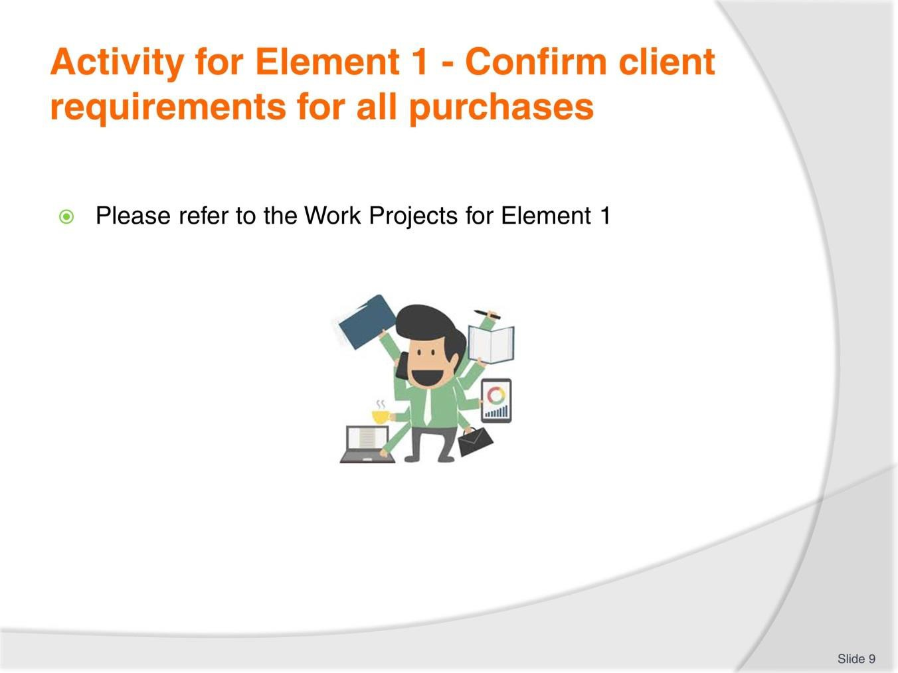
Slide No | Trainer Notes
9. | Ensure learners complete the Work Projects at the end of Element 1. Trainer may decide if these are to be completed in class individually or in groups or alternatively as homework.  A copy of work sheets has been included in the Trainer Guide.  - Review the Summary page for Element 1 to confirm with learners what has been completed for this Element.

Slide
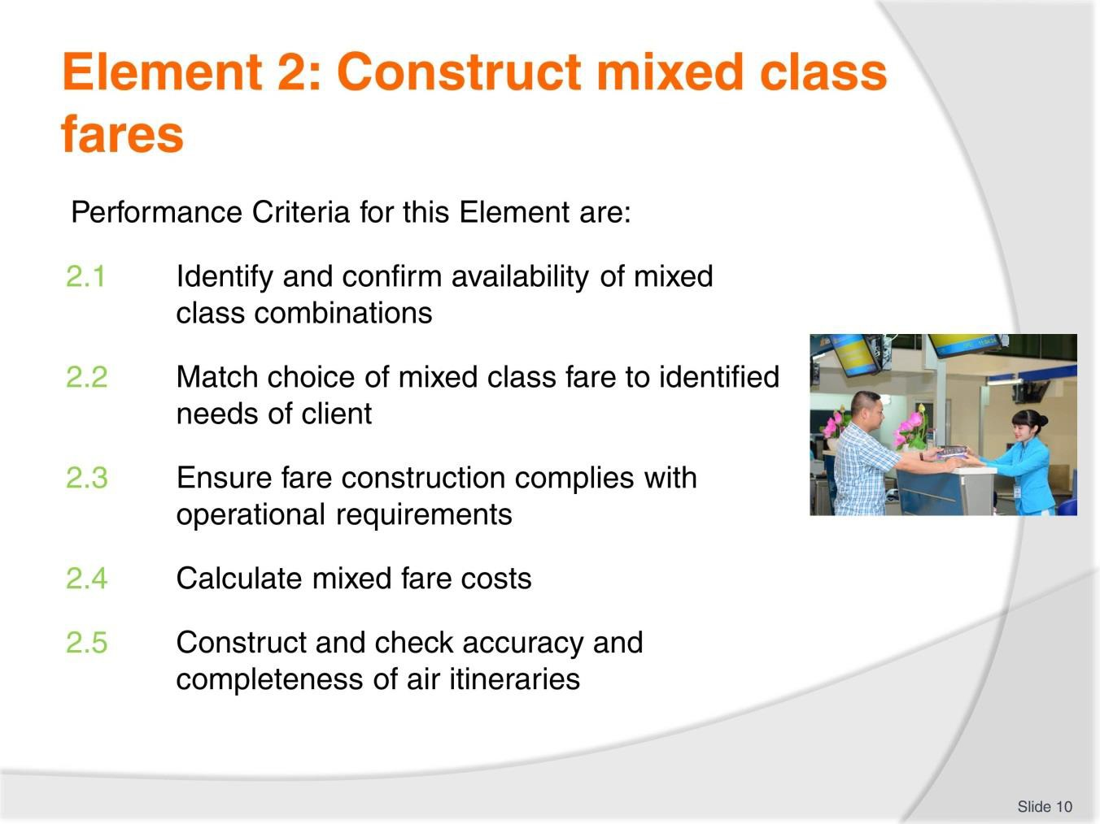
Slide No | Trainer Notes
10. | Trainer to relate performance criteria to element 2.  - Performance criteria is the process by which the students training match the learning element  - The element is the skill  - To assess competency in the skill, the performance criteria is used to outline activities that can be used to assess competency.  The trainer should relate how the performance criteria are related to the element. To be able to Construct mixed class fares the students must be able to:  - Identify and confirm availability of mixed class combinations  - Match choice of mixed class fare to identified needs of client  - Ensure fare construction complies with operational requirements  - Calculate mixed fare costs  - Construct and check accuracy and completeness of air itineraries.

Slide
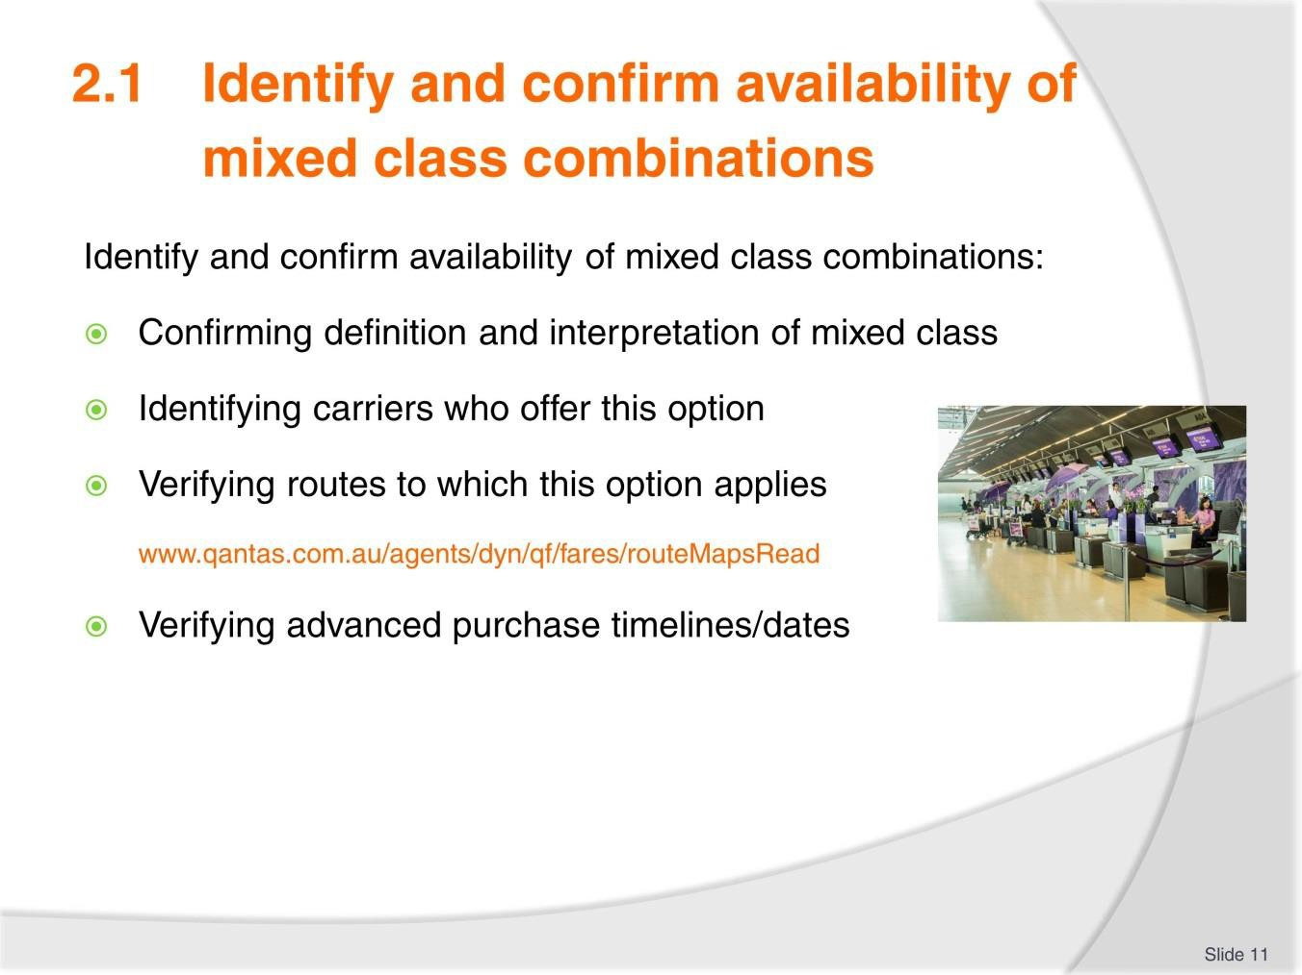
Slide No | Trainer Notes
11. | Trainer to advise: PC: 2.1  Availability of mixed class combinations must include:  - Confirming definition and interpretation of mixed class  - Identifying carriers who offer this option  - Verifying routes to which this option applies  - Verifying advanced purchase timelines/dates.  Group Activity:  - Which carriers offer mixed class tickets?  - Interpret route maps on the following Qantas website: www.qantas.com.au/agents/dyn/qf/fares/routeMapsRead

Slide
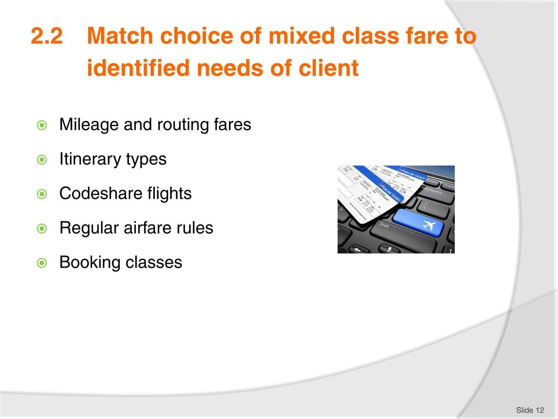
Slide No | Trainer Notes
12. | Trainer to advise: PC: 2.2  - Discuss each of the points listed using TM notes  - Airfare rules and booking classes is mentioned several times throughout this unit so a thorough discussion at this point would be appropriate.  Trainer to provide examples where possible or access appropriate websites or a CRS for demonstration.  Group Activity  - Discuss Itinerary types. Who has experience with flying, booking flights and general travel.

Slide
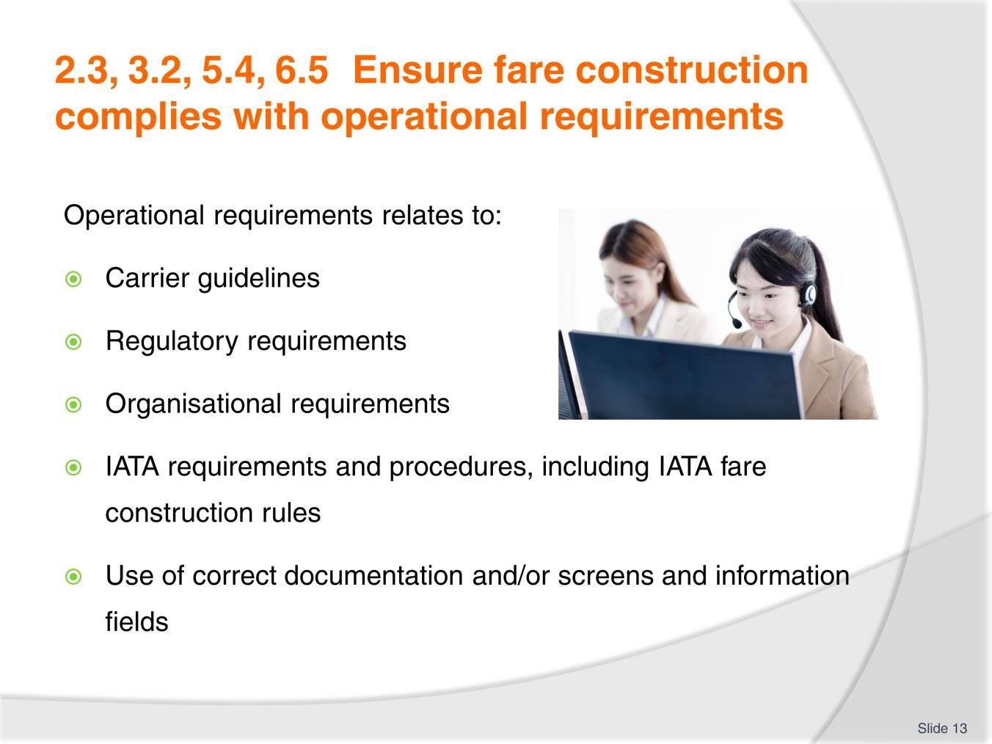
Slide No | Trainer Notes
13. | Trainer to advise: PC: 2.3, 3.2, 5.4, 6.5  Operational requirements relates to:  - Carrier guidelines  - Regulatory requirements  - Organisational requirements  - IATA requirements and procedures, including IATA fare construction rules  - Use of correct documentation and/or screens and information fields.  - Trainer to provide samples if possible or demonstrate to learners using appropriate websites or CRS.

Slide
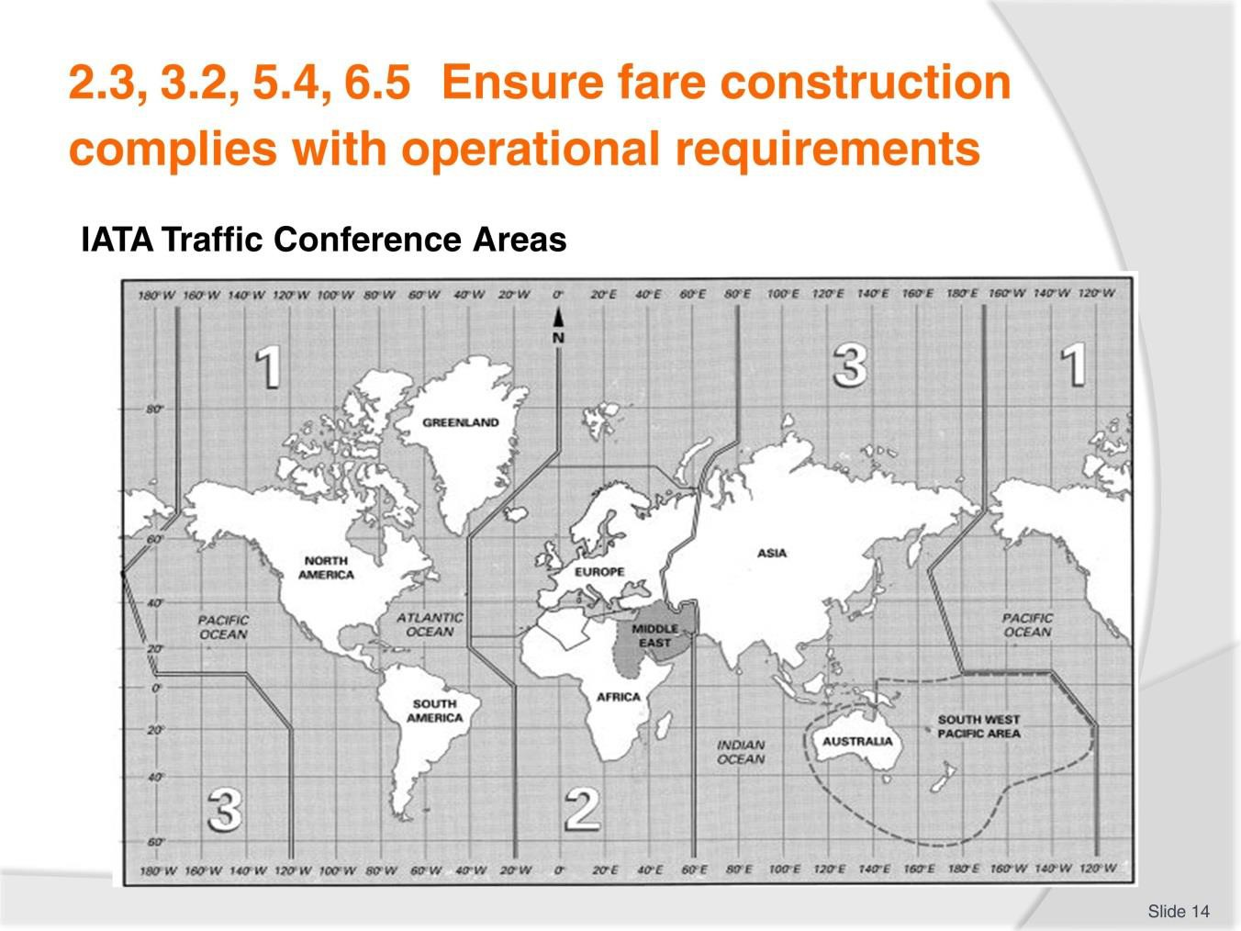
Slide No | Trainer Notes
14. | Trainer to advise: PC: 2.3, 3.2, 5.4, 6.5  An important component of international airfare construction is to consider the whole journey that the passenger wishes to undertake. This includes the airlines flown and the direction of travel across the globe, particularly across the world’s oceans. For fare construction purposes, IATA has divided the world into three Traffic Conference areas, numbered TC1, TC2 and TC3.  You may also come across the terms "Western Hemisphere” and "Eastern Hemisphere". The world is split into two (uneven) halves:  - Western Hemisphere: All of Area 1, that is, north, central and south America  - Eastern Hemisphere: All of Areas 2 and 3, that is, Europe, Africa, Asia and Australia.  Refer to TM and take time to explain these regions. Quiz learners to gauge understanding and further explain as needed.  Global Indicators (GI)  Take time to carefully explain GI and the various terms as listed in the TM.

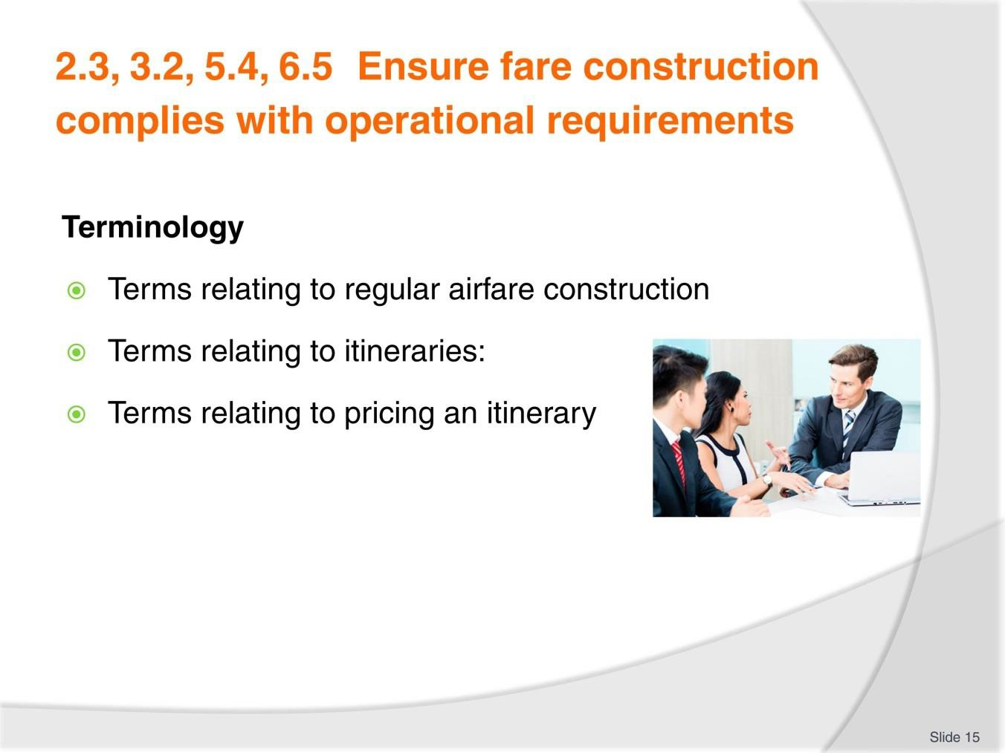
Slide
Slide No
Trainer Notes
15.
Trainer to advise: PC: 2.3, 3.2, 5.4, 6.5
- Review the terminology listed in the TM. Explain those that are not clear.
- Allow time for learners to quiz each other on specific codes, providing the opportunity to verbally identify them.

Slide
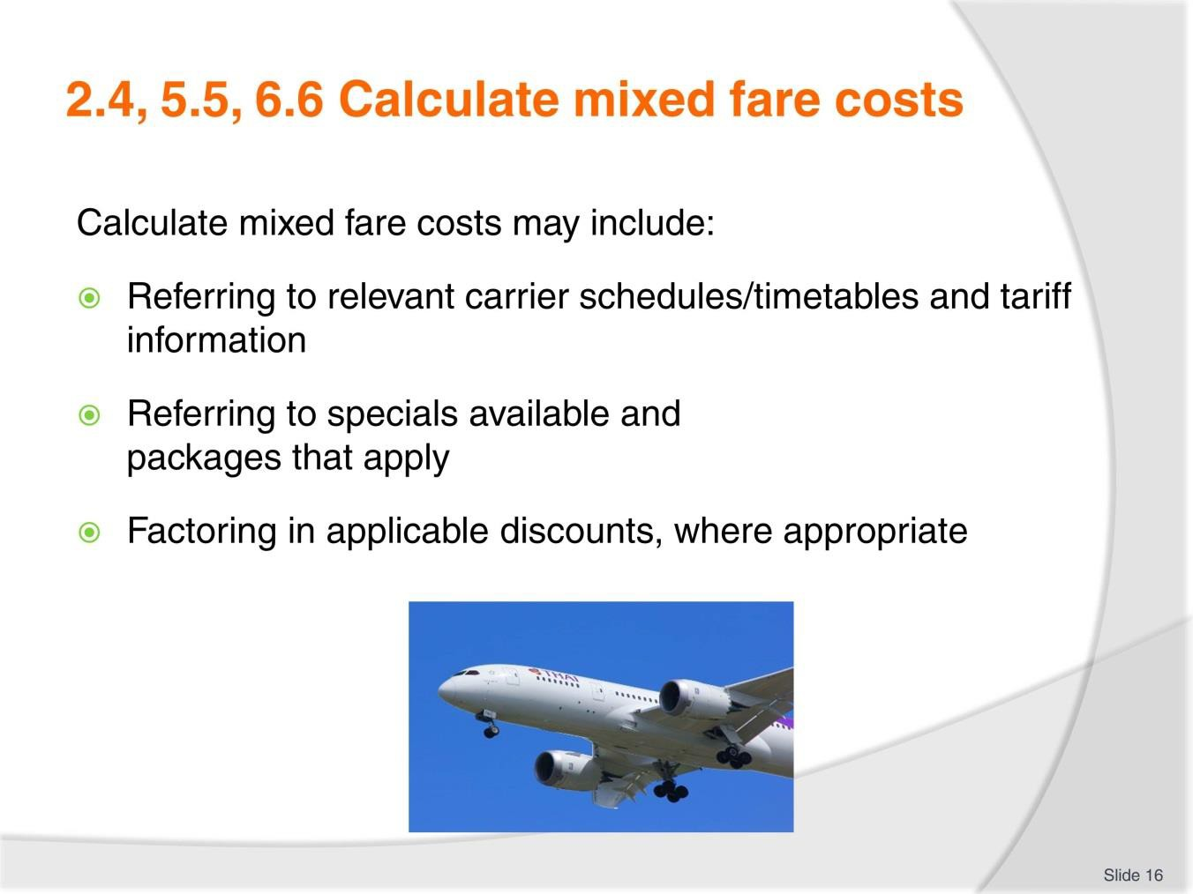
Slide No | Trainer Notes
16. | Trainer to advise: PC: 2.4, 5.5, 6.6  Calculate mixed fare costs may include:  - Referring to relevant carrier schedules/timetables and tariff information  - Referring to specials available and packages that apply  - Factoring in applicable discounts, where appropriate.  Group Discussion  - Fare types. When airlines may discount. Which airlines don’t discount.

Slide
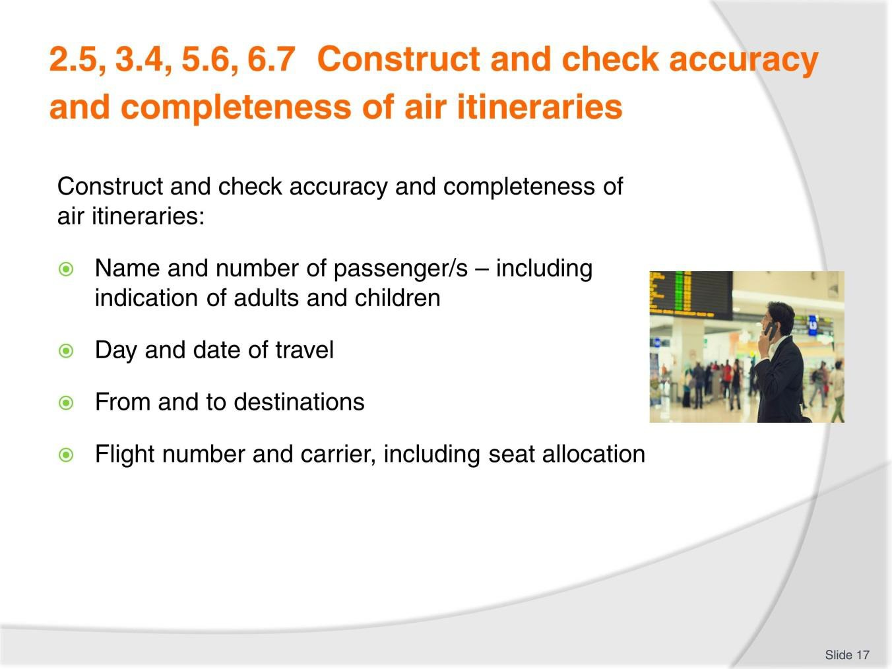
Slide No | Trainer Notes
17. | Trainer to advise: PC: 2.5, 3.4, 5.6, 6.7  Air itineraries may include:  - Name and number of passenger/s – including indication of adults and children  - Day and date of travel  - From and to destinations  - Flight number and carrier, including seat allocation, where applicable  - Departure and arrival times  - Fare, taxes, fees and charges, including sub-totals and total  - Amount paid and amount due, if applicable  - Verification of connections and times, where applicable.  - Discuss enterprise policy and procedure variation. Seek input from learners with some experience.  Trainer to provide examples to view and discuss in detail

Slide
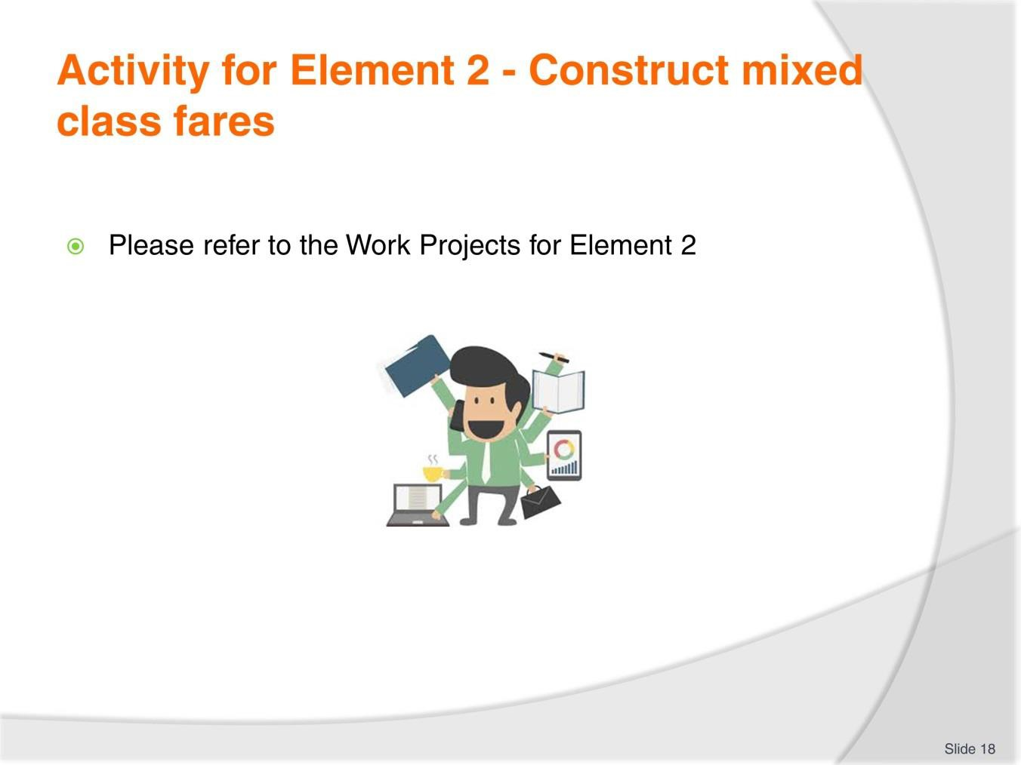
Slide No | Trainer Notes
18. | Ensure learners complete the Work Projects at the end of Element 2. Trainer may decide if these are to be completed in class individually or in groups or alternatively as homework.  A copy of work sheets has been included in the Trainer Guide.  - Review the Summary page for Element 2 to confirm with learners what has been completed for this Element.

Slide
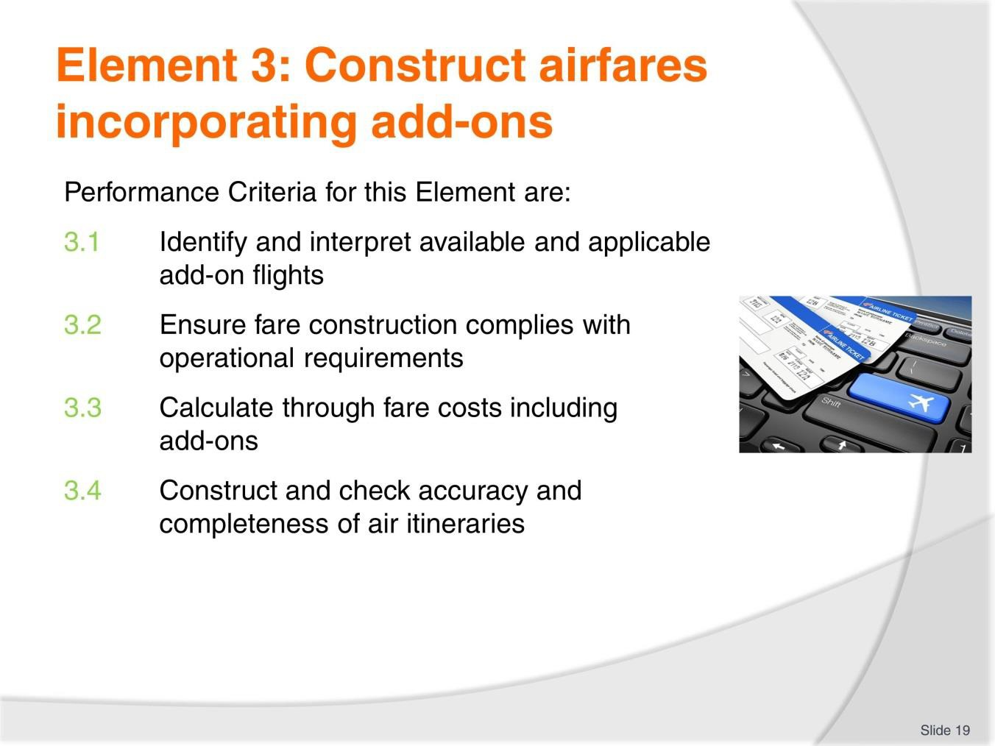
Slide No | Trainer Notes
19. | Trainer to relate performance criteria to element 3.  - Performance criteria is the process by which the students training match the learning element  - The element is the skill  - To assess competency in the skill, the performance criteria is used to outline activities that can be used to assess competency.  The trainer should relate how the performance criteria are related to the element.  To be able to Construct airfares incorporating add-ons the students must be able to:  - Identify and interpret available and applicable add-on flights  - Calculate through fare costs including add-ons.

Slide
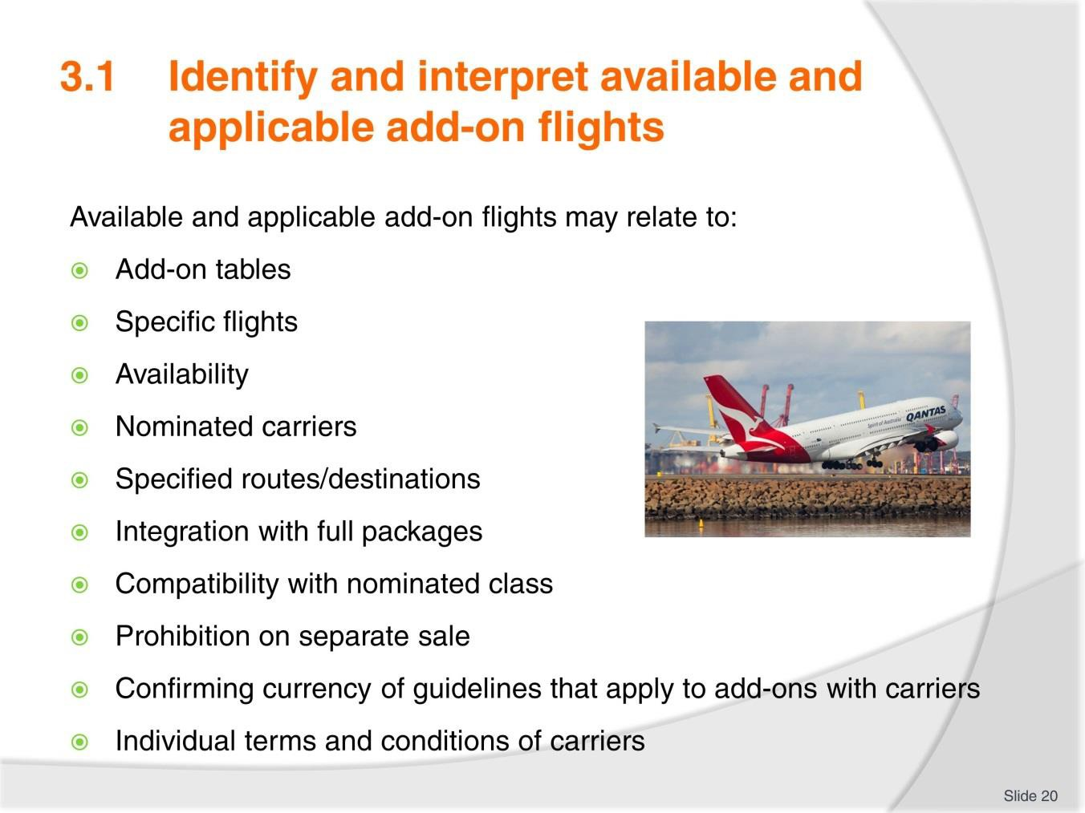
Slide No | Trainer Notes
20. | Trainer to advise on each topic as necessary PC: 3.1  Available and applicable add-on flights may relate to:  - Add-on tables  - Specific flights  - Availability  - Nominated carriers  - Specified routes/destinations  - Integration with full packages  - Compatibility with nominated class  - Prohibition on separate sale  - Confirming currency of guidelines that apply to add-ons with carriers  - Individual terms and conditions of carriers.

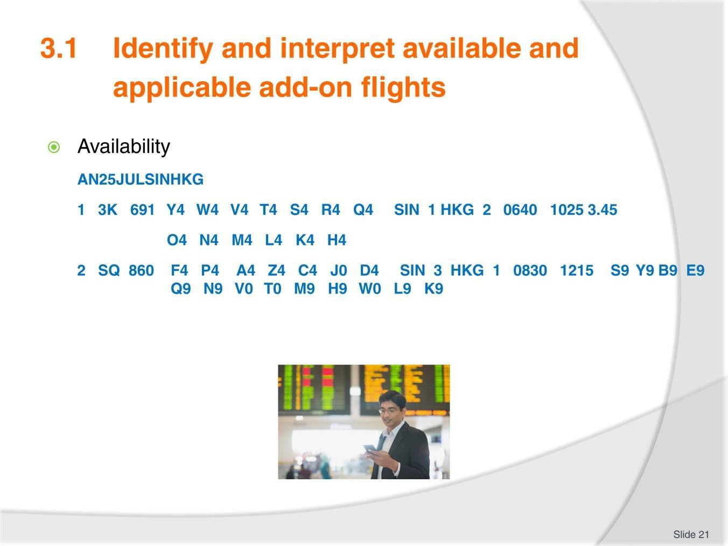
Slide
Slide No
Trainer Notes
21.
Trainer to advise:
PC: 3.1
Using the example and notes from the TM, explain to learners how to break down and
interpret this information.
Group discussion
- Currency codes, airfares and rules.

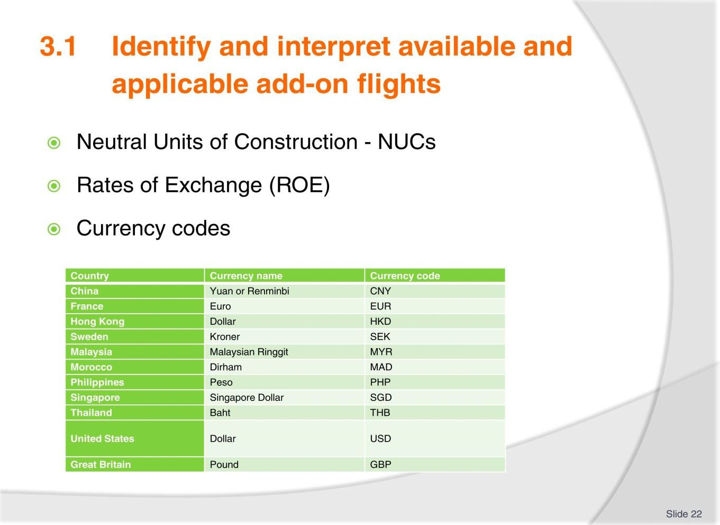
Slide
Slide No | Trainer Notes
22. | Trainer to advise: PC: 3.1 Neutral Units of Construction - NUCs  When constructing regular international airfares, a neutral currency is used. It is referenced as NUC - Neutral Unit of Construction (or Neutral Unit of Currency).This neutral currency has been developed by IATA, specifically for use in international airfare construction.  All regular airfares are published in NUC and can be accessed in a CRS through a Fare Display entry. When constructing an airfare for an itinerary, there are a series of checks that must be conducted. Some of these checks result in a higher airfare needing to be charged. This is referred to as the applicable fare. It is only after determining the applicable airfare that the NUC amount is converted into a real currency using an exchange rate called ROE – Rate of Exchange.  Rates of Exchange (ROE)  The Rates of Exchange are determined by IATA and stored in the CRS. The ROEs are updated quarterly on 01JAN, 01APR, 01JUL and 01OCT, or more frequently if there are significant currency changes during that time.  After constructing an airfare, the agent can do a simple calculation in their CRS to convert NUCs into a real currency. The currency is generally the currency for the first city (country) on the itinerary, or the currency of the country in which the enterprise and CRS are located. For example, a fare from Singapore will be displayed in Singapore dollars. In order to convert NUC to a real currency using the ROE, the agent needs to know the code for the currency. The Galileo entry to convert NUCs using the ROE will be introduced later in this unit.

Currency codes
Each currency code also has an internationally recognised three letter code. Generally, the code will appear in a CRS or on an airline website, before the airfare price to indicate which currency is being quoted.
Some countries choose to use US Dollars (USD) for international airfare calculations due to instability and fluctuations in the local currency.
Activity
Learners to access a currency website and familiarise themselves with popular or common world currencies and their coding. Learners to quiz each other to test their knowledge

Slide
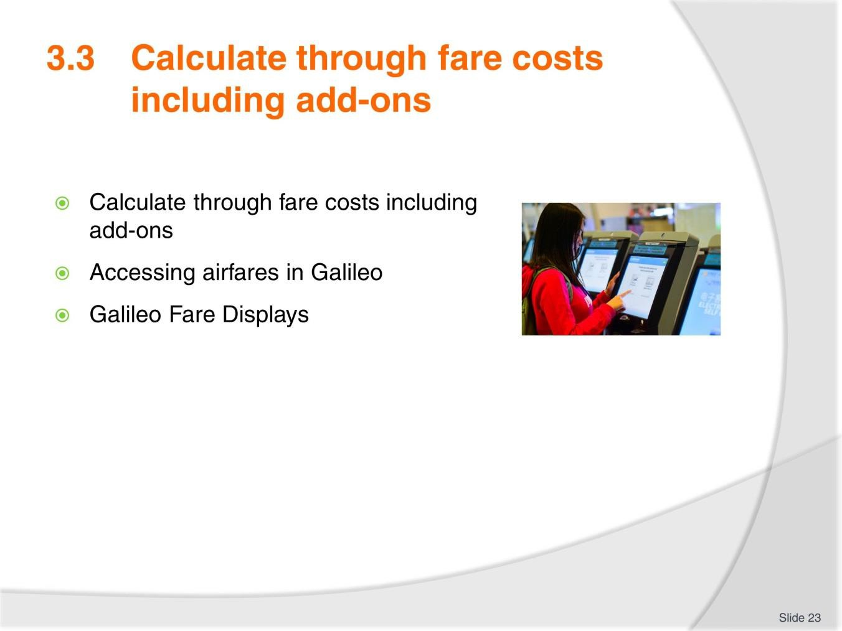
Slide No | Trainer Notes
23. | Trainer to advise: PC: 3.3  - Accessing airfares in Galileo  - Galileo Fare Displays.  Group Discussion/Activity  - After review of TM notes and discussion of topics listed learners to take time to work in pairs and once again interpret the screens in example 1 and 2  - Review the Return Airfare example in TM and ensure understanding. Again working in pairs, interpret the screen in the example.

Slide
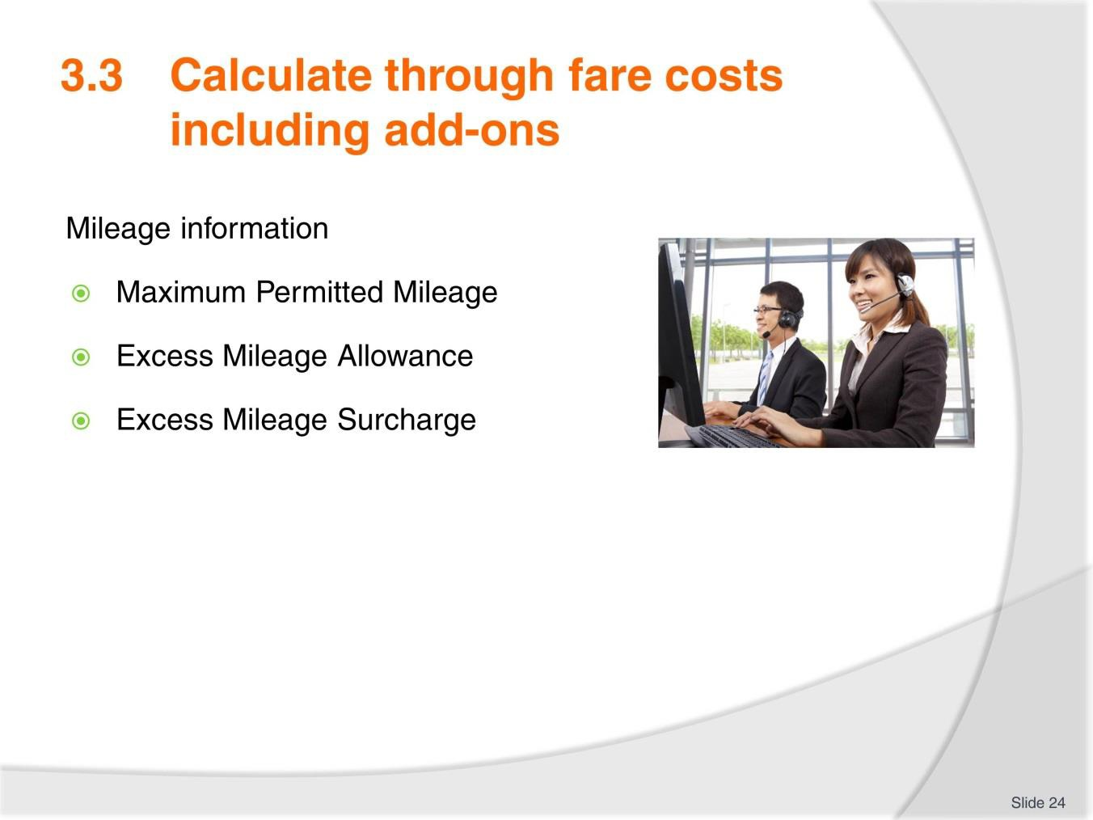
Slide No | Trainer Notes
24. | Trainer to advise: PC: 3.3  Maximum Permitted Mileage  When reading a Fare Display, the Maximum Permitted Mileage (MPM) is displayed to indicate the maximum number of miles that can be flown between the origin and destination cities. This MPM must be compared to the number of miles being flown on the itinerary. A CRS can calculate the mileage very simply but it is important for the agent to be able to interpret the information provided. In order to do this, the agent must be aware of the following mileage terms and concepts:  - MPM – Maximum Permitted Mileage  - TPM – Tickets Point Mileage  - EMS – Excess Mileage Surcharge  - EMA – Excess Mileage Allowance.  Excess Mileage Allowance  There will be itineraries where the TPM is higher than the MPM. In this case, in some circumstances there may be a deduction known as an Excess Mileage Allowance (EMA) which can be applied. IATA has determined which itineraries are entitled to this allowance and will deduct miles from the total TPM if the itinerary is eligible for an EMA.

The EMA example we will consider applies for travel within Area 3 only. When an itinerary only involves travel within TC Area 3 and travel is via Delhi and Mumbai, IATA allows an EMA (if required). This is also the case for an itinerary within TC Area 3 which includes travel via both Karachi and Islamabad.
This is best described using an example. In this Galileo screen, the TPM is calculated for a journey from Vientiane to Bangkok to Delhi to Mumbai.
Excess Mileage Surcharge
In the following example, the itinerary is much longer. This is a more realistic example of an itinerary that might be constructed using a regular airfare. The flown itinerary is Jakarta to Manila to Singapore to Dubai to Paris. Encoded, the itinerary is written as: JKT MNL SIN DXB PAR. The Global Indicator for this itinerary is EH.
Refer to TM for remainder of notes.
Trainer to provide examples for learners to calculate mileage surcharge.

Slide

Slide No | Trainer Notes
25. | Ensure learners complete the Work Projects at the end of Element 3. Trainer may decide if these are to be completed in class individually or in groups or alternatively as homework.  A copy of work sheets has been included in the Trainer Guide.  - Review the Summary page for Element 3 to confirm with learners what has been completed for this Element.

Slide
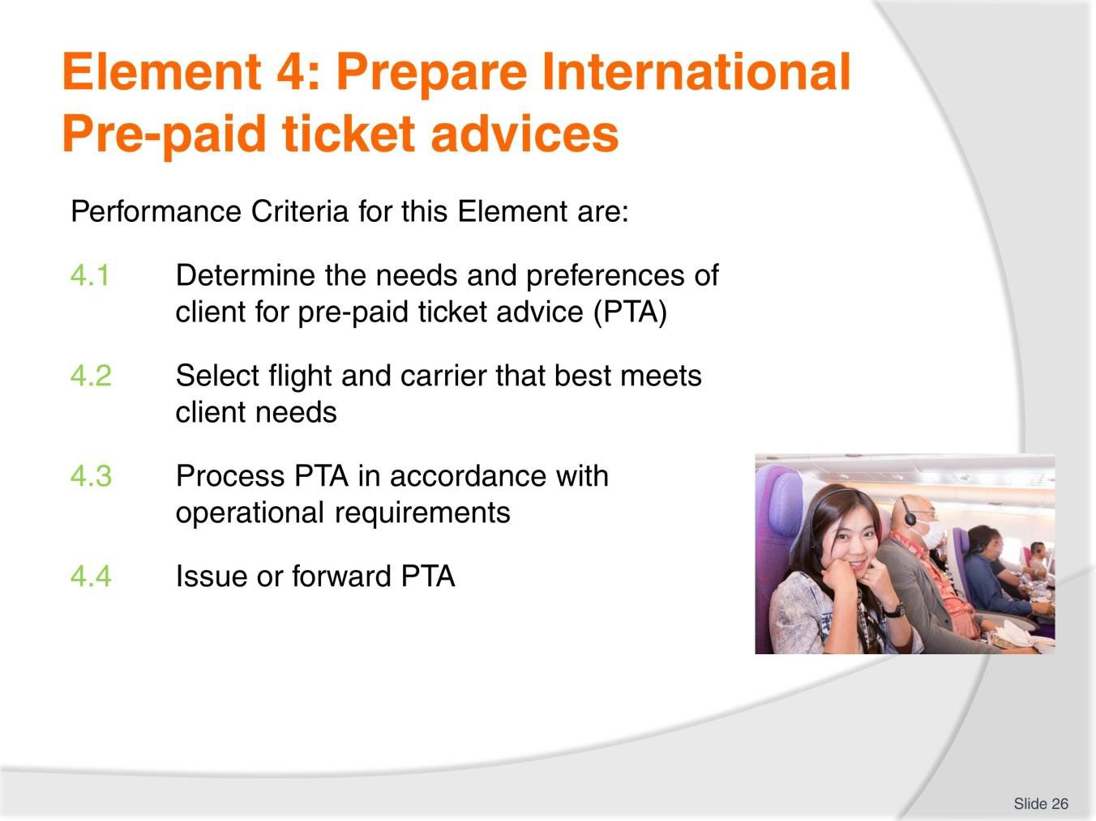
Slide No | Trainer Notes
26. | Trainer to relate performance criteria to element 4.  - Performance criteria is the process by which the students training match the learning element  - The element is the skill  - To assess competency in the skill, the performance criteria is used to outline activities that can be used to assess competency.  The trainer should relate how the performance criteria are related to the element.  To be able to Prepare International Pre-paid ticket advices the students must be able to:  - Determine the needs and preferences of client for pre-paid ticket advice (PTA)  - Select flight and carrier that best meets client needs  - Process PTA in accordance with operational requirements  - Issue or forward PTA.

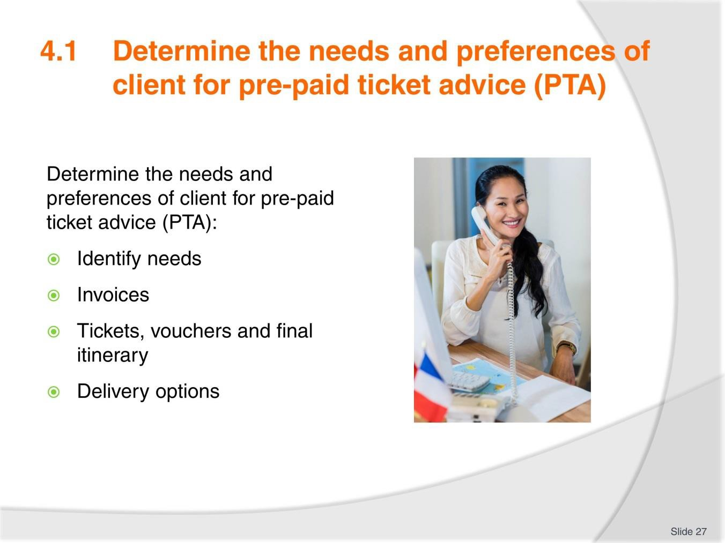Slide

Slide No Trainer Notes

  - Trainer to advise: PC: 4.1
    - Identify needs
    - Invoices
    - Tickets, vouchers and final itinerary
    - Delivery options.
Activity
In pairs or small groups create a 3 day, 2 night tour for clients of your choosing and research the following airline structures:
    - Invoice
    - Tickets
    - Vouchers.

Slide
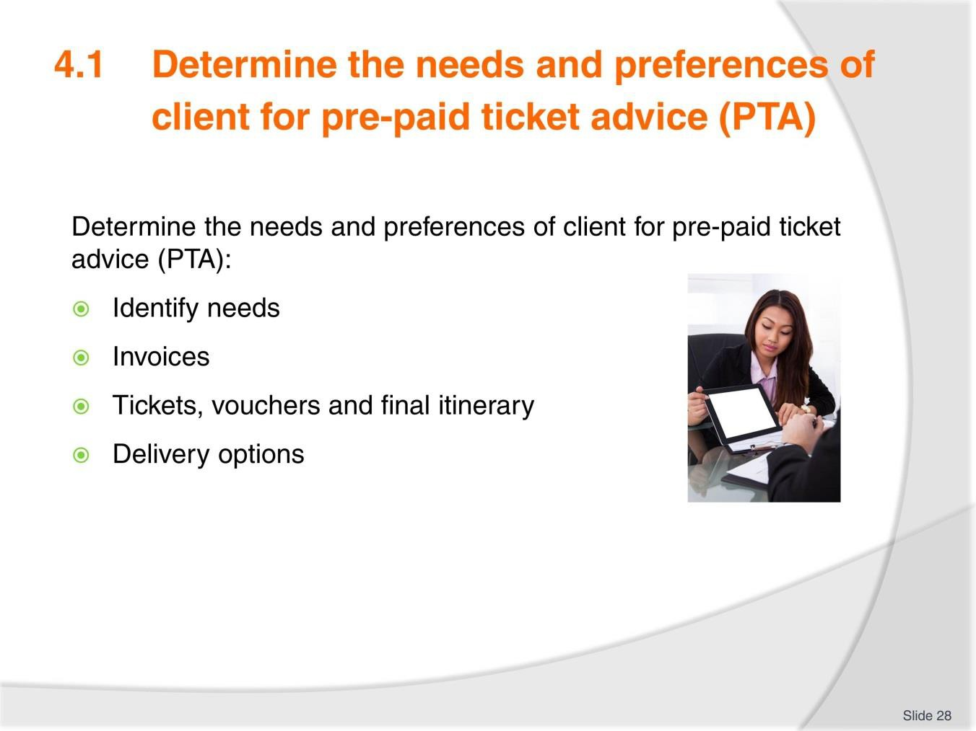
Slide No | Trainer Notes
28. | Trainer to advise: PC: 4.1  - Identify needs  - Invoices  - Tickets, vouchers and final itinerary  - Delivery options.  Group Activity  Following on from previous slide continue to research the following airline structures:  - Final Itinerary  - Delivery options  - Create an email informing a client for their final itinerary. Trainer to determine if groups will present their findings.

Slide
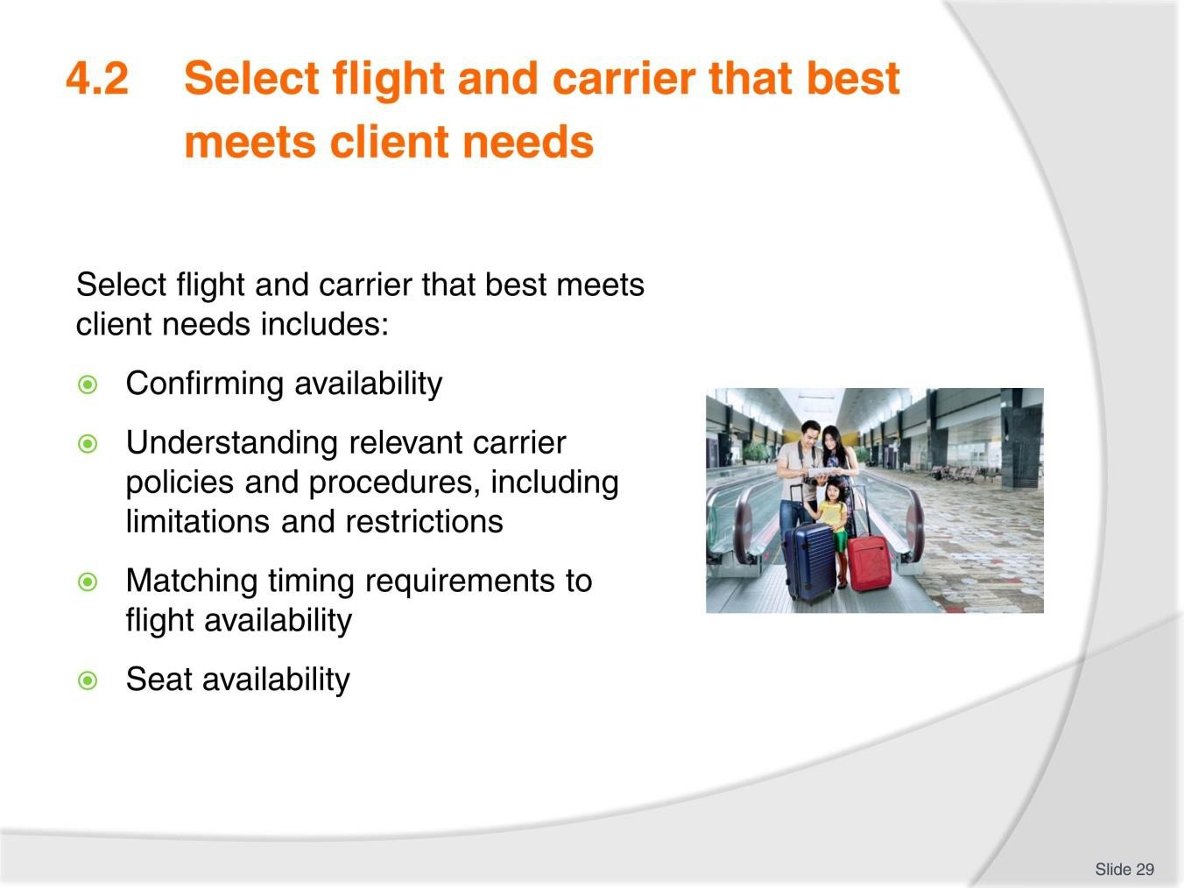
Slide No | Trainer Notes
29. | Trainer to advise: PC: 4.2  Select flight and carrier may include:  - Confirming availability  - Understanding relevant carrier policies and procedures, including limitations and restrictions  - Matching timing requirements to flight availability  - Seat availability  - Meeting connecting flights  - Package limitations, where applicable.  Activity  Trainer note: This activity may follow on from previous or a new scenario may be created.  - Select a flight carrier and complete the following information. Once completed, present your findings  - Confirming availability  - Understanding relevant carrier policies and procedures, including limitations and restrictions

- Matching timing requirements to flight availability
- Seat availability
- Meeting connecting flights
- Package limitations, where applicable.

Slide
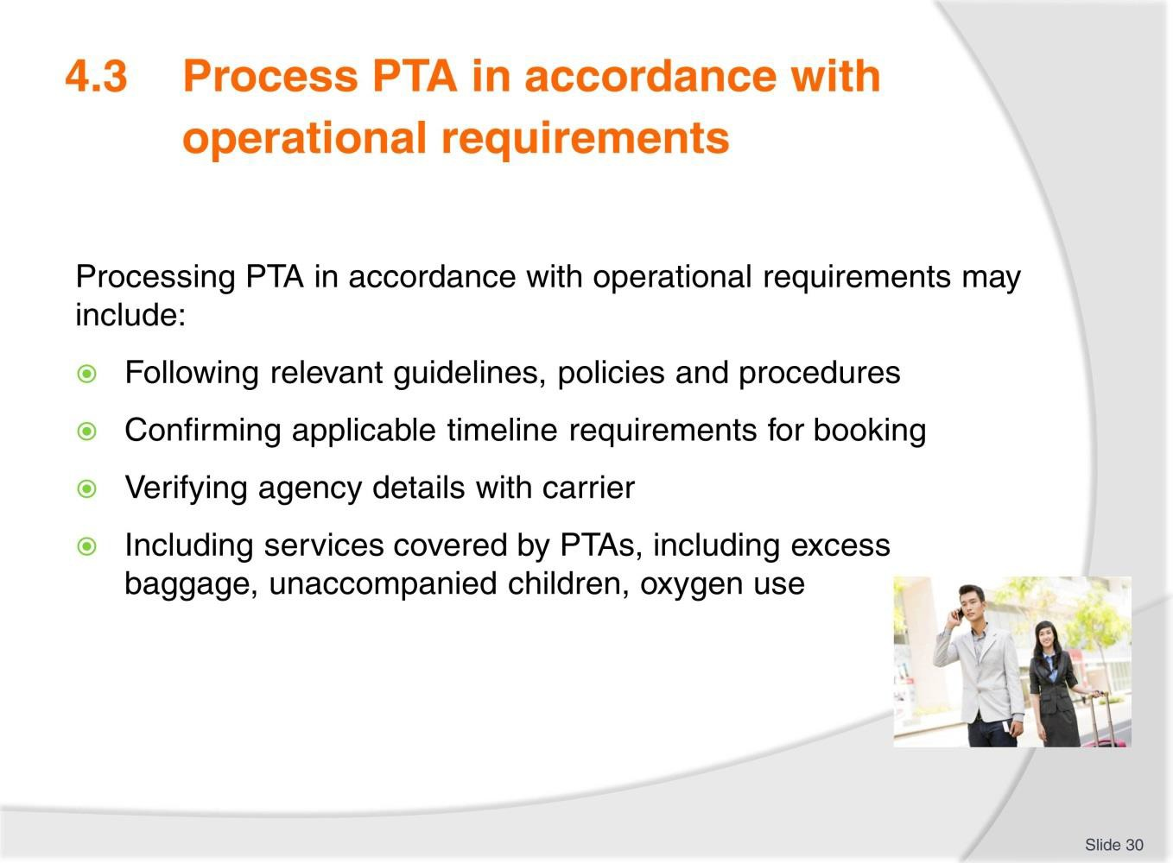
Slide No | Trainer Notes
30. | Trainer to advise: PC: 4.3  Process PTA may include:  - Following relevant guidelines, policies and procedures  - Confirming applicable timeline requirements for booking  - Verifying agency details with carrier  - Including services covered by PTAs, including excess baggage, unaccompanied children, oxygen use  - Obtaining fare quote  - Applying service charge  - Raising Miscellaneous Charge Order (MCO).  Group Activity  - Identify one airline and discuss one of the following items based on that airline- present your findings once you have completed  - Following relevant guidelines, policies and procedures  - Confirming applicable timeline requirements for booking  - Verifying agency details with carrier  - Including services covered by PTAs, including excess baggage, unaccompanied children, oxygen use

Slide
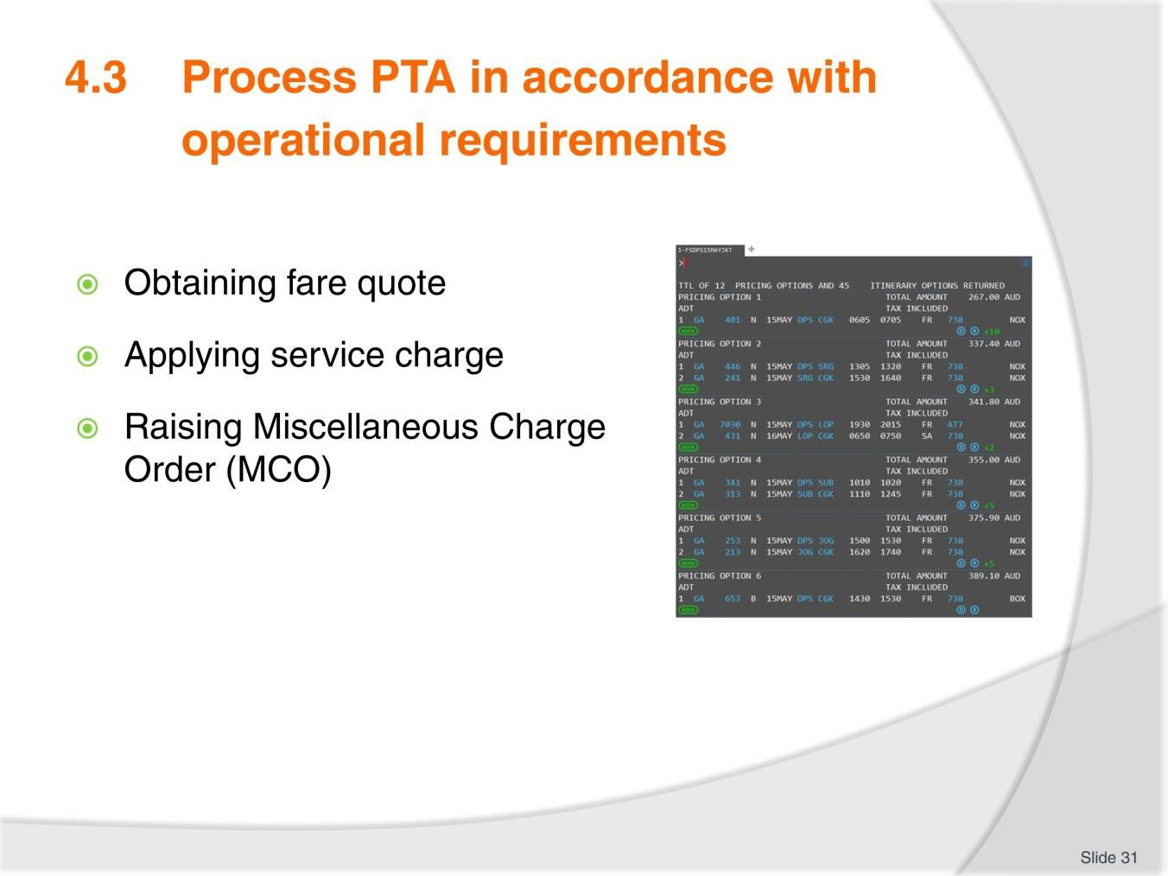
Slide No | Trainer Notes
31. | Trainer to advise: PC: 4.3  Process PTA may include: continued  - Obtaining fare quote  - Applying service charge  - Raising Miscellaneous Charge Order (MCO).  Note to trainer: Since 2008 paper tickets were finally phased out and replaced with electronic ticketing, so this process is now much simpler. All ticket transactions are now reported through the agent GDS to the Data Processing Centre and V-MPDs can be issued.  Miscellaneous charge orders (MCO  Miscellaneous charge orders (MCO) have now been replaced with a virtual MPD  A multi-purpose document (MPD) is used by the agent to make payment to airlines for non-air services such as excess baggage, ground transportation and accommodation. The document is now called a Virtual MPD (abbreviated to V-MPD) which is issued by the agent  Group Activity – continues from previous slide  - Identify one airline and discuss one of the following items based on that airline- present your findings once you have completed

- Obtaining fare quote
- Applying service charge
- Raising Miscellaneous Charge Order (MCO).

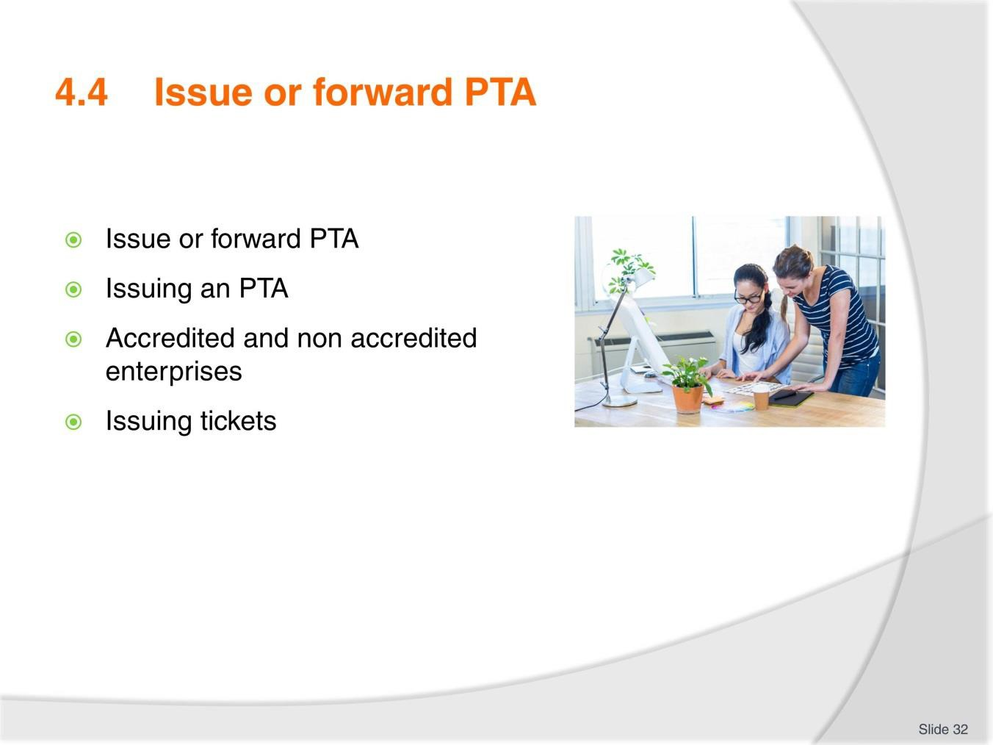
Slide
Slide No
Trainer Notes
32.
Trainer to advise: PC: 4.4
- Issuing an PTA
- Accredited and non-accredited enterprises
- Issuing tickets.
Group Discussion
- Identify and Discuss Accredited and non-accredited enterprises.

Slide
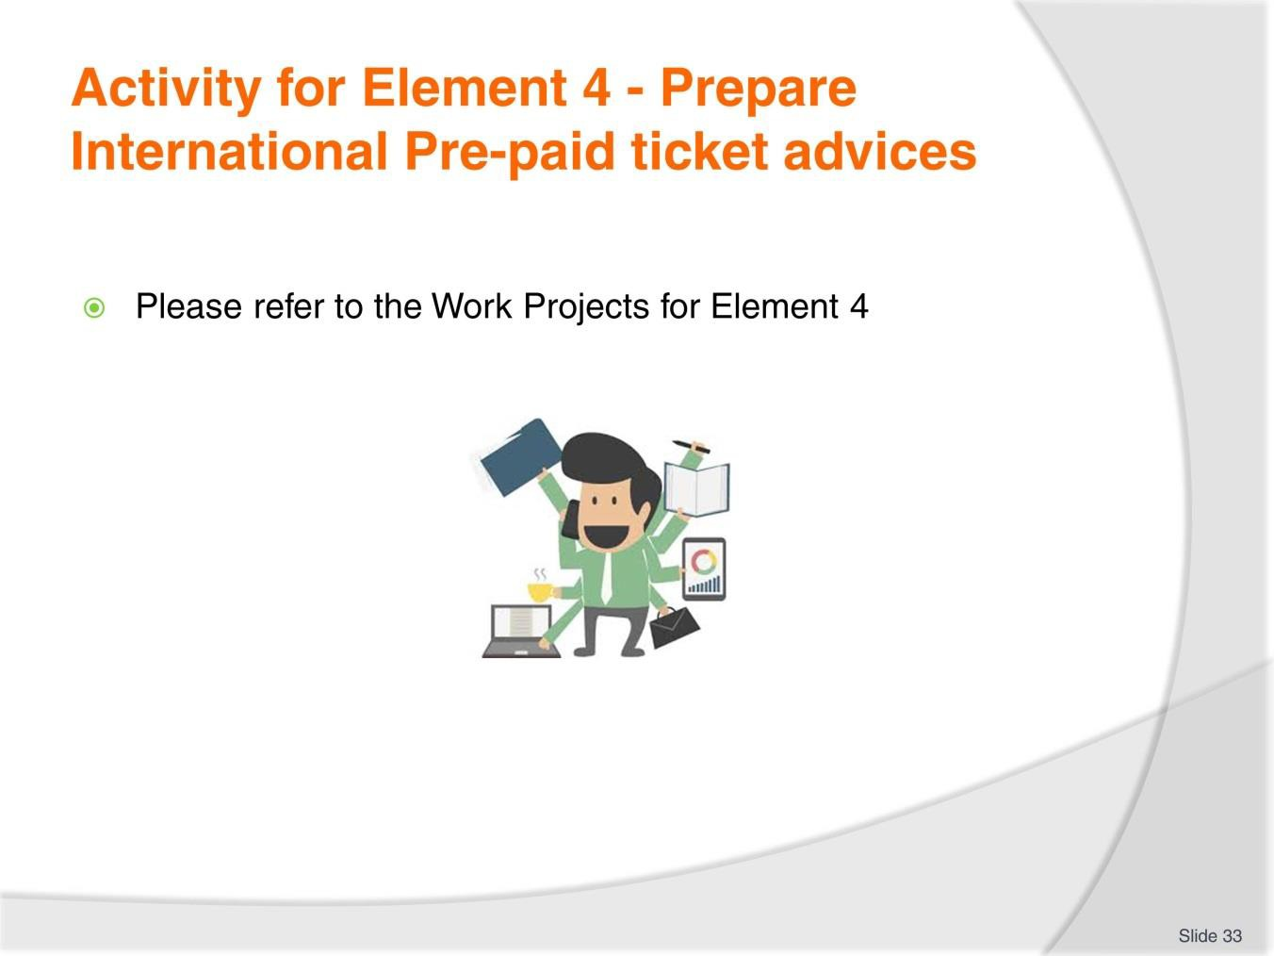
Slide No | Trainer Notes
33. | Ensure learners complete the Work Projects at the end of Element 4. Trainer may decide if these are to be completed in class individually or in groups or alternatively as homework.  A copy of work sheets has been included in the Trainer Guide.  - Review the Summary page for Element 4 to confirm with learners what has been completed for this Element.

Slide
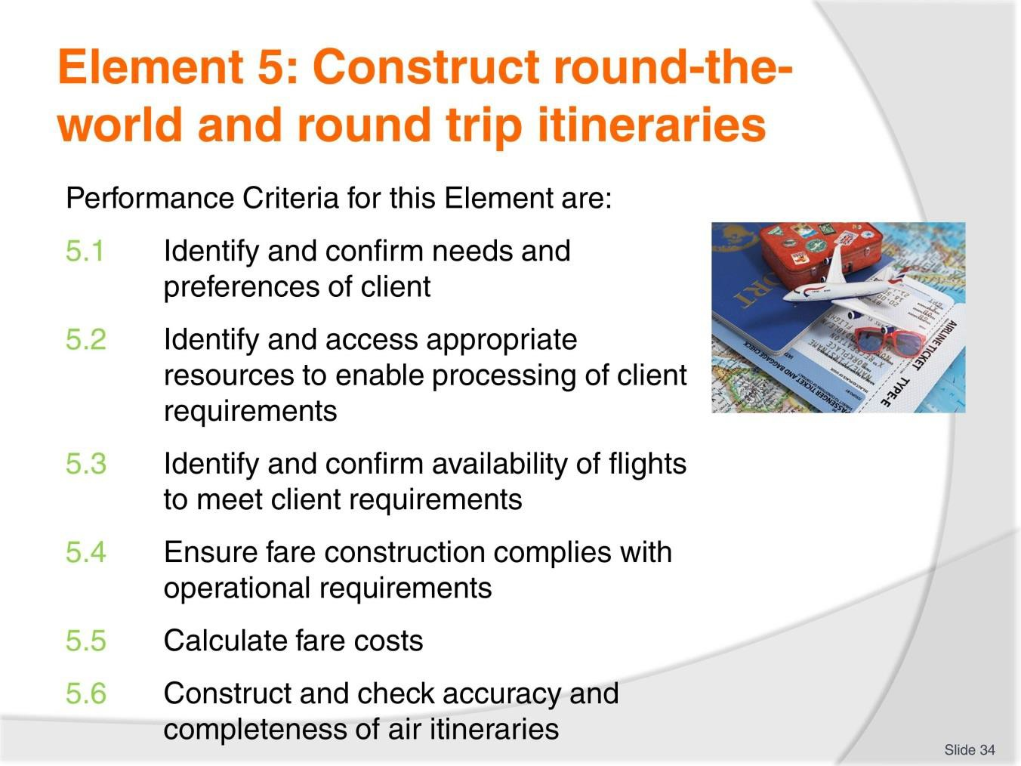
Slide No | Trainer Notes
34. | Trainer to relate performance criteria to element 5.  - Performance criteria is the process by which the students training match the learning element  - The element is the skill  - To assess competency in the skill, the performance criteria is used to outline activities that can be used to assess competency.  The trainer should relate how the performance criteria are related to the element.  To be able to Construct round-the-world and round trip itineraries the students must be able to:  - Identify and confirm needs and preferences of client.

Slide
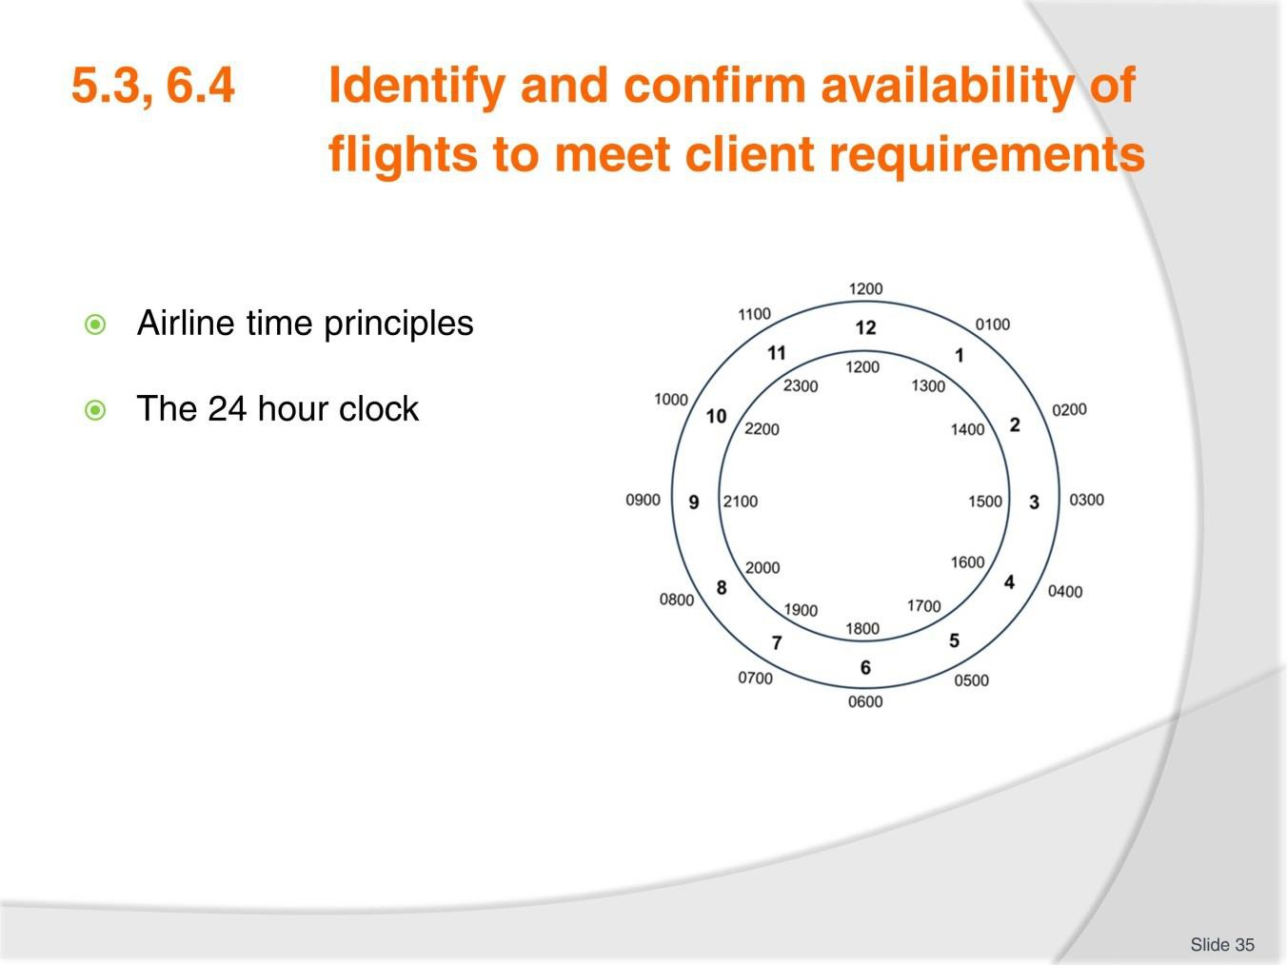
Slide No | Trainer Notes
35. | Trainer to note that many PCs from this element are repeated and are covered in previous slides. Trainer to decide relevance of repeating or revisiting these slides based on training needs.  Trainer to advise: PC: 5.3,6.4 Discuss  - Take time to explain each of the listed points.  - The following website has an interactive map that may be useful for activities: http://www.timeanddate.com/time/map/  Activity – 24 hour clock  Conduct a quick quiz for converting clock times.  17.30, 0030, 19.50, 2100, 1545, 2025, 1615, 1400, 2340, 1310, 0500, 0915 Now  convert 9.30pm, 825am, midday, midnight, 11pm, 5.55am, 7.20pm  If conducted in quiz fashion with a time limit and quick pace this can be a funny exercise. Aim to go around the class 2-3 times depending on group size.  Activity - 24 hour time zones.  Calculate the following city times:  - 7pm in Jakarta what time is it in New York

- 2pm in Phnom Penh what time is it in Auckland and Manila
- 11pm in Vientiane what time is it in London
- Midnight in KL what time is it in Bombay
- 5am in Bandar Seri Begawan what time is it in Toronto and Bangkok.

Slide
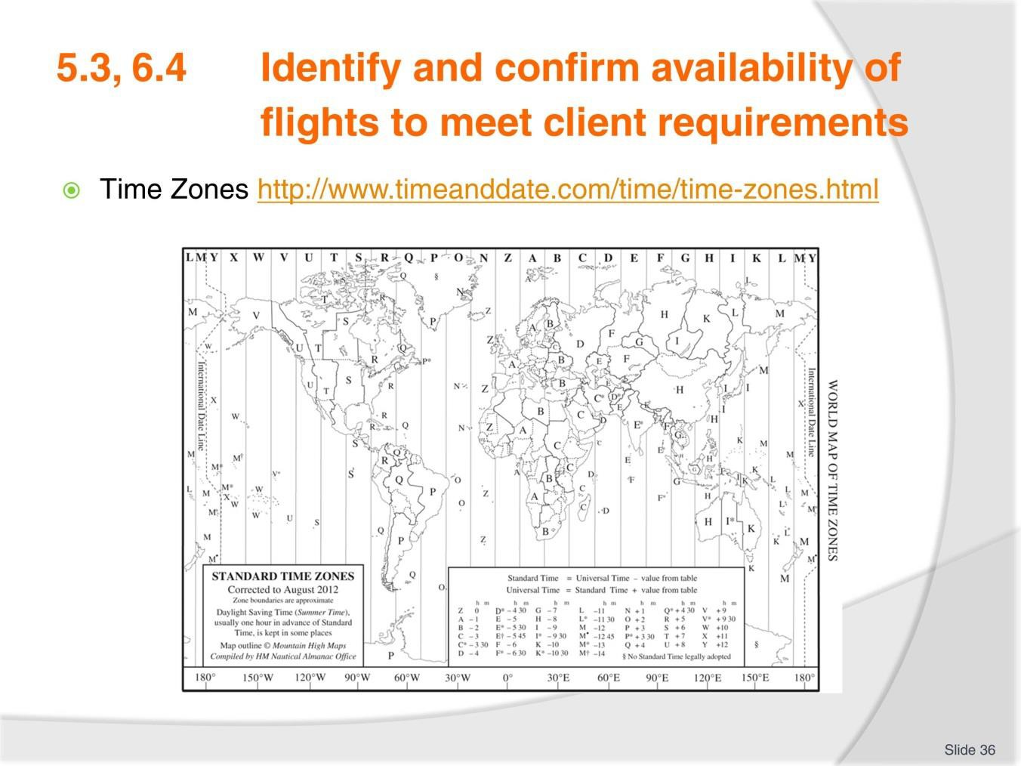
Slide No | Trainer Notes
36. | Time Zones  The Greenwich Meridian, also known as the prime meridian or International Meridian, is the "starting point" for dividing the Earth's surface into time zones. Each time zone is 15 degrees of longitude wide (with local variations) and the local time is one hour earlier than the zone immediately to the east on the map  The number of standard time zones is debatable and discussed among various sources, particularly with regards to the International Date Line.  Reference: http://www.timeanddate.com/time/time-zones.html. This website has a great deal of useful information and is worth exploring.  A basic explanation is that time zones to the west of UTC are behind UTC and times to the east of UTC are ahead of UTC.  E.g. If the time is 1200 noon in London (as Greenwich coincides with the position of London) it will be morning in the USA.  If the time is noon in London, then it will be the afternoon in parts of Asia. Access the website and continue discussion on time zones.

Slide
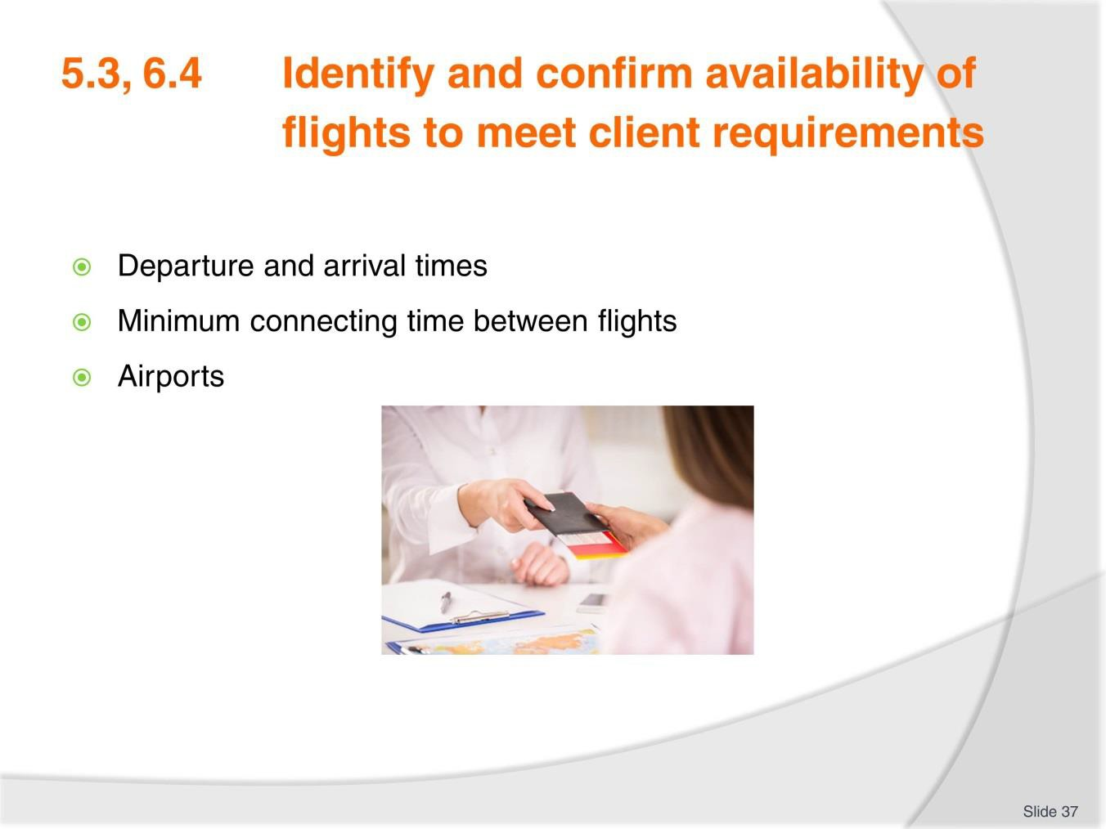
Slide No | Trainer Notes
37. | Trainer to advise: PC: 5.3,6.4 Departure and arrival times  Airline timetables will always be stated in local time for arrival and departure; therefore you will need to consult the CRS to confirm the duration of the flight, or the timetable if it details that information. Never estimate the flight duration from the arrival and departure times as you must take into account the times zones the flight may cross. Times must be converted back to UTC/GMT time before flight durations can be calculated.  Minimum connecting time between flights  Minimum connecting time is the minimum time you must allow for a passenger to complete a transfer from one flight to another. This time will vary depending if the client needs to change carriers, terminals or even airports. You will learn in your CRS training how to confirm the minimum time allowance and what requirements there are. It is your responsibility to ensure that your passenger has sufficient connecting time between their flights.  Airports  Airlines operate flights from various airports and terminals. Some airports have all their terminals (domestic and international) in the same location. In some cities there may be various airline specific terminals within an airport precinct. For example in Malaysia there are two airports utilising three terminals.

Slide
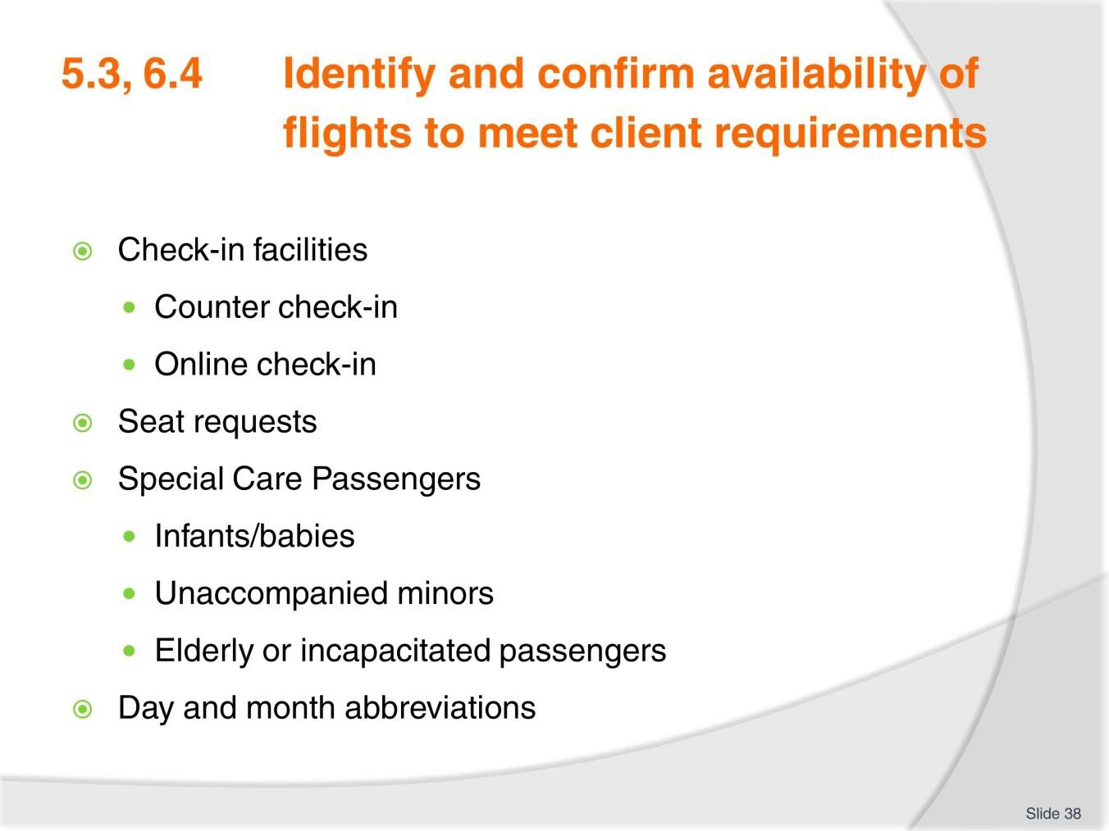
Slide No | Trainer Notes
38. | PC: 5.3,6.4  Discuss the following points referring to TM notes. Share relevant experience.  - Check-in facilities  - Counter check-in  - Online check-in  - Seat requests  - Special Care Passengers  - Infants/babies  - Unaccompanied minors  - Elderly or incapacitated passengers.  Ensure all learners are familiar with common universal abbreviations and frequently used industry abbreviations

Slide
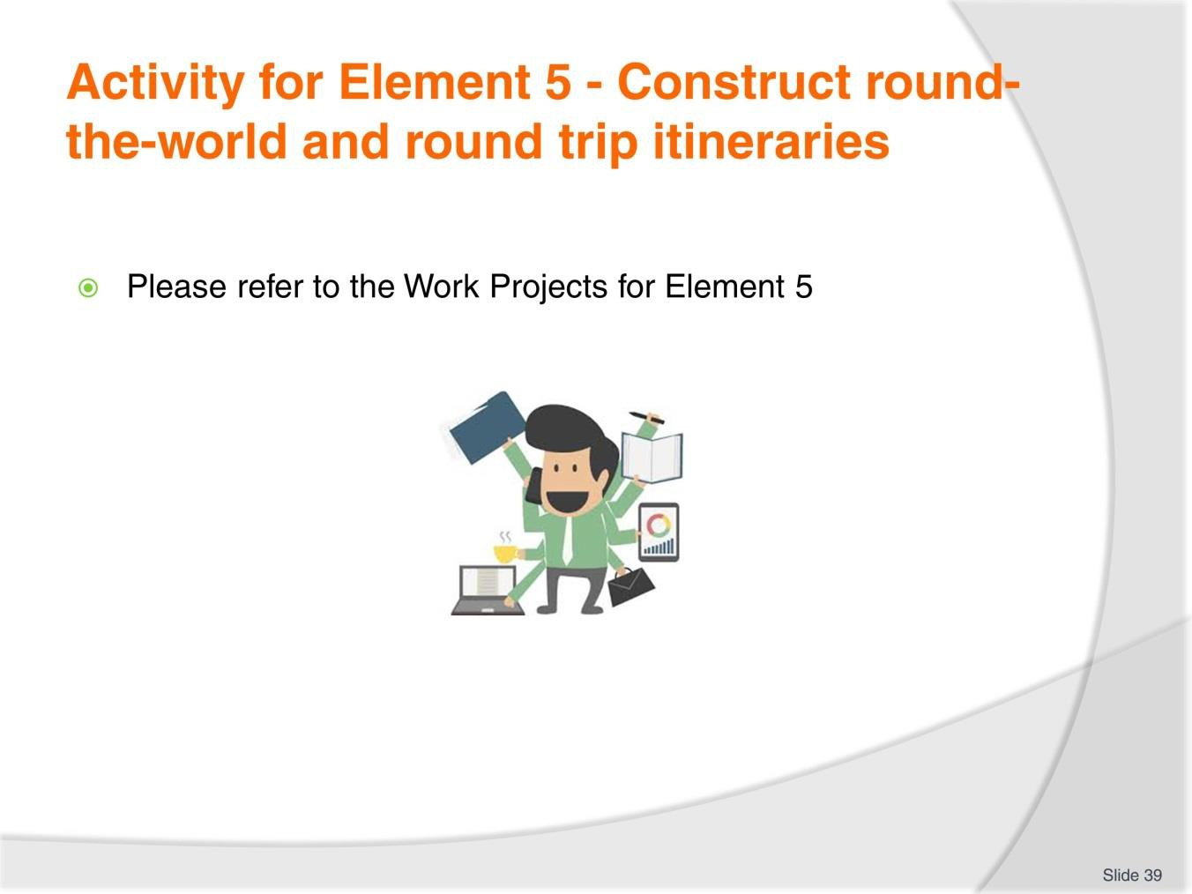
Slide No | Trainer Notes
39. | Ensure learners complete the Work Projects at the end of Element 5. Trainer may decide if these are to be completed in class individually or in groups or alternatively as homework.  A copy of work sheets has been included in the Trainer Guide.  - Review the Summary page for Element 5 to confirm with learners what has been completed for this Element.

Slide
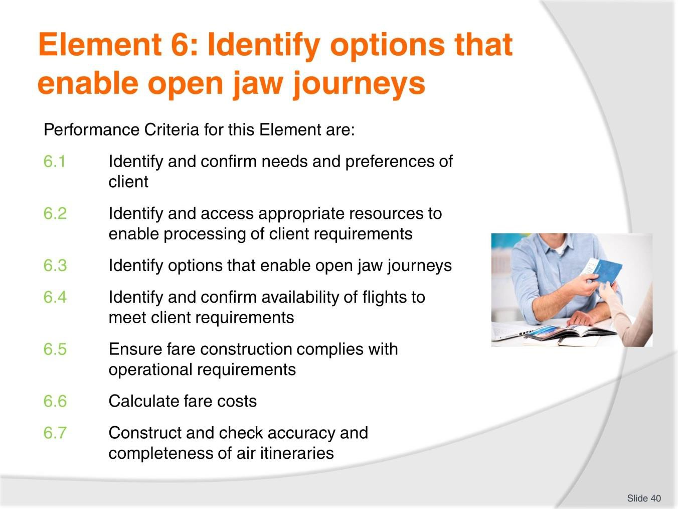
Slide No | Trainer Notes
40. | Trainer to relate performance criteria to element 6.  - Performance criteria is the process by which the students training match the learning element  - The element is the skill  - To assess competency in the skill, the performance criteria is used to outline activities that can be used to assess competency.  The trainer should relate how the performance criteria are related to the element.  To be able to Identify options that enable open jaw journeys the students must be able to:  - Identify options that enable open jaw journeys.

Slide
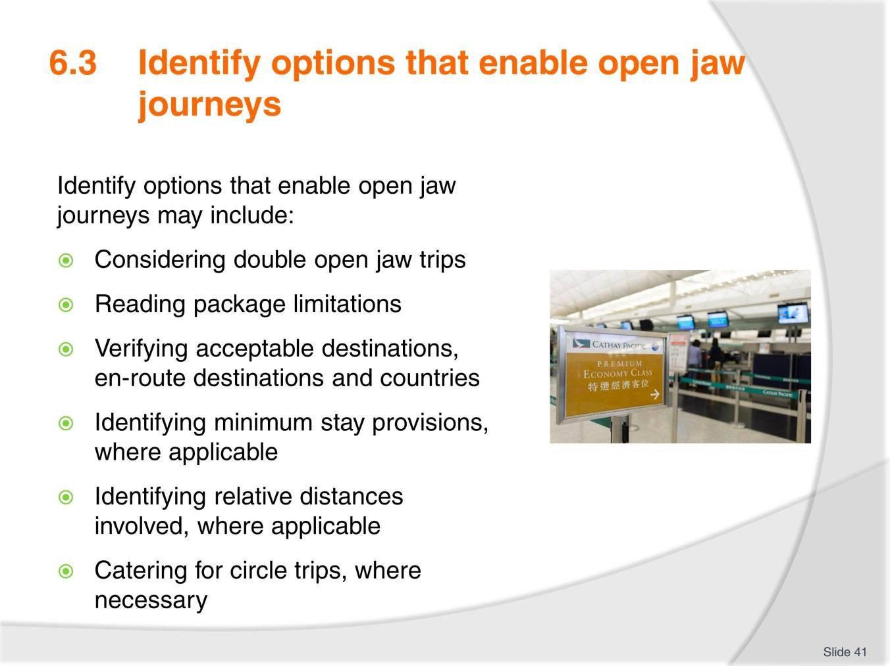
Slide No | Trainer Notes
41. | Trainer to advise: PC: 6.3  Identify options that enable open jaw journeys may include:  - Considering double open jaw trips  - Reading package limitations  - Verifying acceptable destinations, en route destinations and countries, including limitations on intra-country and inter-country applications  - Conformity with airline and airfare rules, including understanding of the limitations imposed by these  - Identifying minimum stay provisions, where applicable  - Identifying relative distances involved, where applicable  - Catering for circle trips, where necessary.

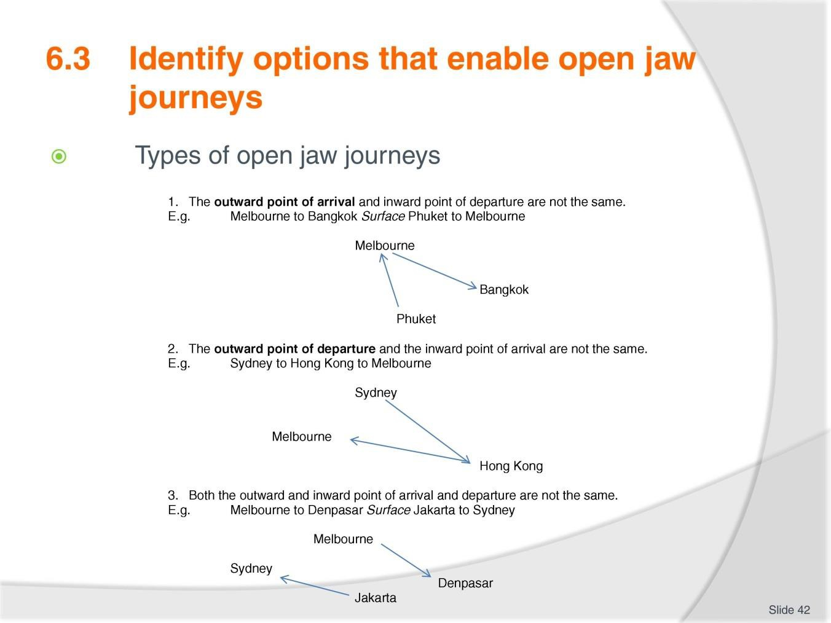
Slide
Slide No
Trainer Notes
42.
Trainer to advise: PC: 6.3
- Discuss examples of open jaw journeys as needed.

Slide
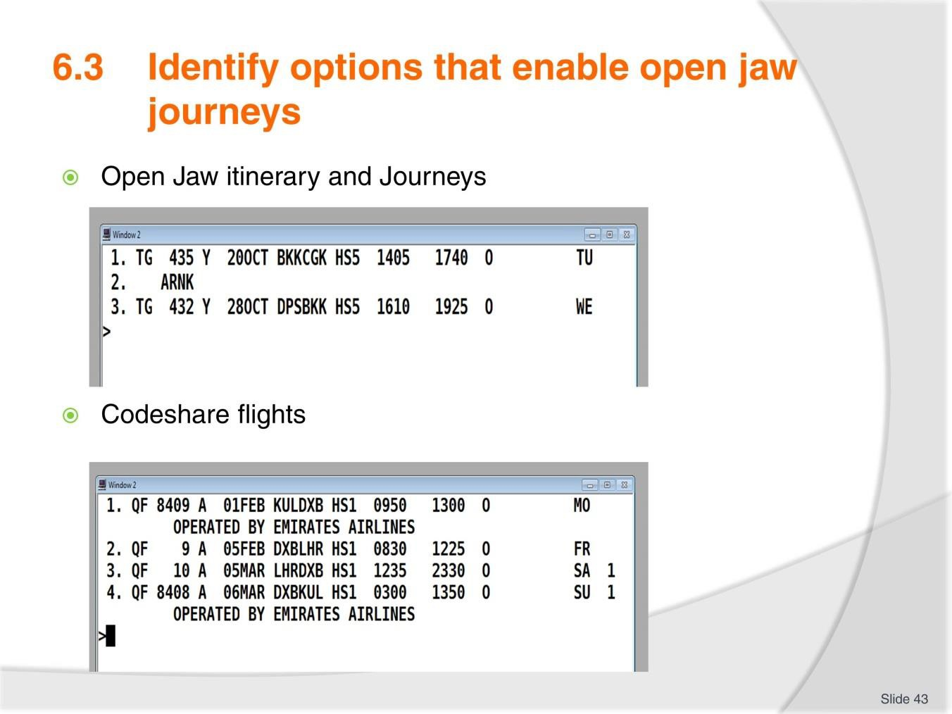
Slide No | Trainer Notes
43. | Trainer to advise: PC: 6.3  Open Jaw itinerary and Journeys  The flights in this itinerary are operated by Thai Airways, flying from Bangkok to Jakarta and returning from Denpasar to Bangkok. The ‘ARNK’ between flights indicates that this sector has not been booked by the agent and means ‘Arrival Unknown’ (or own arrangements). The ‘HS5’ indicates that five seats are being held.  This return journey includes two components.  The outbound component is a non-stop flight from Bangkok to Jakarta. The inbound component is a non-stop flight from Denpasar to Bangkok. Jakarta to Denpasar is a surface sector.  Codeshare flights  This itinerary contains codeshare flights which have Qantas flight numbers but are operated by Emirates (Segments 1 and 4). You will note that the Qantas flight numbers contain four digits. This is a way of identifying codeshare services although this is also clearly advised on this booked itinerary.

Slide
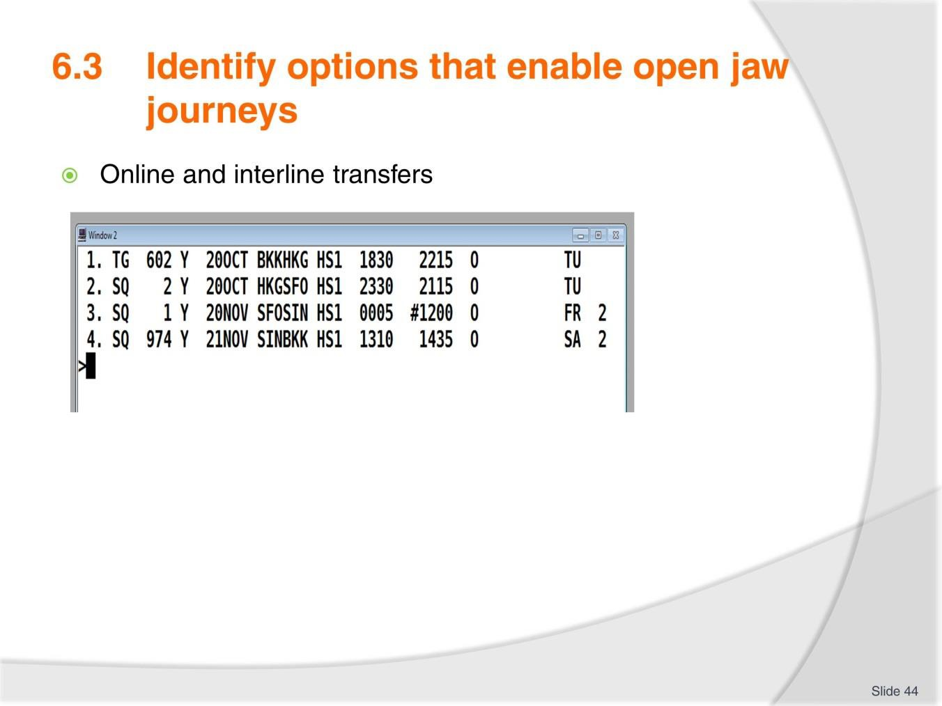
Slide No | Trainer Notes
44. | Trainer to advise: PC: 6.3  Online and interline transfers  The itinerary below is a return journey from Bangkok to San Francisco, flying with Thai Airways and Singapore Airlines.  On the outbound component, the passenger will transit through Hong Kong.  On the inbound component, the passenger will transit through Singapore. Note that flight SQ1 arrives into Singapore at #1200, meaning 12.00pm the next day – 21 November.  The passenger will arrive into Hong Kong on Thai Airways and depart on Singapore Airlines. This is called an interline transfer.  The passenger will return from San Francisco to Singapore and change aircraft, continuing to fly with Singapore Airlines. This is called an online transfer.

Slide
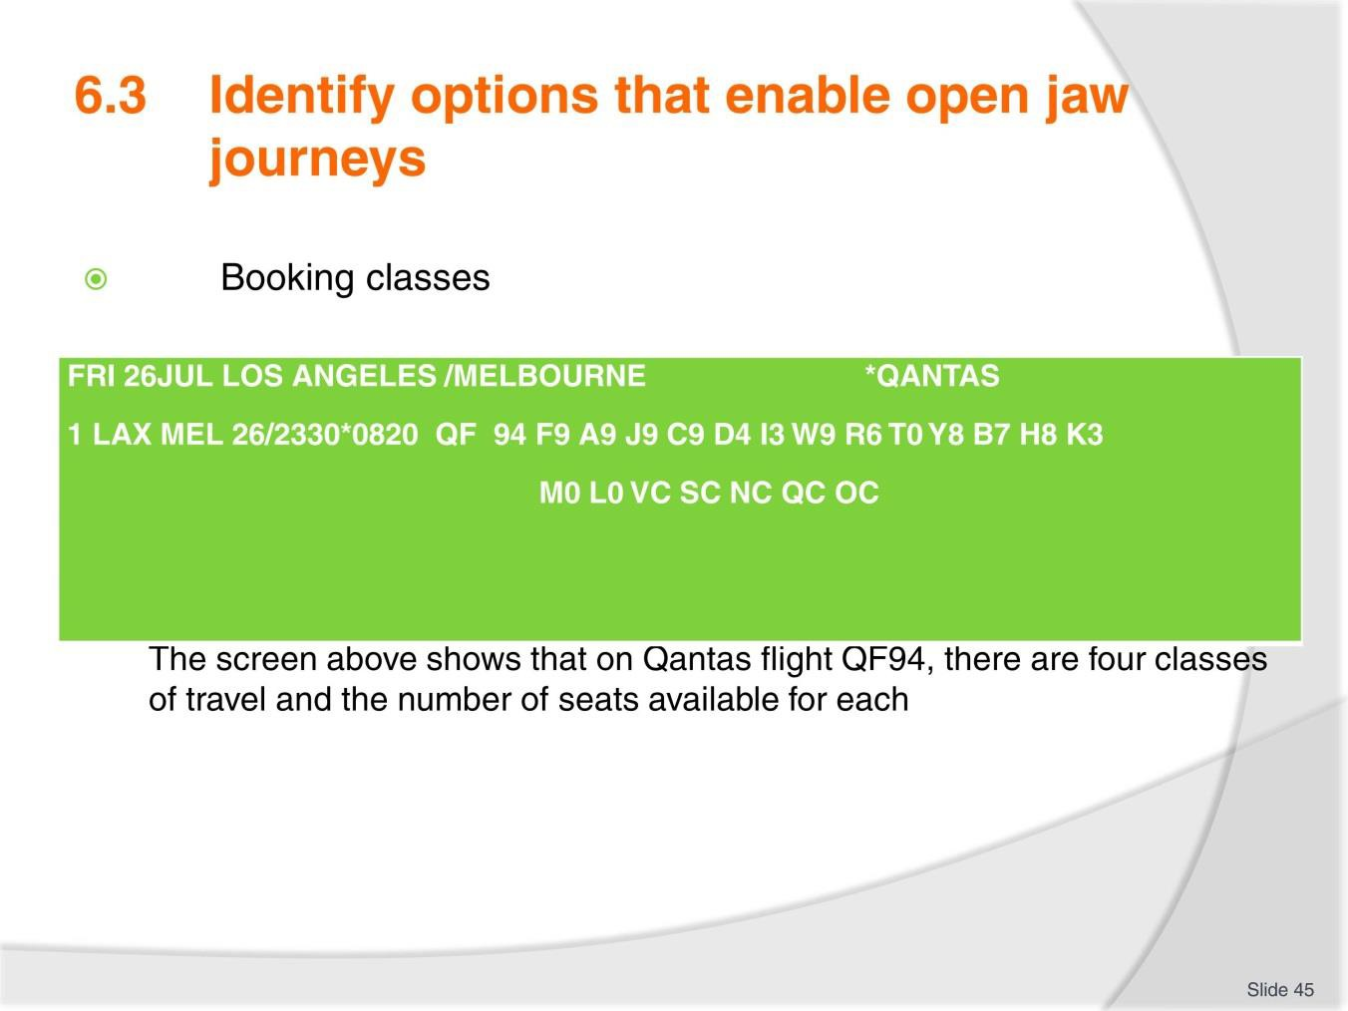
Slide No | Trainer Notes
45. | Trainer to advise: Explain how to interpret the screen information utilising TM notes as well.  PC: 6.3  When an availability screen is displayed in the CRS, the information is displayed in order beginning with first class, then business class, premium economy and economy class. All booking classes on flights can be seen in each availability screen, assuming the operating aircraft offers all classes of service. For example, if there is no F shown on a line in the display, there will not be a first class service offered on that flight.  When reading an availability screen, remember that the airline will only show a maximum of nine seats for each booking class. The airline controls this information and can change their allocation at any time to control the number of seats available at each price level.  The following screen shows the seats available on a Qantas flight from Los Angeles to Melbourne. This screen is called an Availability screen and the entries will be included later on how to display this information.

Slide
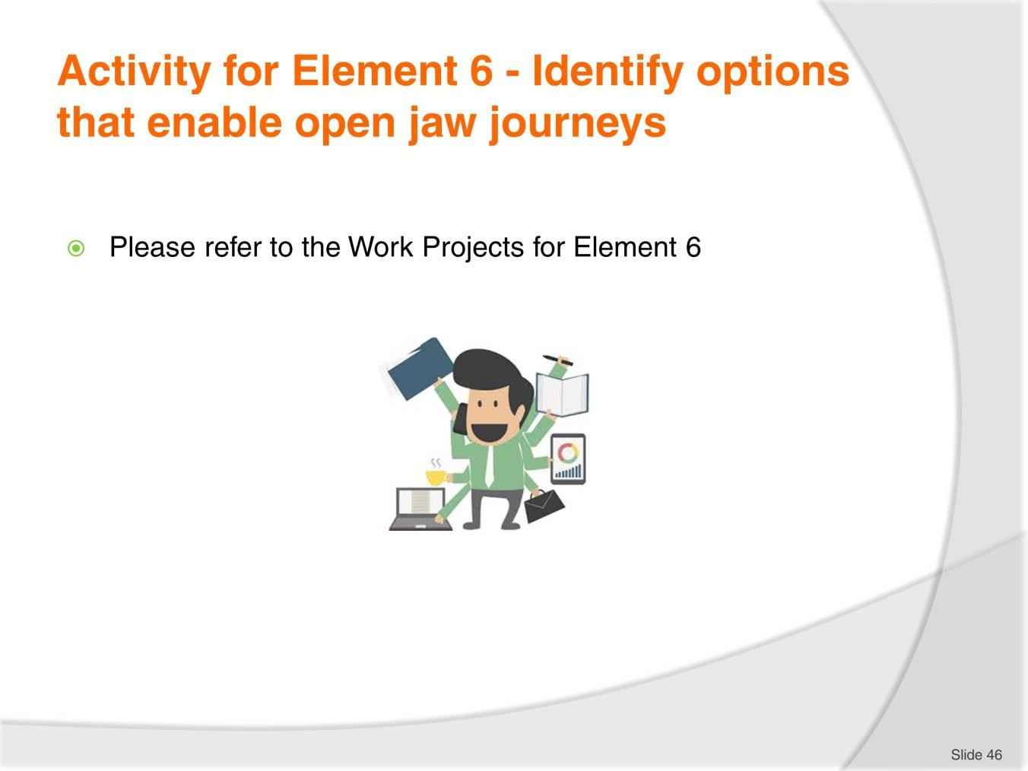
Slide No | Trainer Notes
46. | Ensure learners complete the Work Projects at the end of Element 6. Trainer may decide if these are to be completed in class individually or in groups or alternatively as homework.  A copy of work sheets has been included in the Trainer Guide.  - Review the Summary page for Element 6 to confirm with learners what has been completed for this Element.

Slide
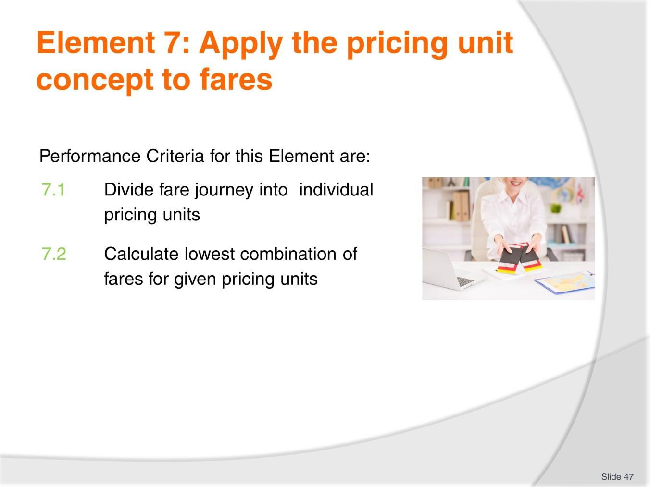
Slide No | Trainer Notes
47. | Trainer to relate performance criteria to element 7.  - Performance criteria is the process by which the students training match the learning element  - The element is the skill  - To assess competency in the skill, the performance criteria is used to outline activities that can be used to assess competency.  The trainer should relate how the performance criteria are related to the element.  To be able to Apply the pricing unit concept to fares the students must be able to:  - Divide fare journey into individual pricing units  - Calculate lowest combination of fares for given pricing units.

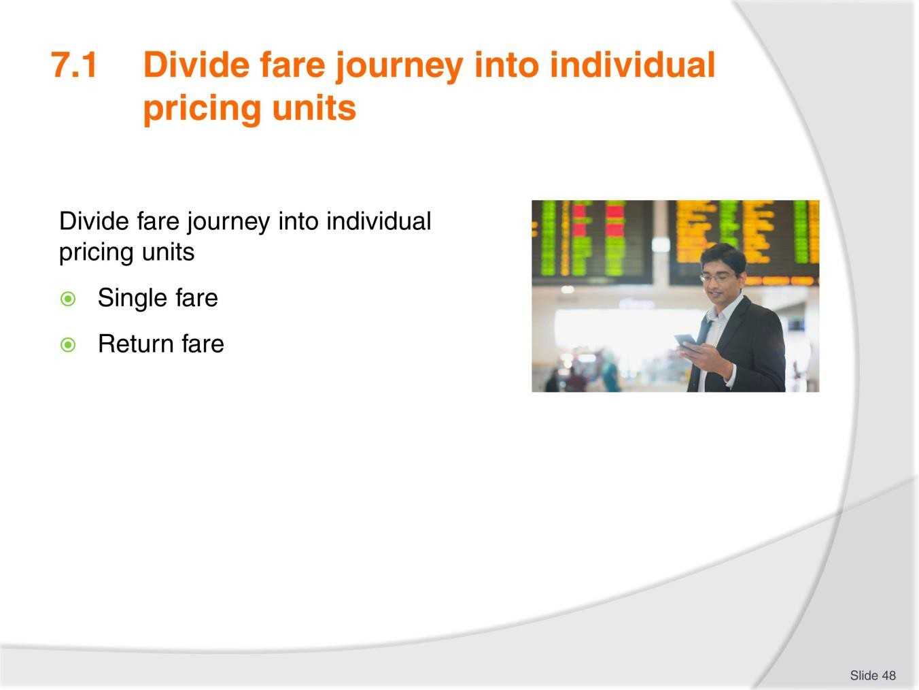
Slide
Slide No
Trainer Notes
48.
Trainer to advise: PC: 7.1
Fare journey must include:
- Single fare
- Return fare.
Discuss
- One way journeys
- Return Journeys.

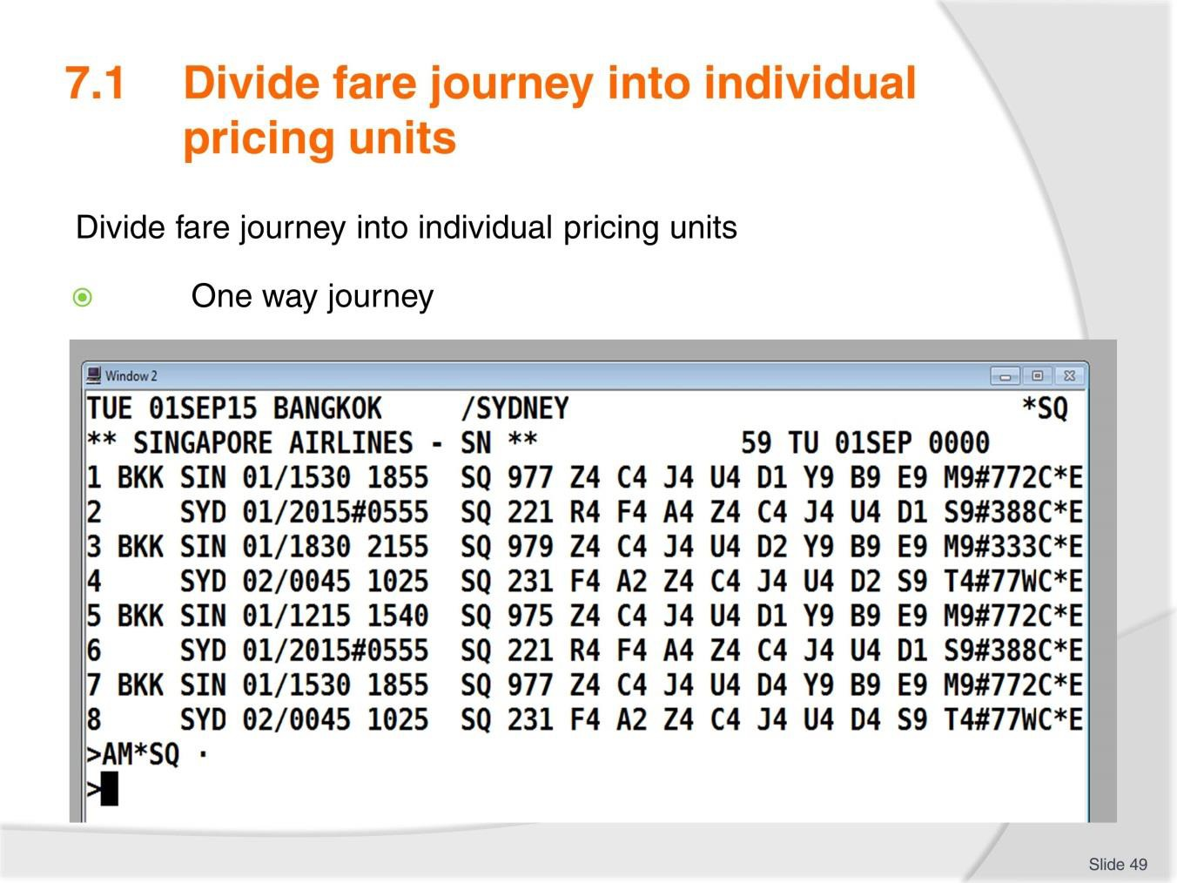
Slide
Slide No
Trainer Notes
49.
Trainer to advise: PC: 7.1
This screen shows that there are multiple options to travel from Bangkok to Sydney via Singapore, flying Singapore Airlines.

Slide
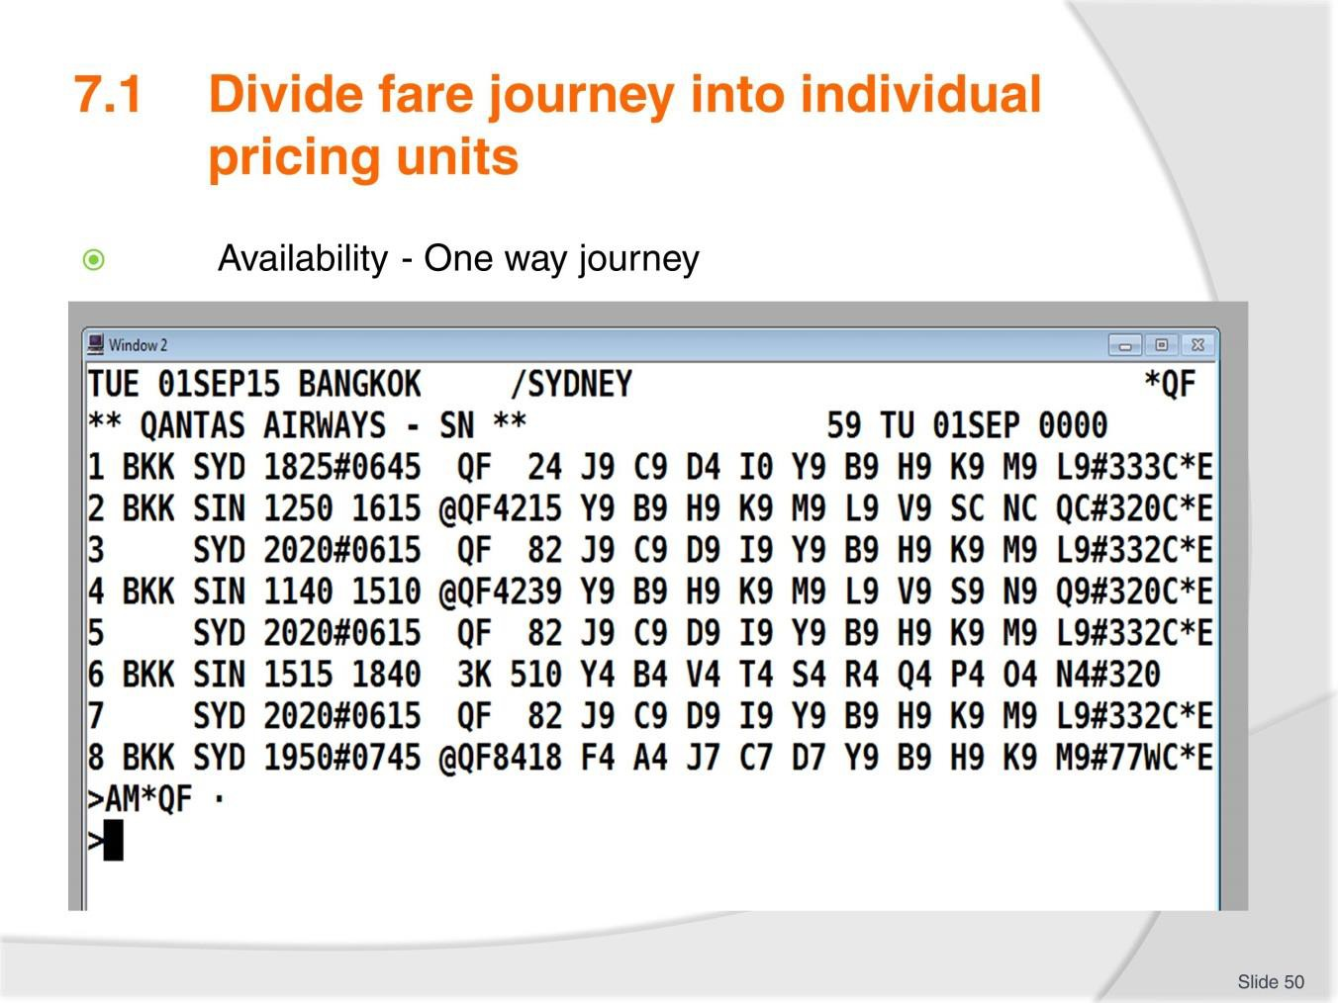
Slide No | Trainer Notes
50. | Trainer to advise: PC: 7.1 Availability - One way journeys  Using the Availability entry example above, you could continue to book flights and start creating an itinerary. In order to do this, you would need to know which booking class you will need to use. This information is obtained from a fare display which we will consider in a moment.  Imagining that the above flight itinerary was booked from Bangkok to Sydney only (either with Qantas or Singapore Airlines), this would create a one way journey.  The journey from Bangkok to Sydney on Qantas would be a single sector one way journey.  The journey from Bangkok to Sydney, via Singapore, flying Singapore would be a one way journey with two sectors. Singapore would be considered an intermediate point.  If the passenger is only in Singapore for a short time waiting for their next flight, this intermediate point is referred to as a transit.  If the passenger wishes to stay in Singapore for more than 24 hours, Singapore is considered an intermediate stopover flight. This would require the journey to be booked in two segments, using two availability screens. For example:  - Entry: A01SEPBKKSIN*SQ  - Entry: A03SEPSINSYD*SQ (Two night stopover in Singapore)

Slide
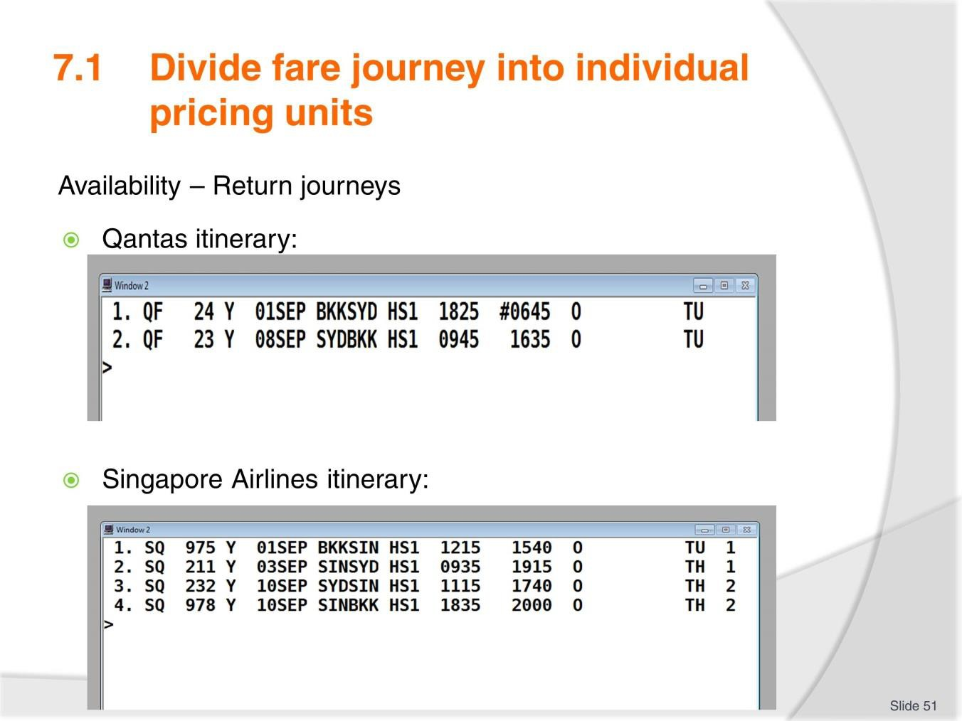
Slide No | Trainer Notes
51. | Trainer to advise: PC: 7.1  Continuing with the examples above, imagine that the passenger wishes to return from Sydney one week later.  The Qantas entry would be:  - Entry: A08SEPSYDBKK*QF  The Singapore Airlines entry would be:  - Entry: A10SEPSYDBKK*SQ  (Assuming no stopover is required in Singapore):  Although we have not yet considered which booking classes or flights to book, and the entries required for this part of the process, let’s look at the itineraries that could be created for these booking examples:

Slide
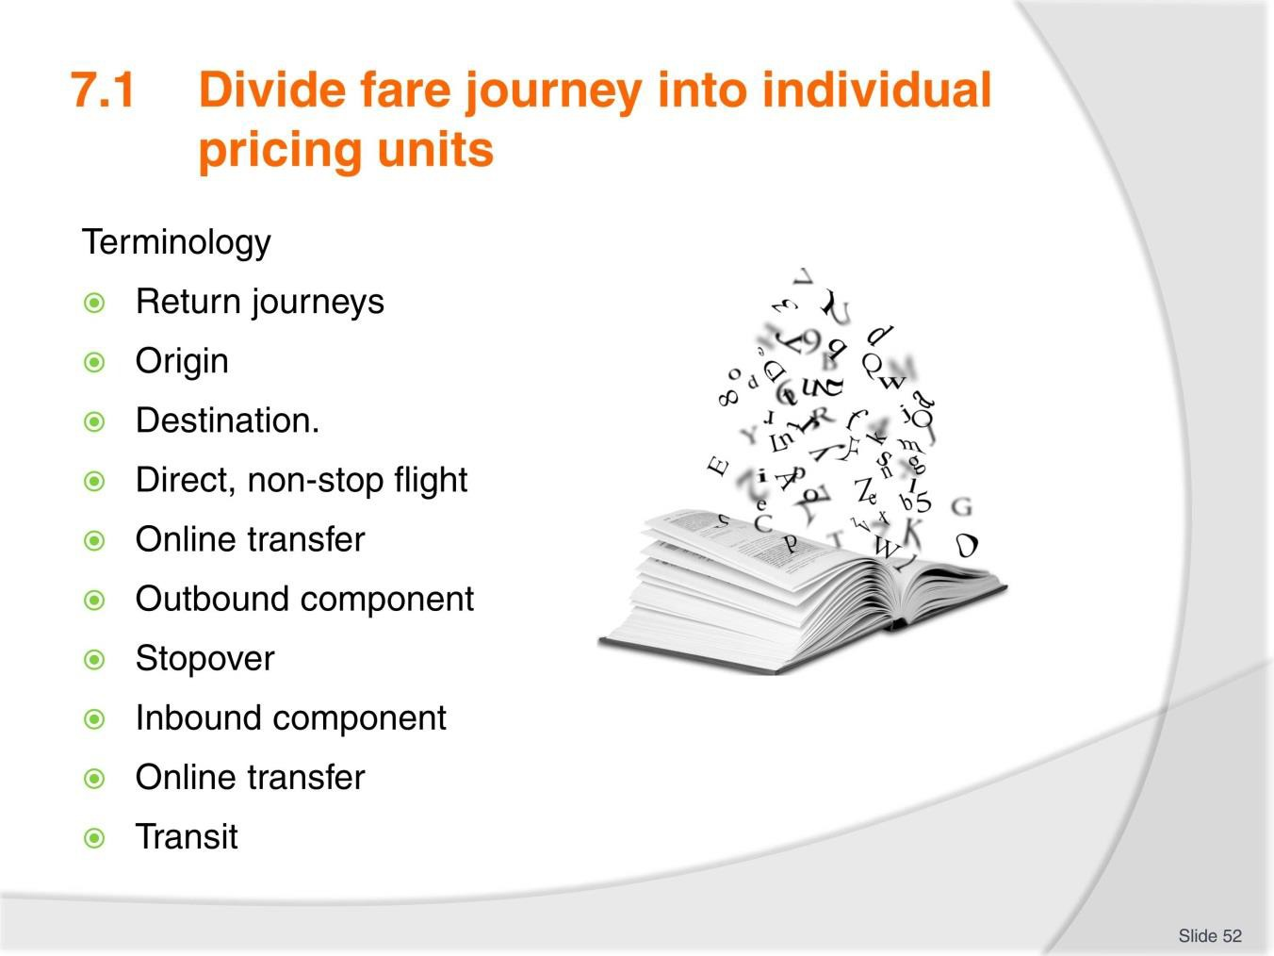
Slide No | Trainer Notes
52. | Trainer to advise and quiz learners on terminology used in this section. PC: 7.1  Terminology  Both itinerary examples above are return journeys. Bangkok is the origin and Sydney is the destination.  The Qantas itinerary has a direct, non-stop flight in each direction.  The Singapore Airlines itinerary has an online transfer through Singapore on the outbound component and Singapore is a stopover. On the inbound component, there is also an online transfer through Singapore, and Singapore is a transit point.

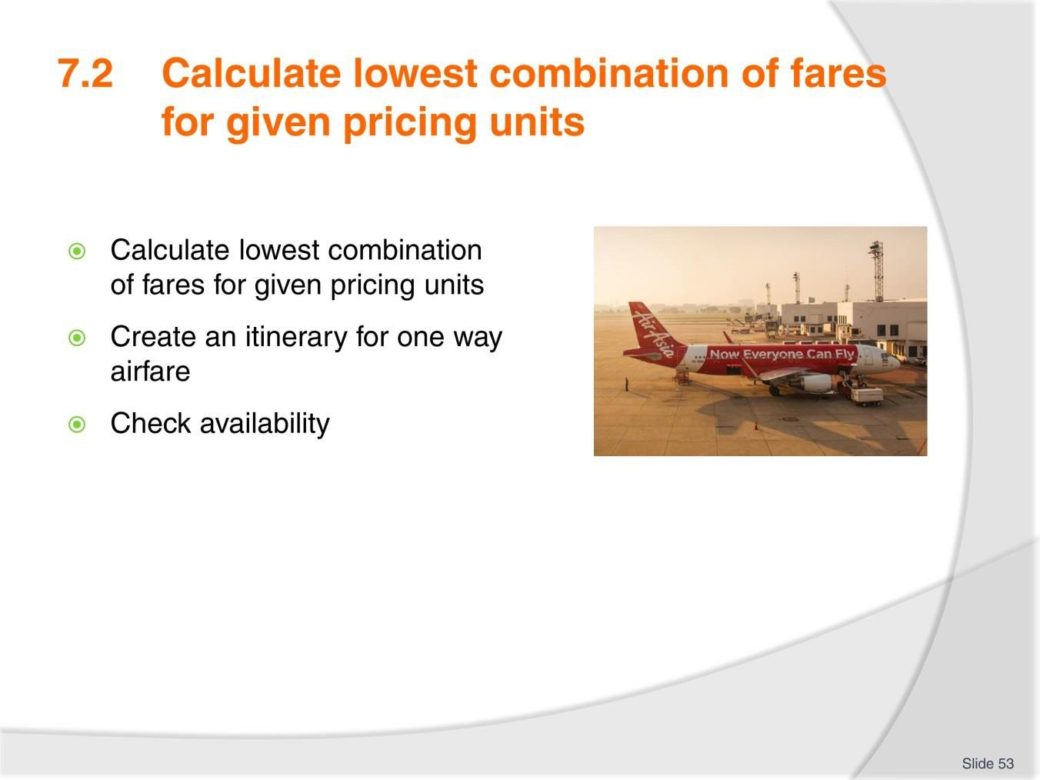
Slide
Slide No
Trainer Notes
53.
Trainer to advise: PC: 7.2
- Create an itinerary for one way airfare
- Check availability.
Activity
- Create an itinerary for one way airfare providing the lowest price point.

Slide
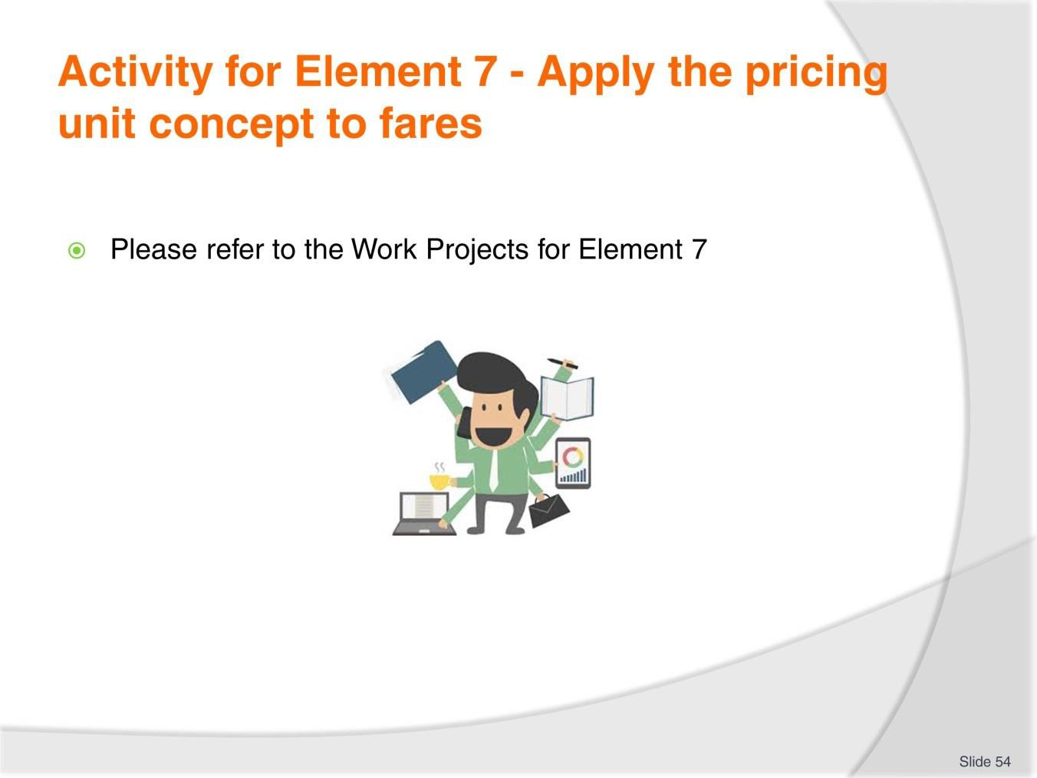
Slide No | Trainer Notes
54. | Ensure learners complete the Work Projects at the end of Element 7. Trainer may decide if these are to be completed in class individually or in groups or alternatively as homework.  A copy of work sheets has been included in the Trainer Guide.  - Review the Summary page for Element 7 to confirm with learners what has been completed for this Element.

Slide
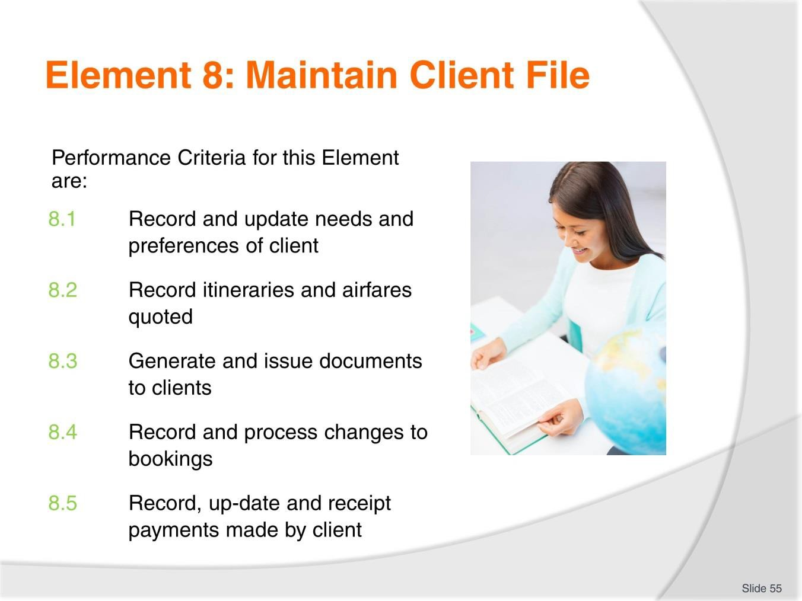
Slide No | Trainer Notes
55. | Trainer to relate performance criteria to element 8.  - Performance criteria is the process by which the students training match the learning element  - The element is the skill  - To assess competency in the skill, the performance criteria is used to outline activities that can be used to assess competency.  The trainer should relate how the performance criteria are related to the element. To be able to Maintain Client File the students must be able to:  Record and update needs and preferences of client  - Record itineraries and airfares quoted  - Generate and issue documents to clients  - Record and process changes to bookings  - Record, up-date and receipt payments made by client.

Slide
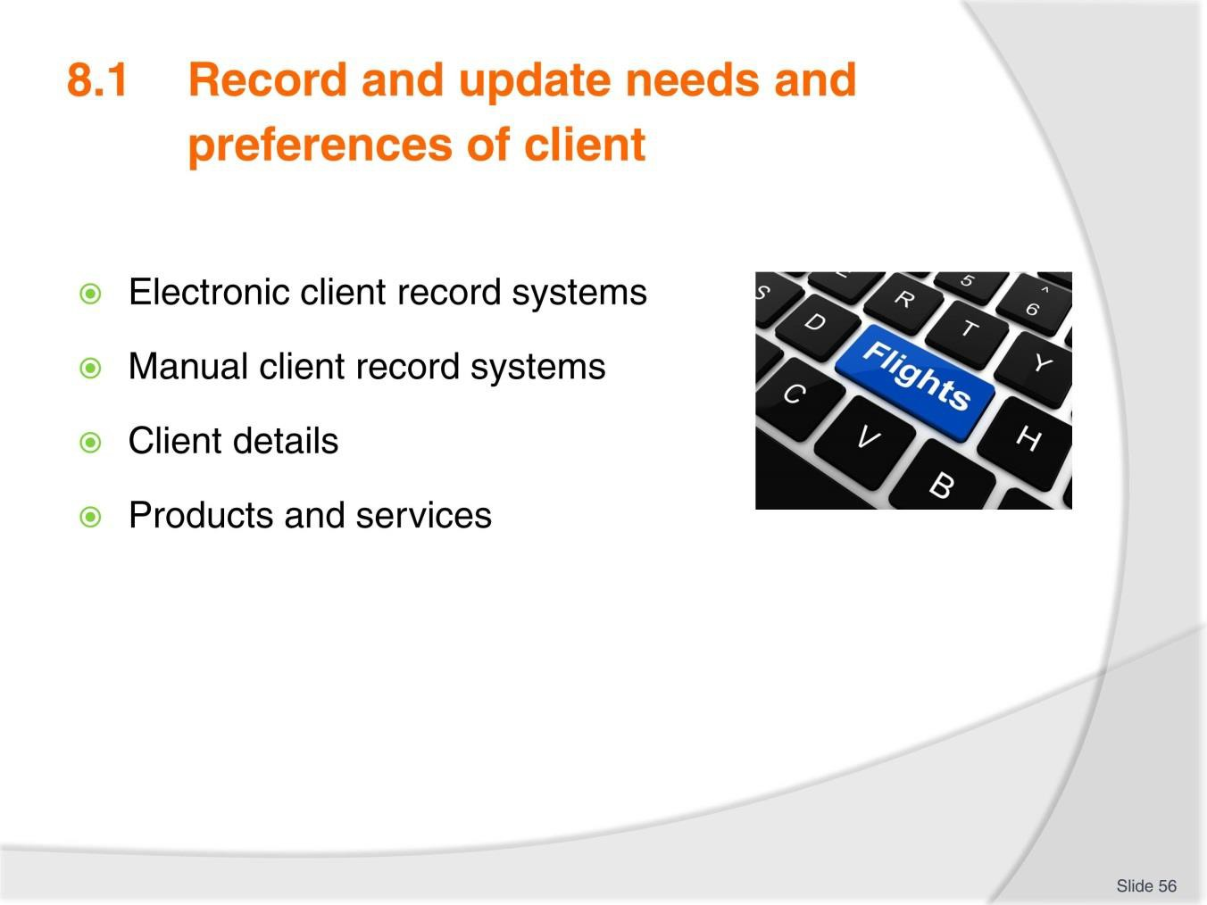
Slide No | Trainer Notes
56. | Trainer to advise: PC: 8.1 Refer to TM notes for these topics.  Electronic client record systems and Manual client record systems  Most travel agents use one of the following methods to record the detail of the products and services booked, their status and other relevant client detail.  - A totally manual system  - A totally electronic system  - A combination of both – most common.  Products and services  To ensure accuracy when preparing to issue documentation the following should be checked prior to commencing voucher production.  - All passenger names match their photo ID/passport  - All passenger names are correct across all items, products or services  - All items, products or services have a confirmed status  - There is date/city continuity for all items, product or services booked  - There are no unexplained gaps in the itinerary  - The booking is fully paid. Refer to TM for further notes.

Slide
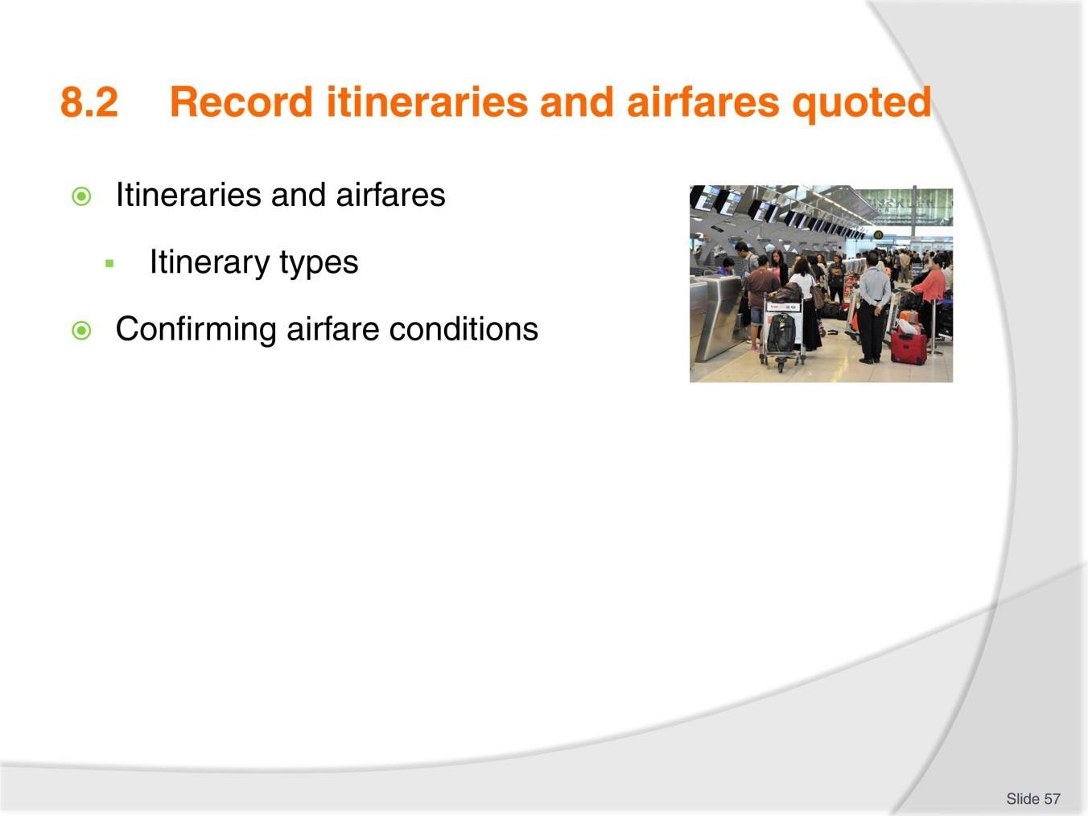
Slide No | Trainer Notes
57. | Trainer to advise: PC: 8.2  Itineraries and airfares quoted may include:  - All types of fares and trips offered by the host enterprise  - Through fares incorporating add-ons  - Mixed class fares  - Round, circle and open jaw trips  - Fares incorporating intermediate points  - Fares incorporating sector journeys and side-trips  - Fares incorporating airport and other taxes.  Discuss airfare conditions and penalties and clearly identifying these with the client.  Group Activity  Create an itinerary one of the following itineraries and include a quote for the client:  - Round or circle or open jaw trips.

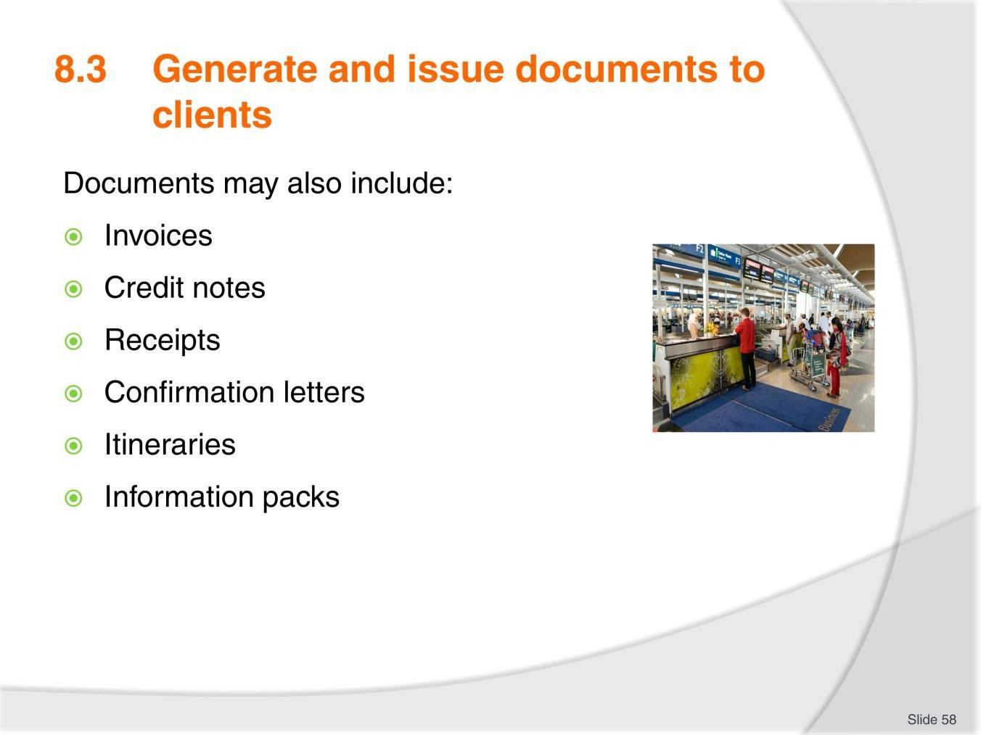Slide

Slide No Trainer Notes

- Trainer to advise: PC: 8.3
Documents may include:
  - Invoices
  - Credit notes
  - Receipts
  - Confirmation letters
  - Itineraries
  - Information packs.
  - Ensure learners are familiar with each type of document. Have samples available if possible.

Slide
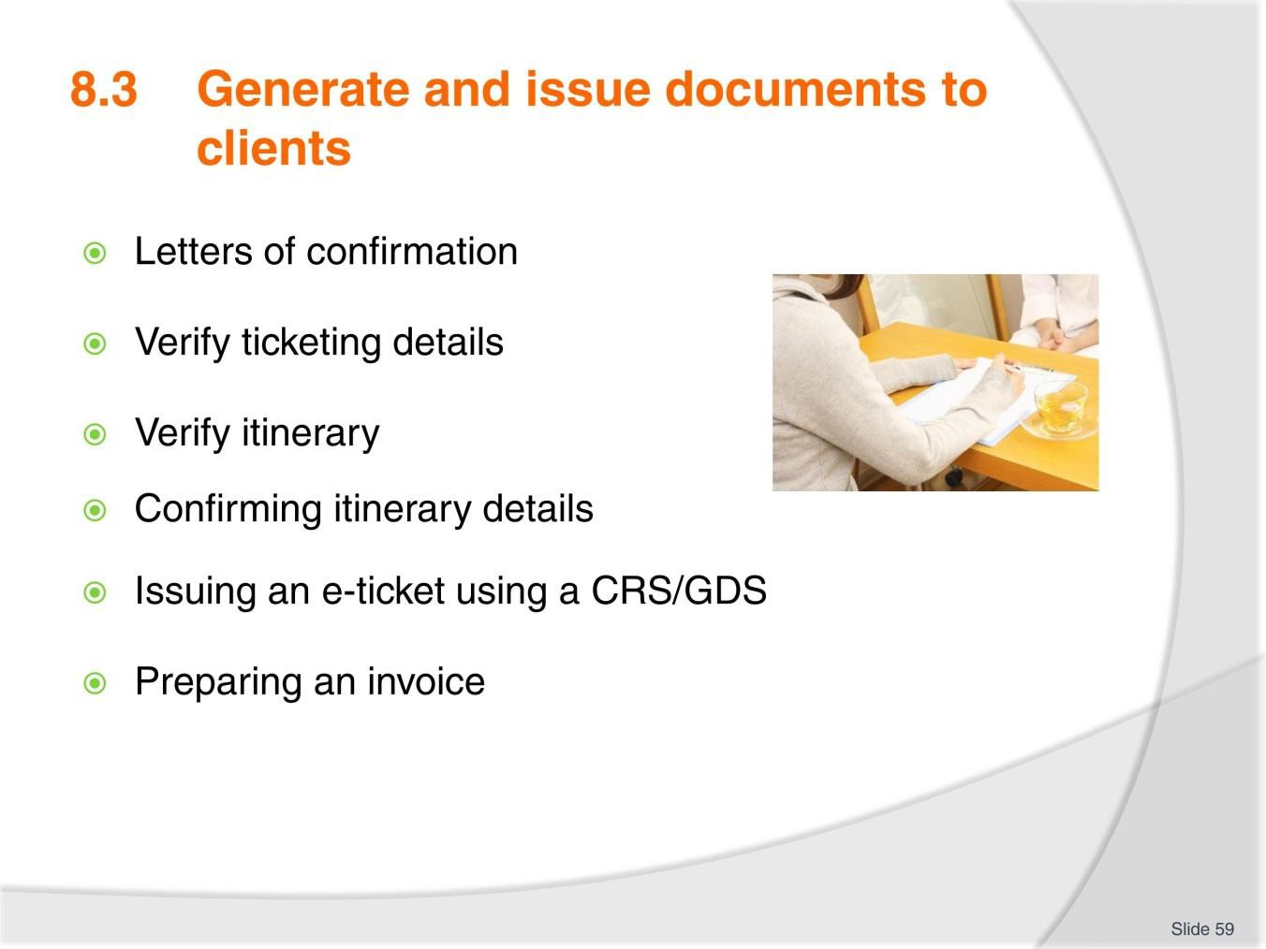
Slide No | Trainer Notes
59. | Trainer to advise: PC: 8.3  Using TM notes identify the importance of detailing information in writing and verifying key details for tickets and itinerary regarding names, dates times and so on.  Complete the activity in the TM.  Review sample tickets identifying key sections to explain and confirm with client. Have a sample invoice available for review and discussion as needed.  Activity  Based on the itinerary created in the previous activity at 8.2 , have learners create one  of the following documents:  - Invoice  - Credit note  - Receipt  - Confirmation letter  - Information pack.  - Share completed work with the group.

Slide
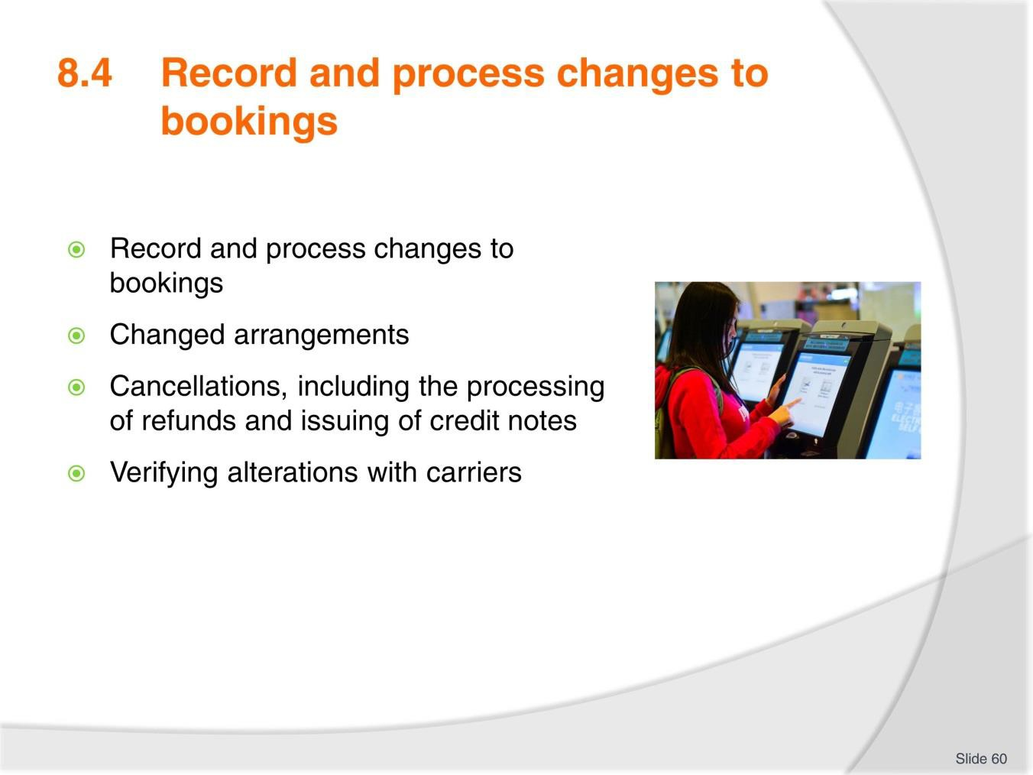
Slide No | Trainer Notes
60. | Trainer to advise: PC: 8.4  Changes to bookings may include:  - Changed arrangements  - Cancellations, including the processing of refunds and issuing of credit notes  - Verifying alterations with carriers  - Confirming alterations with clients and issuing appropriate confirmations and amended documentation.  Activity  - Based on the itinerary created in the previous activity: made an amendment to meet the clients need. Share the completed changes with the group.

Slide
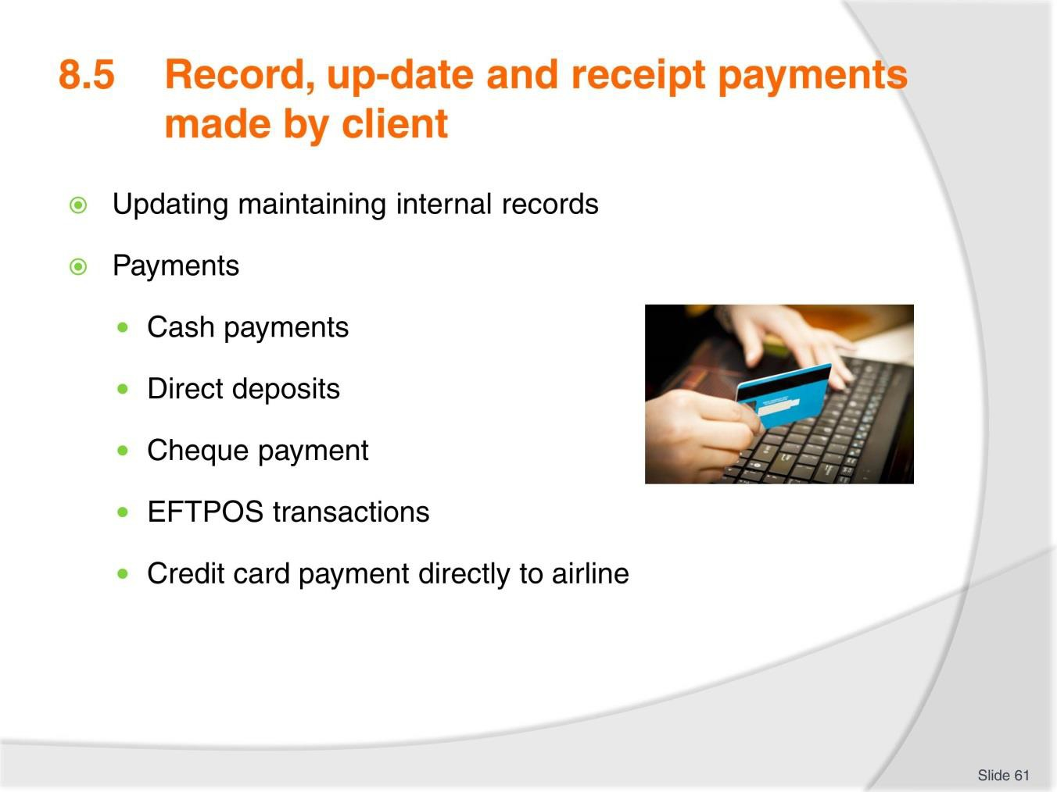
Slide No | Trainer Notes
61. | Trainer to advise: PC: 8.5 Updating maintaining internal records  It is essential that the enterprise maintains accurate and up to date financial records for each booking. The client record will store all of the client’s personal information and details on their current booking and may be linked to past bookings made by the client. Record keeping software used by a travel enterprise is designed to be both an accounting system and client database. To ensure accuracy, all information on payments received should be recorded immediately.  If the client has paid in full for their travel arrangements, you may now update their client records and order their airline ticket/s. If only part payment is received, do not issue airline tickets until the final payment has been received and receipted.  Discuss each of the payment methods and why one is preferred over the other in an agency.  Payments may include:  - Credit card  - Cash  - Personal, business and traveller’s cheque  - Direct debit, such as electronic funds transfer  - Invoice/account

- Telephone
- E-mail or other electronic transmission.

Slide
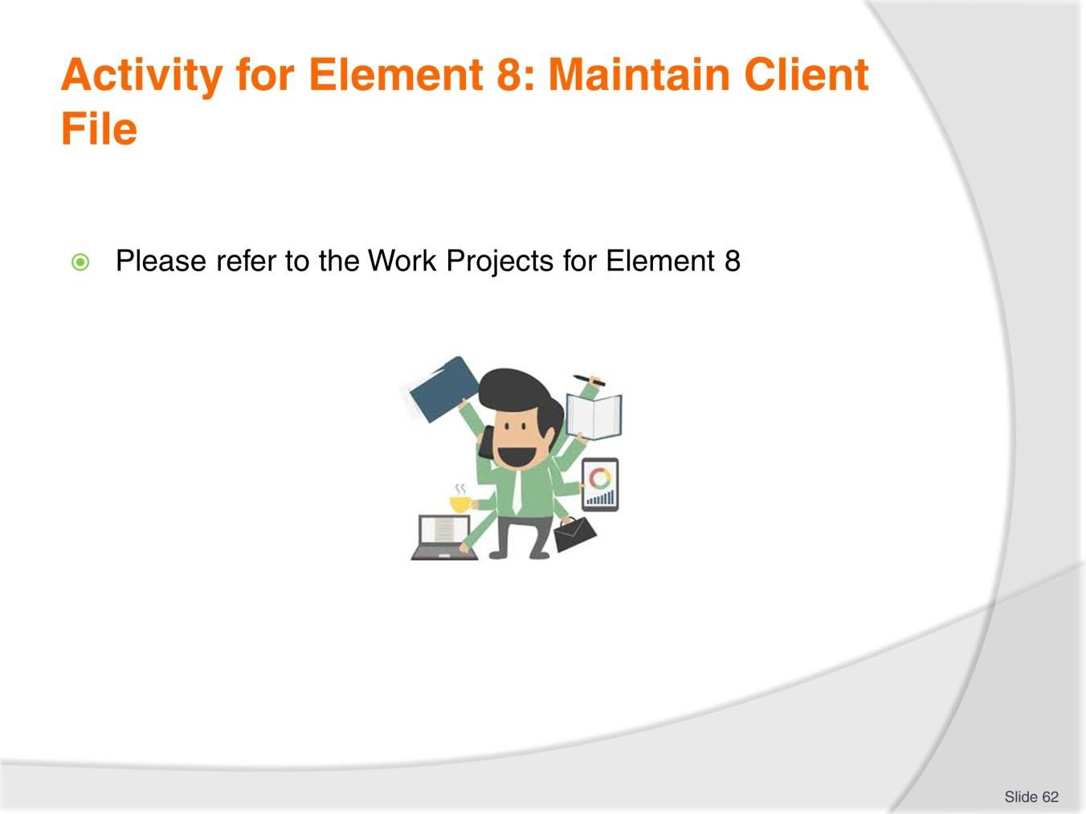
Slide No | Trainer Notes
62. | Ensure learners complete the Work Projects at the end of Element 8. Trainer may decide if these are to be completed in class individually or in groups or alternatively as homework.  A copy of work sheets has been included in the Trainer Guide.  - Review the Summary page for Element 8 to confirm with learners what has been completed for this Element.

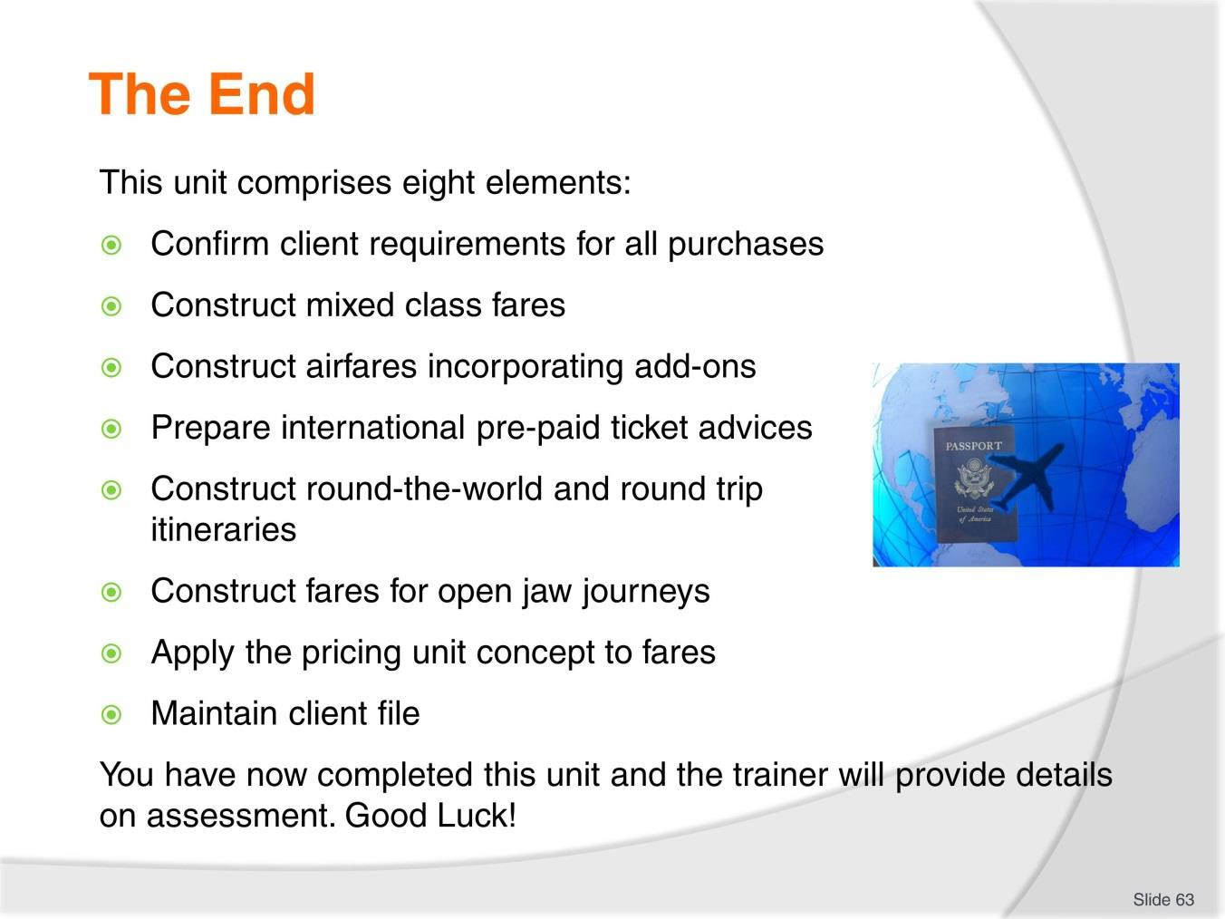
Slide
Slide No
Trainer Notes
63.
Trainer advises learners on what assessment is required and how it is to be conducted.

Recommended training equipment

Computers
One for each participant, with:
- Internet access
- Access to a Computer Reservation System and training manuals
- Client Management System software and instructions
- Software for creating documentation.

Software systems manuals
- Computer Reservation System Operations
- Computer Reservation Systems E-Ticketing
- Client Management System Operations.

Organisational policies, procedures and standards
- Policies for payments
- Policies for ticket issuance methods
- Document templates.

Documentation
Examples of:
- Agency branded ticket wallets and business cards
- E-tickets
- Itineraries
- Boarding passes
- Travel documentation associated with booking travel documentation, including airlines, tour operators, car hire and accommodation enterprises
- Invoices and receipts.

General Resources
- Printer
- Pens and paper
- World Map
- Calculators.

Instructions for Trainers for using PowerPoint – Presenter View
Connect your laptop or computer to your projector equipment as per manufacturers’ instructions.
In PowerPoint, on the Slide Show menu, click Set up Show.
Under Multiple monitors, select the Show Presenter View check box.
In the Display slide show on list, click the monitor you want the slide show presentation to appear on.
Source: http://office.microsoft.com

Note:

In Presenter View:
You see your notes and have full control of the presentation Your trainees only see the slide projected on to the screen

More Information

You can obtain more information on how to use PowerPoint from the Microsoft Online Help Centre, available at: http://office.microsoft.com/training/training.aspx?AssetID=RC011298761033

Note Regarding Currency of URLs

Please note that where references have been made to URLs in these training resources trainers will need to verify that the resource or document referred to is still current on the internet. Trainers should endeavour, where possible, to source similar alternative examples of material where it is found that either the website or the document in question is no longer available online.

Appendix – ASEAN acronyms

AADCP | ASEAN – Australia Development Cooperation Program
ACCSTP | ASEAN Common Competency Standards for Tourism Professionals
AEC | ASEAN Economic Community
AMS | ASEAN Member States
ASEAN | Association of Southeast Asian Nations
ASEC | ASEAN Secretariat
ATM | ASEAN Tourism Ministers
ATPMC | ASEAN Tourism Professionals Monitoring Committee
ATPRS | ASEAN Tourism Professional Registration System
ATFTMD | ASEAN Task Force on Tourism Manpower Development
CATC | Common ASEAN Tourism Curriculum
MRA | Mutual Recognition Arrangement
MTCO | Mekong Tourism Coordinating office
NTO | National Tourism Organisation
NTPB | National Tourism Professional Board
RQFSRS | Regional Qualifications Framework and Skills Recognition System
TPCB | Tourism Professional Certification Board



